

Software Project Management
AY2024 Semester 1

SCHOOL OF INFOCOMM TECHNOLOGY
Diploma in Information Technology

ASSIGNMENT

Duration : Week 6 to Week 17

Individual/Team : Both individual and Team (4 to 5 students)

Format : Submission by Group Leader
via Brightspace (40%)

Cut-Off Date/Time
Final : Sunday, 28 Jul 2024, 23:59 hrs (week 15)

 | Module Group: | P03
 | Student Number | Student Name | Grade
1 | S10258457 | Yeo Jin Rong
2 | S10262552 | Ng Kai Huat Jason
3 | S10258272 | Liang Ding Xuan
4 | S10258126 | An Yong Shyan
5 | S10262567 | Tan Guo Zhi Kelvin

Penalty for late submission:
10 marks per day (including Sunday and public holiday)

1. Project Overview 6
1.1 Product Goal 6
1.2 Team Roles and Responsibilities 7
1.3 Definition of Done 8
1.3.1 Code Quality 8
1.3.2 Testing 8
1.3.3 Functionality 8
1.3.4 Version Control 8
1.3.5 Deployment 8
2. Sprint 1 9
2.1 Sprint burndown chart report 9
2.1.1 Sprint Dates 9
2.1.2 Sprint Goal 9
2.1.3 Sprint Burndown Chart 9
2.1.4 Scope Changes Log 10
2.1.5 Incomplete Issues 12
2.1.6 Completed Issues 12
2.1.7 Issues complete outside of Sprint 13
2.1.8 Increment 13
2.3 Sprint Review Discussion 15
2.3.1 Sprint Review Date 15
2.3.2 Stakeholder Inspection of Outcome of Sprint 15
2.3.3 Insights 16
2.3.4 Future Adaptations 16
2.4 Sprint Retrospective 16
2.4.1 Highlights of our Scrum Team 16
2.4.2 Impediments to our Scrum Team 16
2.4.3 Opportunities for our Scrum Team 17
2.4.4 Negative Practices of our Scrum Team 17
2.4.5 Positive Practices to implement for our Scrum Team 17
2.4.6 Practices to continue for our Scrum Team 17
2.4.7 Miro Discussion Board 18
3. Sprint 2 19
3.1 Sprint burndown chart report 19
3.1.1 Sprint Dates 19
3.1.2 Sprint Goal 19
3.1.3 Sprint Burndown Chart 19
3.1.4 Scope Changes Log 20
3.1.5 Incomplete Issues 20
3.1.6 Completed Issues 21
3.1.7 Issues complete outside of Sprint 21
3.1.8 Increment 22
3.2 Sprint Review Discussion 23
3.2.1 Sprint Review Date 24
3.2.2 Stakeholder Inspection of Outcome of Sprint 24
3.2.3 Insights 25
3.2.4 Future Adaptations 25
3.3 Sprint Retrospective 26
3.3.1 Highlights of our Scrum Team 26
3.3.2 Impediments to our Scrum Team 26
3.3.3 Opportunities for our Scrum Team 26
3.3.4 Negative Practices of our Scrum Team 26
3.3.5 Positive Practices to implement for our Scrum Team 26
3.3.6 Practices to continue for our Scrum Team 26
3.3.7 Miro Discussion Board 27
4. Sprint 3 29
4.1 Sprint burndown chart report 29
4.1.1 Sprint Dates 29
4.1.2 Sprint Goal 29
4.1.3 Sprint Burndown Chart 29
4.1.4 Scope Changes Log 30
4.1.5 Incomplete Issues 31
4.1.6 Completed Issues 31
4.1.7 Issues complete outside of Sprint 32
4.1.8 Increment 33
4.2 Sprint Review Discussion 36
4.2.1 Sprint Review Date 36
4.2.2 Stakeholder Inspection of Outcome of Sprint 36
4.2.3 Insights 37
4.2.4 Future Adaptations 37
4.3 Sprint Retrospective 38
4.3.1 Highlights of our Scrum Team 38
4.3.2 Impediments to our Scrum Team 38
4.3.3 Opportunities for our Scrum Team 38
4.3.4 Negative Practices of our Scrum Team 38
4.3.5 Positive Practices to implement for our Scrum Team 39
4.3.6 Practices to continue for our Scrum Team 39
4.3.7 Miro Discussion Board 40
5. Sprint 4 41
5.1 Sprint burndown chart report 41
5.1.1 Sprint Dates 41
5.1.2 Sprint Goal 41
5.1.3 Sprint Burndown Chart 41
5.1.4 Scope Changes Log 42
5.1.5 Incomplete Issues 43
5.1.6 Completed Issues 44
5.1.7 Issues complete outside of Sprint 45
5.1.8 Increment 46
5.2 Sprint Review Discussion 50
5.2.1 Sprint Review Date 50
5.2.2 Stakeholder Inspection of Outcome of Sprint 50
5.2.3 Insights 51
5.2.4 Future Adaptations 51
5.3 Sprint Retrospective 52
5.3.1 Highlights of our Scrum Team 52
5.3.2 Impediments to our Scrum Team 52
5.3.3 Opportunities for our Scrum Team 52
5.3.4 Negative Practices of our Scrum Team 52
5.3.5 Positive Practices to implement for our Scrum Team 52
5.3.6 Practices to continue for our Scrum Team 53
5.3.7 Miro Discussion Board 53
Appendix A 54
Appendix B 150
Sprint 1 150
Sprint 2 151
Sprint 3 152
Sprint 4 153
Overall Sprint 154
Table of Contents

1. Project Overview
The project involves developing a city-building strategy game named “Ngee Ann City”, where the player has to build the happiest and most prosperous city possible in Ngee Ann City, achieving the highest score by strategically constructing various buildings. Players manage resources, make tactical decisions about placement, and optimize building arrangements to maximize points and profits while minimizing upkeep costs.

Product Goal
The product will offer two game modes: Arcade and Free Play.
Arcade Mode:
- Initial Resources: The player starts with 16 coins.

- City Grid: A fixed grid with a difficulty selector – 5x5, 7x7, 10x10, 20x20.

- Building Constraints:
  - Players build one of two randomly selected buildings each turn, in a permutation of 5 choose 2
  - The first building can be placed anywhere.
  - Subsequent buildings must be adjacent to existing structures, in a vertical and/or horizontal manner only.

- Scoring: Each type of building has specific scoring rules, contributing to the overall points.

- Goal: Maximize points with limited coins and a fixed grid.

Free Play Mode:
- Resources: Unlimited coins.

- City Grid: Starts at 5x5 and expands by 5 rows when a building is constructed at the border.

- Building Constraints:
  - Players can build any type of building each turn, anywhere on the grid.

- Scoring: Same as Arcade mode.

- Upkeep Costs:
  - Each building type has specific upkeep costs and profit generation per turn.
  - Buildings generate coins and require upkeep based on their type and adjacency.
- Goal: Continuously expand and develop the city, balancing profits and costs to sustain growth and maximize points.
Building Types and Characteristics:
- Residential (R):
  - Scores: 1 point per adjacent R or C, 2 points per adjacent O, or 1 point if next to I.
  - Profit: Generates 1 coin per turn.
  - Upkeep: Each cluster requires 1 coin per turn.

- Industry (I):
  - Scores: 1 point per I in the city.
  - Profit: Generates 2 coins per turn.
  - Upkeep: Costs 1 coin per turn.

- Commercial (C):
  - Scores: 1 point per adjacent C.
  - Profit: Generates 3 coins per turn.
  - Upkeep: Costs 2 coins per turn.

- Park (O):
  - Scores: 1 point per adjacent O.
  - Upkeep: Costs 1 coin per turn.

- Road (*):
  - Scores: 1 point per connected road in the same row.
  - Upkeep: Each unconnected segment costs 1 coin per turn.

Team Roles and Responsibilities
Yeo Jin Rong: Product Owner
Responsible for defining the overall goal and vision of the product, managing the product backlog and ensuring that value is ultimately delivered to the stakeholders in a reasonable timeframe

Ng Kai Huat Jason: Scrum Master
Facilitates the Scrum process, removes impediments that hinder the effectiveness of the Scrum team and ensures that the team adheres to Scrum practices

Liang Ding Xuan: Developer
Works on coding, testing, and implementing game features in tandem

An Yong Shyan: Developer
Works on coding, testing, and implementing game features in tandem

Tan Guo Zhi Kelvin: Developer
Works on coding, testing, and implementing game features in tandem

Definition of Done

Code Quality
- Feature must be implemented as per acceptance criteria listed in User Story
- Code must be reviewed and approved through a peer review process, with a minimum of 1 colleague reviewing the code
- Code must be free of known and documented bugs, free of technical debt if appropriate
- Code must be documented thoroughly, inclusive of inline comments and relative documentation in repository

Testing
- Feature(s) must be tested through multiple browsers (Google Chrome, Edge, Firefox, etc)
- Feature(s) must be tested repeatedly when integrating, to ensure that all increments are functional

Functionality
- Feature(s) must be showcased and briefly elaborated on to the Product Owner, approved to ensure that is in line with the product vision and goal
- Feature(s) must meet and suffice all defined acceptance criteria(s)
- Feature must be user-tested where applicable and appropriate to ensure ease of use and user-experience (UI/UX)

Version Control
- Work done must be committed to branch in Github before approval
- Branch must be merged into main only after peer review and approval, as well as after all tests are successful, ensuring that increment does not compromise sprint goal
- Repository must be updated with latest work done (code) as per each sprint, with the main branch being a stable version of the game

Deployment
- Each increment must be ready for deployment from Github

2. Sprint 1

2.1 Sprint burndown chart report

2.1.1 Sprint Dates
May 27th, 2024 - June 10th, 2024

2.1.2 Sprint Goal
Construct a useful and viable product increment that serves as a good foundation for future game features.
1) Main menu must be implemented and functional
2) Starting of game must be successful and properly display a grid
3) Handle "Exit" from game and game modes gracefully

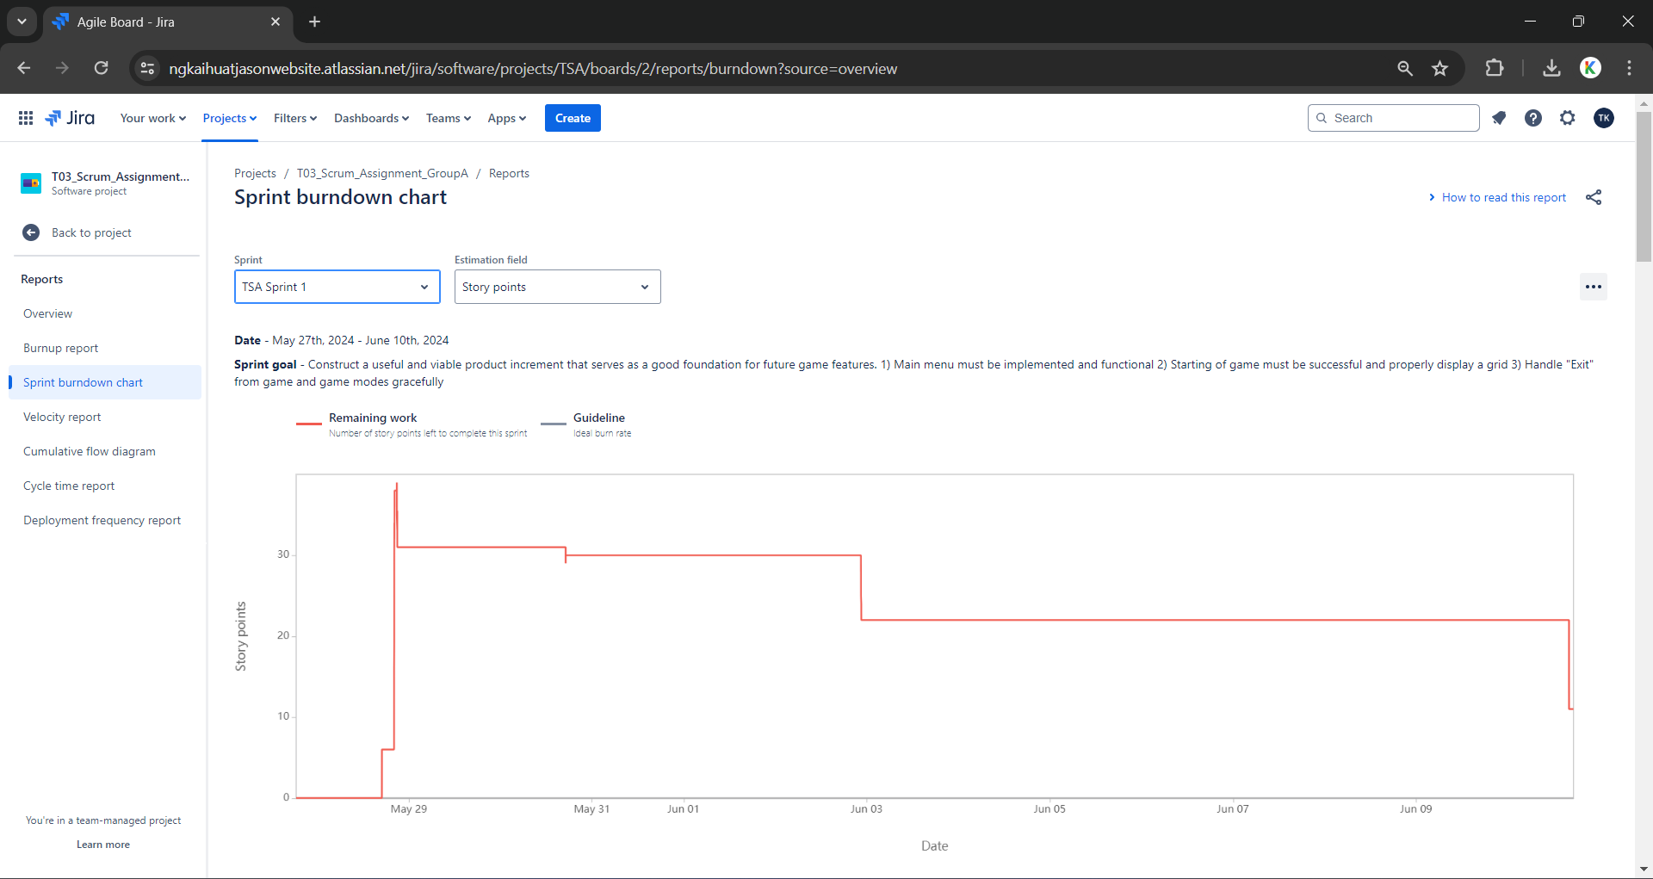
2.1.3 Sprint Burndown Chart

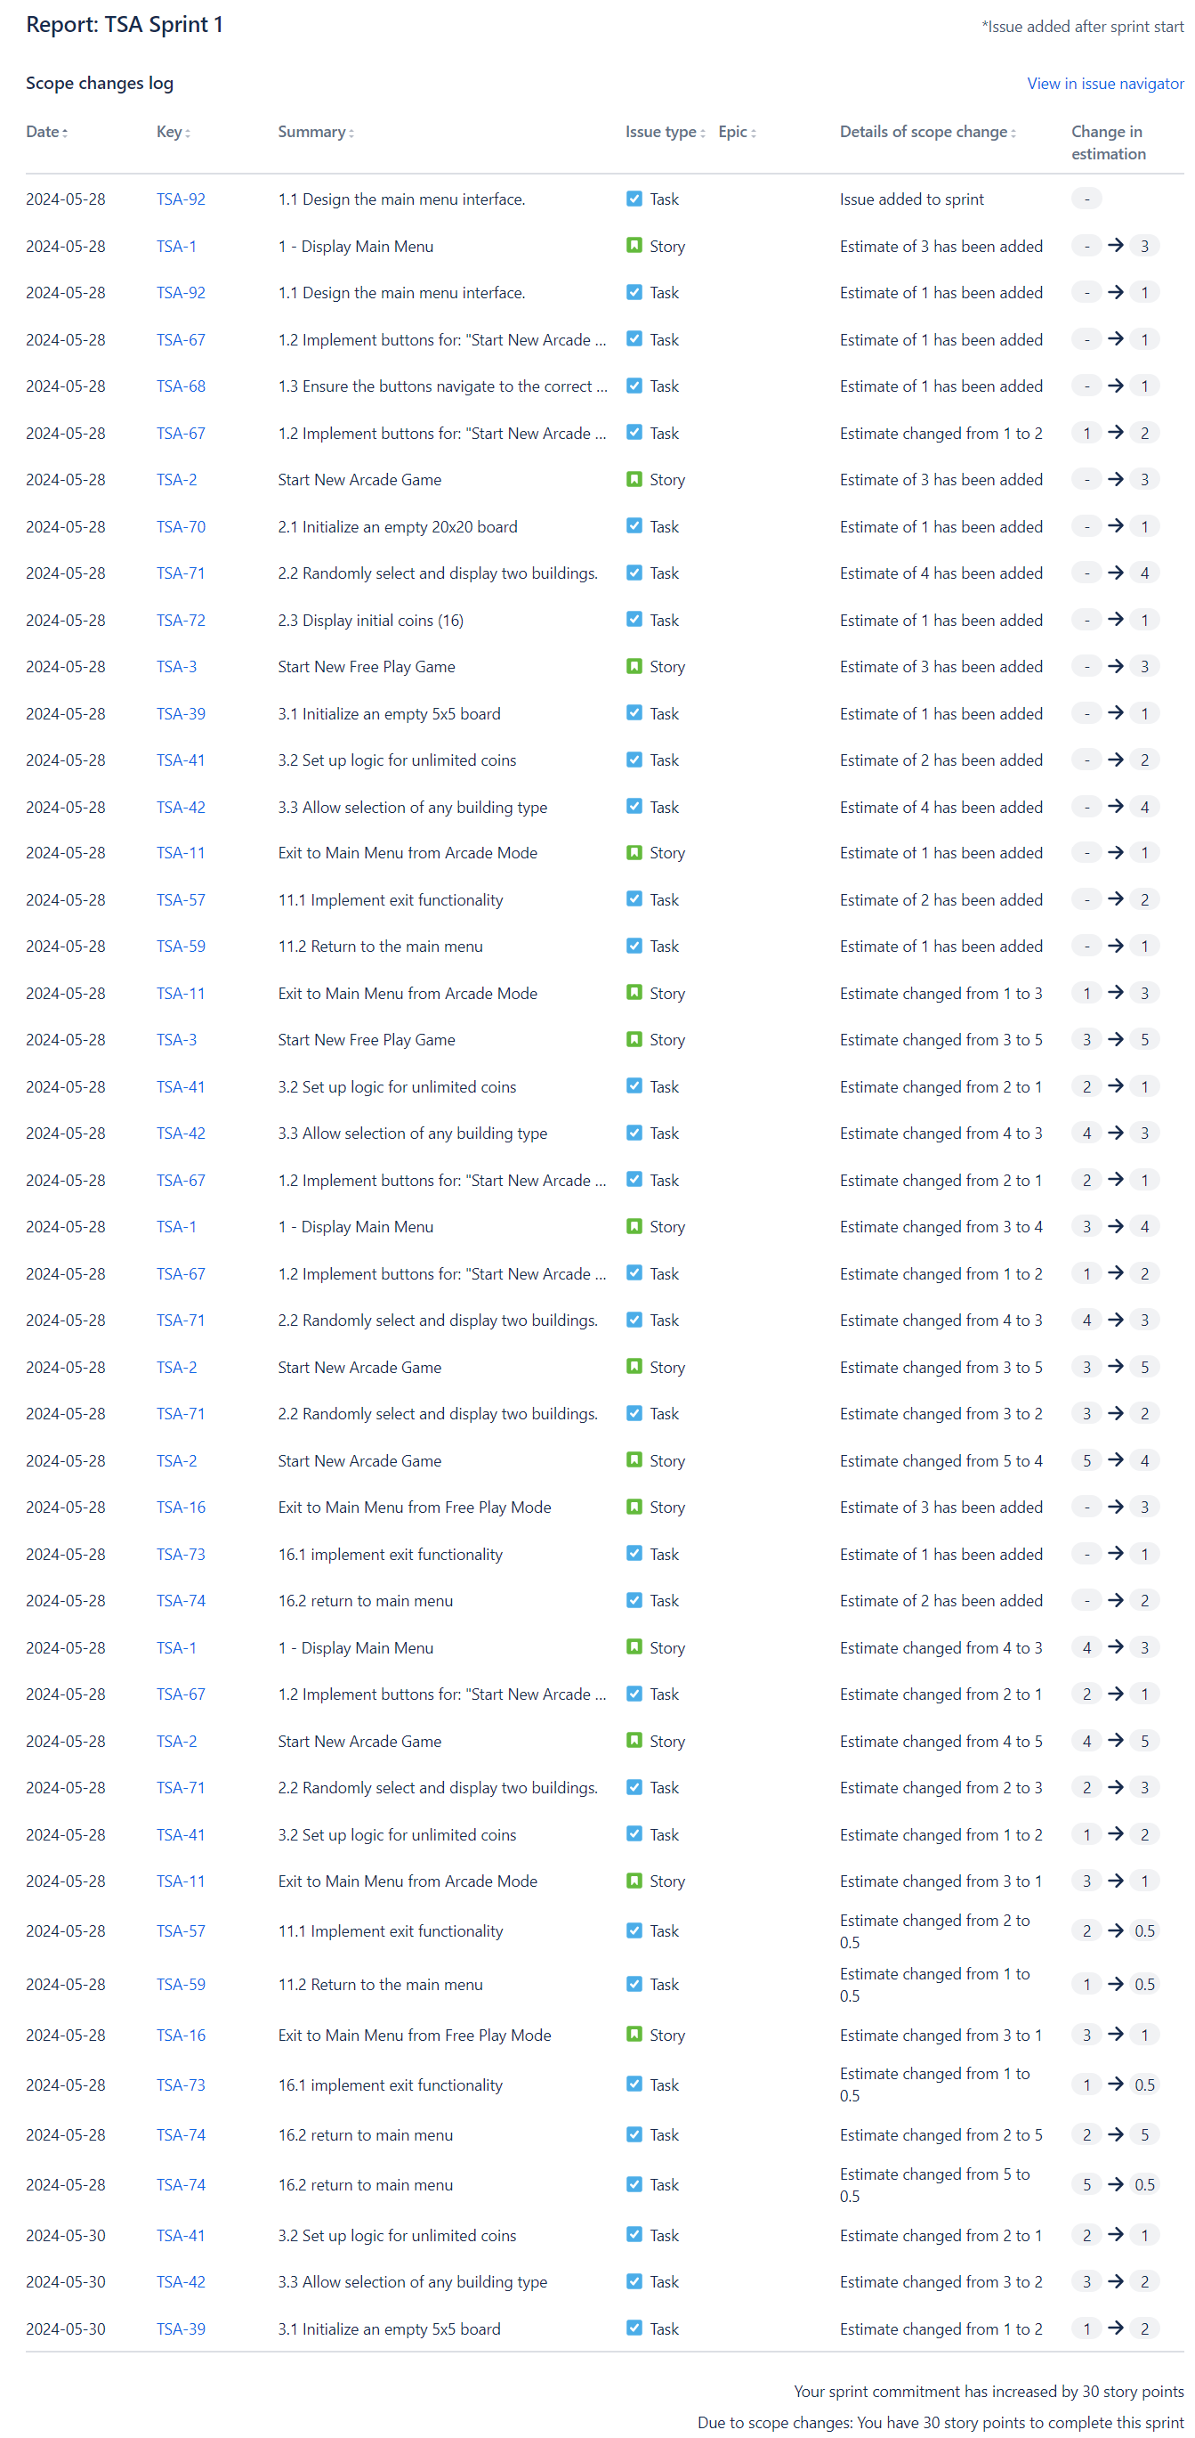
2.1.4 Scope Changes Log

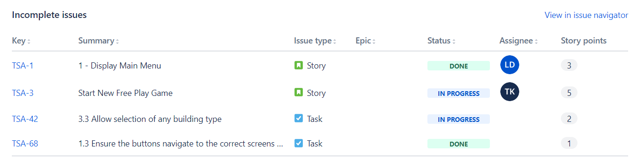
2.1.5 Incomplete Issues
- Main Menu did not meet the definition of done, as functionality was not fully implemented, along with all its relative sub tasks

- “Start New Free Play Game” did not meet definition of done, along with all its respective sub tasks

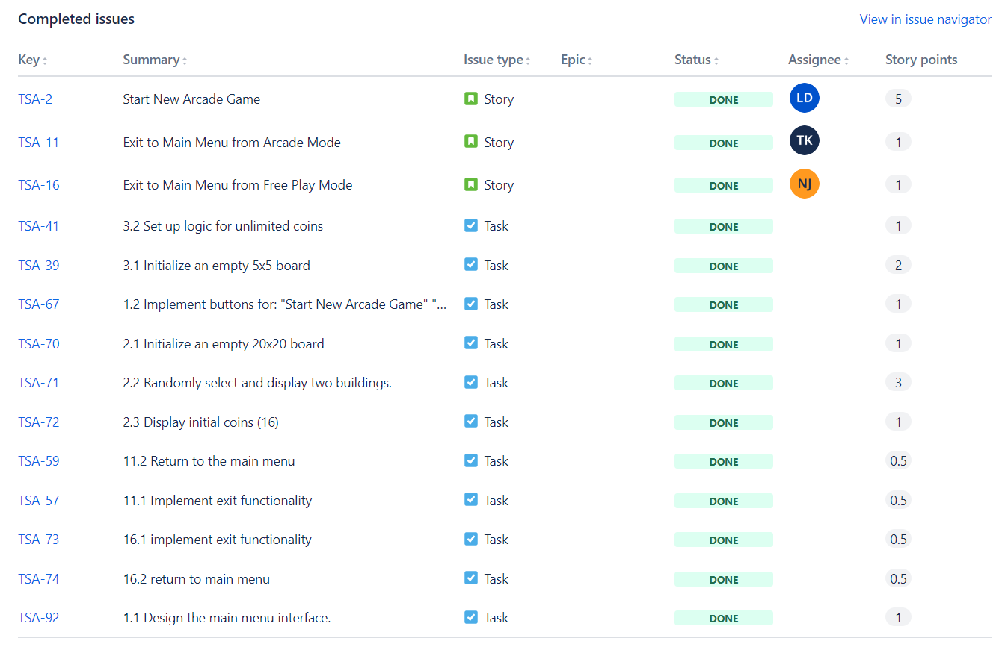
2.1.6 Completed Issues

- “Start New Arcade Game Mode” User Story was implemented fully, meeting its definition of done.
- “Exit to Main Menu” User Stories also have met the definition of done
- For more clarification on each issue, such as each Story’s individual acceptance criteria, please refer to Appendix A

2.1.7 Issues complete outside of Sprint
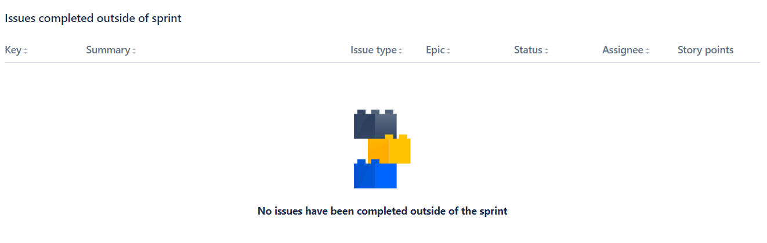
- No issues were completed outside of the sprint

2.1.8 Increment

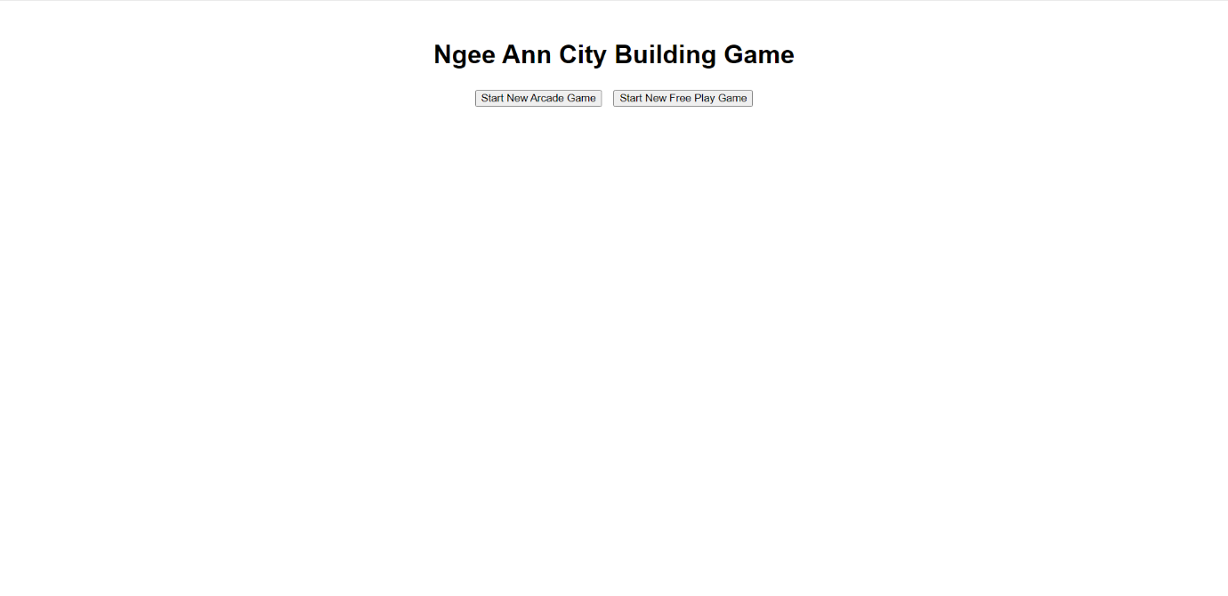
- Sprint 1 Main Menu

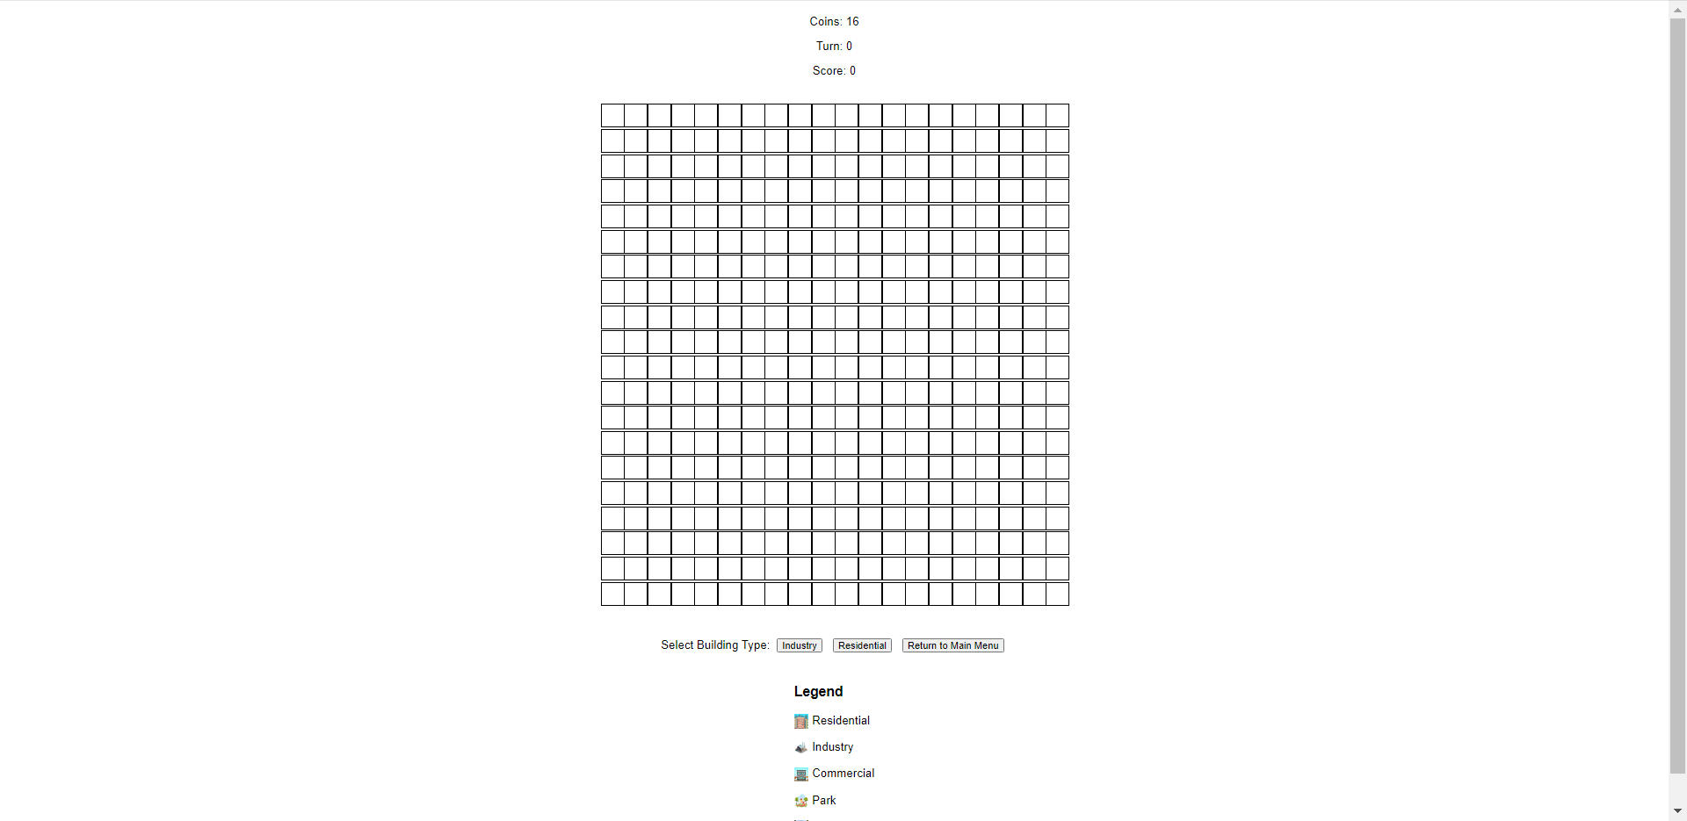
- Sprint 1 Arcade Mode
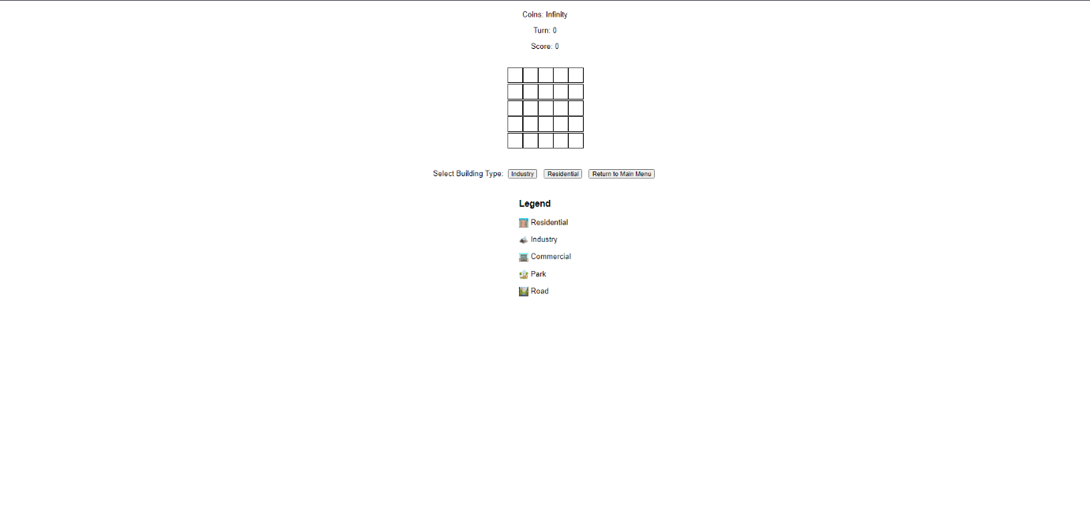

- Sprint 1 Free-play Mode

2.3 Sprint Review Discussion
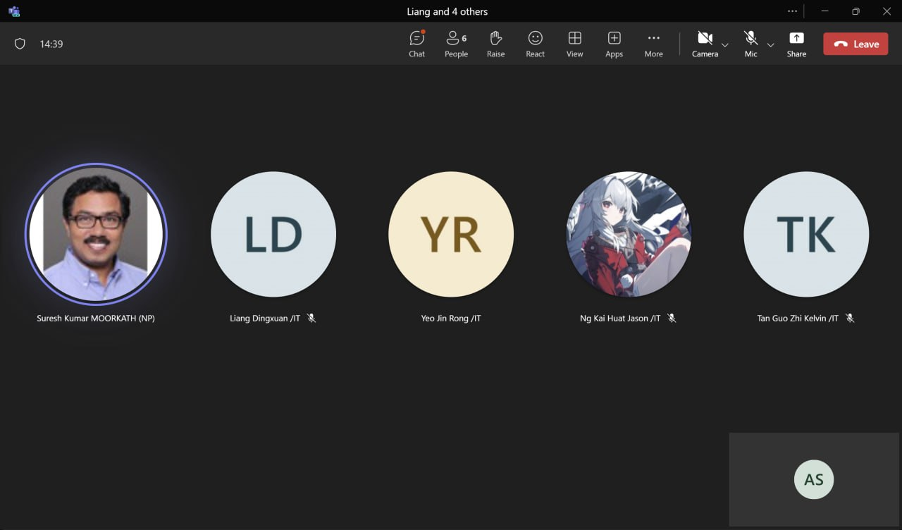

2.3.1 Sprint Review Date
Date: 3rd June 2024

2.3.2 Stakeholder Inspection of Outcome of Sprint
During our Sprint Review, our team interacted with our stakeholder as they inspected our increment produced from the Sprint. We began by demonstrating the functionality of the Main Menu, as well as the initial game state of both the Arcade and Free Play Mode.
Our team clarified with the stakeholder on some key misconceptions that required clarification, particularly in the game logic.
First, we re-confirmed that the Arcade Game mode requires a 20x20 grid, while Free Game mode requires a 5x5 grid that has capability to be expanded up to 20x20.
Secondly, we cleared up specifications on the logic of calculating score for the buildings and what does “adjacent” or “surrounding” specifically pertains to. Originally, the logic was intended to define adjacent buildings either horizontally, vertically or diagonally. However, after clarification from the stakeholder, it is now understood that adjacent only refers to horizonal or vertical adjacency, in other words only through the X and Y Axis.
Thirdly, we clarified that the functionality of coins being calculated is exclusive to the Arcade Game mode, while the functionality of profit and upkeep is exclusive the Free Play Game mode.

2.3.3 Insights
Through the Sprint Review and our interaction with the stakeholder, we gained valuable insights on how to improve the efficiency and productivity of our Scrum Team. We learned the importance of ironing out and having a common understanding of the game’s logic to ensure there are no conflicts in logic subsequently when implementing more complex components of the game. Additionally, it was important to break down the complexity of the game into simpler aspects to better understand the requirements to construct functional feature(s).

Our Scrum team also recognises that requirements can adapt and morph over time, due to inputs from stakeholder or clarifications on previously unsettled misconceptions, so our product must be modular to accommodate changes easily, rather than reconstructing work from the ground up.

2.3.4 Future Adaptations
In the subsequent sprint, our Scrum team will continue constructing the game in HTML, CSS and JavaScript. Our team will focus on the game logic of placing buildings. By focusing on the foundational aspects of the game logic, our scrum team aims to be able to continue to progressively implement features into Arcade Game Mode and Free Play Mode simultaneously, with both game modes being constructed at a relatively similar pace.

2.4 Sprint Retrospective
Overall, our Scrum Team has identified impediments in our overall work processes and issues in workflow. We have identified key issue(s) and have elaborated on them as follows:

2.4.1 Highlights of our Scrum Team
- Our scrum team was punctual and contributed to all scrum events, taking initiative and participating in discussion proactively.

2.4.2 Impediments to our Scrum Team
- Due to common test and assignments from other modules, our Scrum Team experienced haphazard delivery of work and scheduling of scrum events. This could be improved by having a set timeframe and schedule of major scrum events (planning and retrospective).

2.4.3 Opportunities for our Scrum Team
- Scrum team could improve time-management with ongoing assignments by leaving specific time slots dedicated to scrum events. For example, an effort will be made to conduct Sprint Retrospective on the last Friday of a given Sprint, to allow for ease of scheduling and consistent routine.

2.4.4 Negative Practices of our Scrum Team
- Scrum team had difficulty in deciding on what work to be done as our focus was not fine-tuned to a specific feature or task. This led to procrastination due to a tendency to wait for foundational work to be done first, which compounded into developers making independent decisions without conferring with others. An example of such negative practice is overriding other developers code without confirmation and altering it’s logic without proper documentation and approval.

2.4.5 Positive Practices to implement for our Scrum Team
- Scrum team can improve on communication throughout the team, by focusing on providing constructive and actionable feedback rather than fruitless criticism. Peer-reviewing of code also serves to facilitate better communication between members to understand the overall product better
- Scrum team can also refocus on one task/user story at a time to have a consistent output of work that meets Definition of Done, as well as having a reliable workflow.

2.4.6 Practices to continue for our Scrum Team
- Scrum team despite assignments were still present and punctual for daily scrum and scrum events.
- Continue refining and clarifying of product back log to properly reflect product goal
- Scrum Team should continue scrutinising definition of done as progress is made on product

2.4.7 Miro Discussion Board
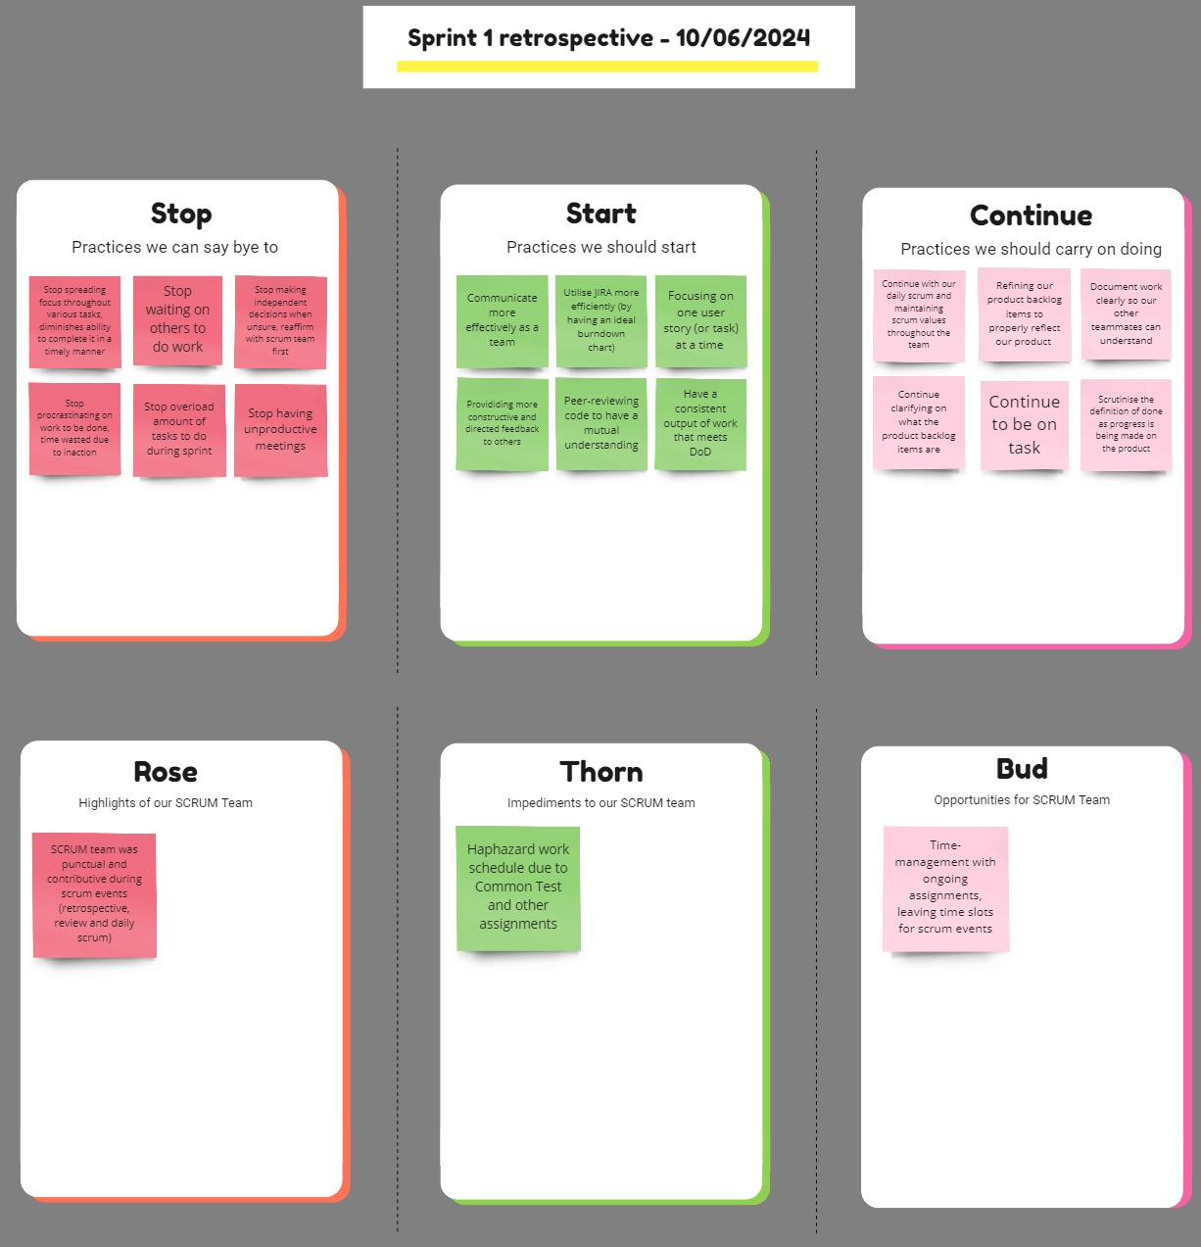

Link to SPM Sprint 1 Miro Retrospective Board:
https://miro.com/app/board/uXjVK9wpDsU=/?share_link_id=468173674750

3. Sprint 2

3.1 Sprint burndown chart report

3.1.1 Sprint Dates
June 10th, 2024 - June 24th, 2024

3.1.2 Sprint Goal
The goal of this sprint is to implement the functionality and starting game logic for the Arcade Mode. This provides us with a focus to build the foundation of the game after already constructing the main menu

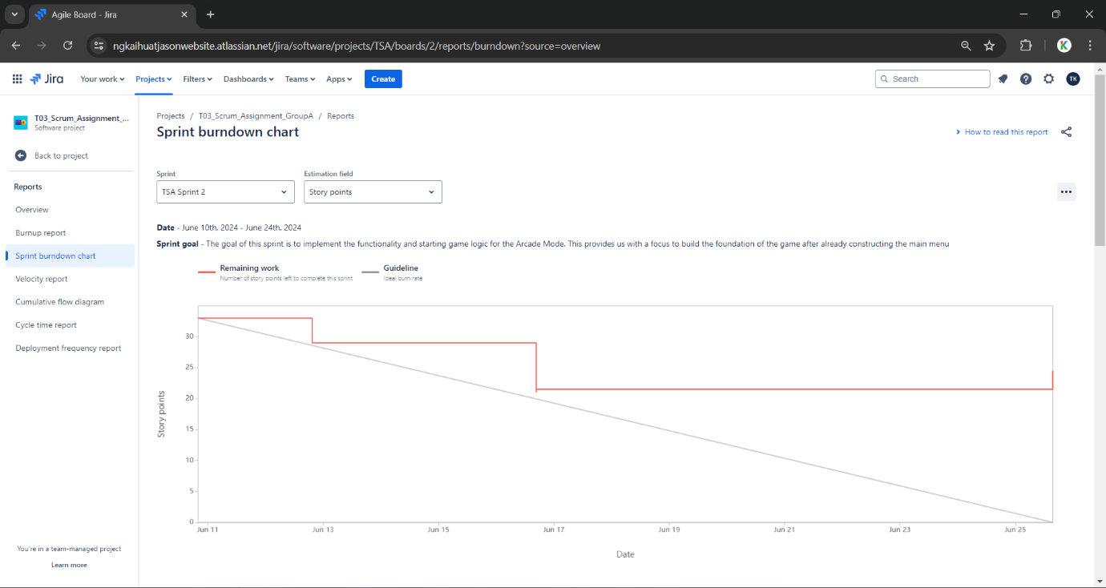
3.1.3 Sprint Burndown Chart

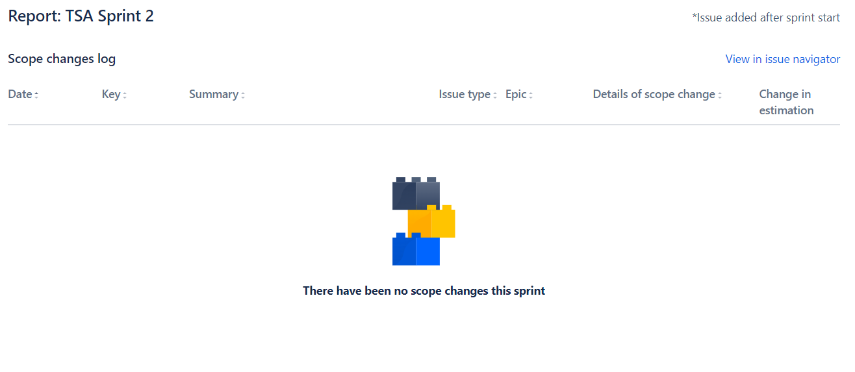
3.1.4 Scope Changes Log

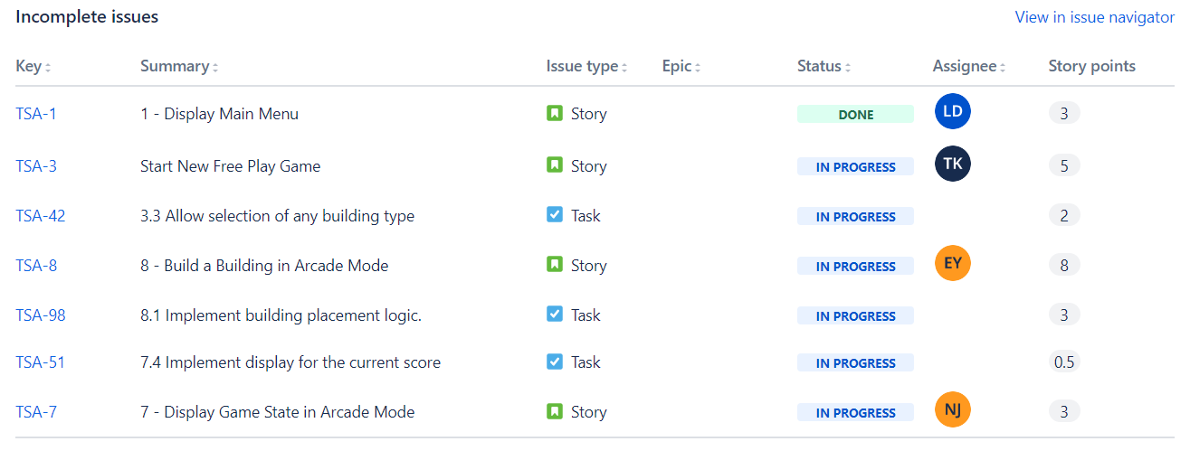
3.1.5 Incomplete Issues

- “Display Main Menu” is incomplete due to not meeting definition of done, additionally revamps for its UI/UX are planned
- “Start New Free Play Game” is incomplete, due to refocus on delivering Arcade Game Mode as fully functional before beginning work on Free Play Mode

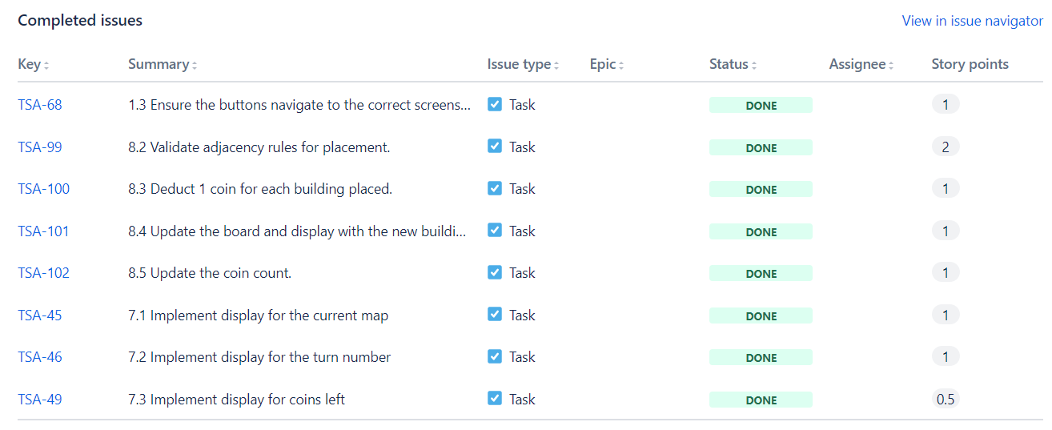
3.1.6 Completed Issues

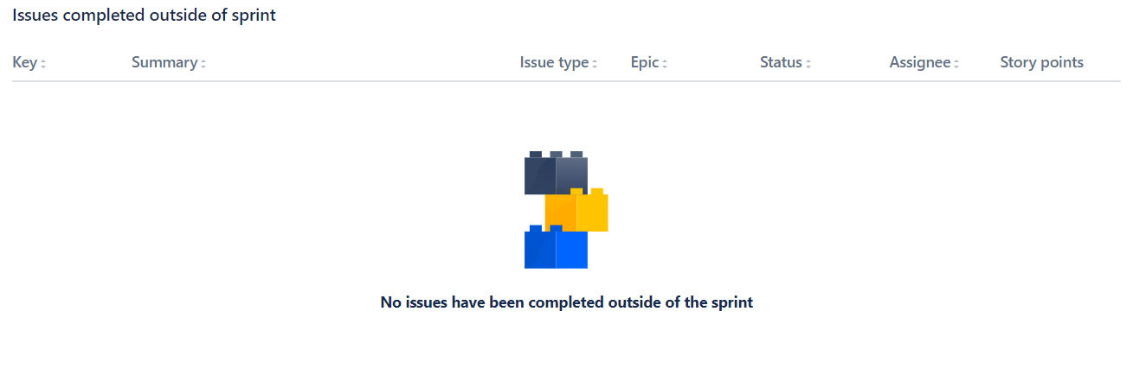
3.1.7 Issues complete outside of Sprint

- No issues have been completed outside of the sprint as listed in Jira
- However, a UI/UX revamp has been implemented for the Main Menu

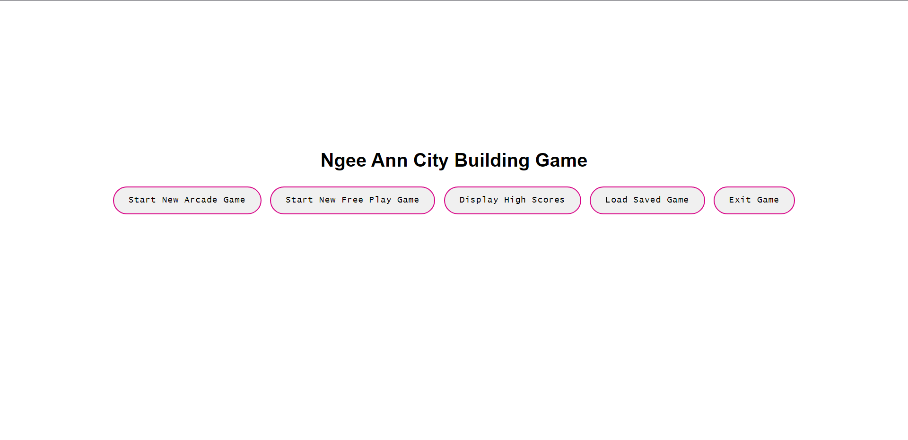
3.1.8 Increment
Sprint 2 Main Menu
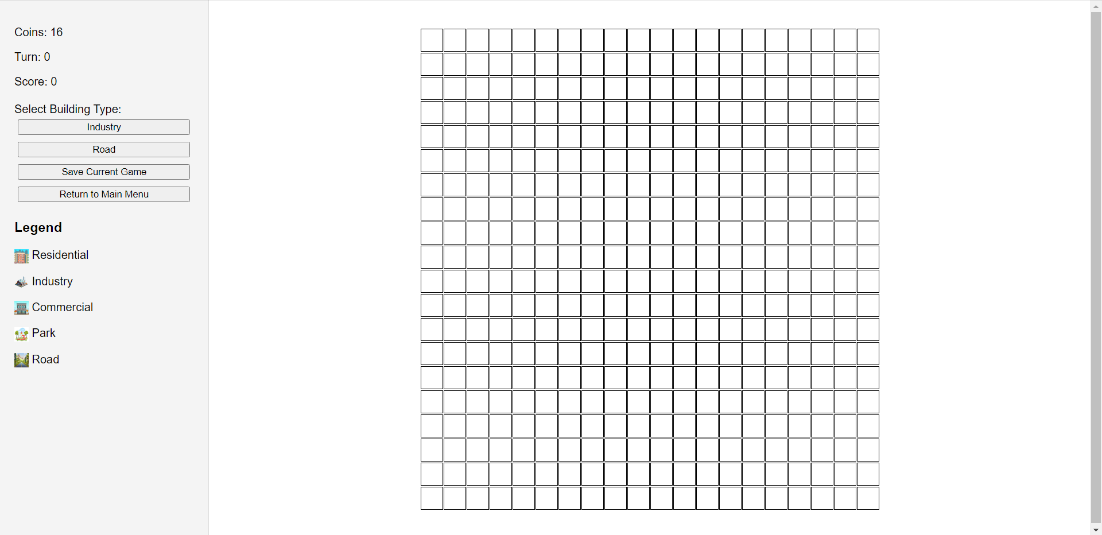
Sprint 2 Arcade Mode without Buildings

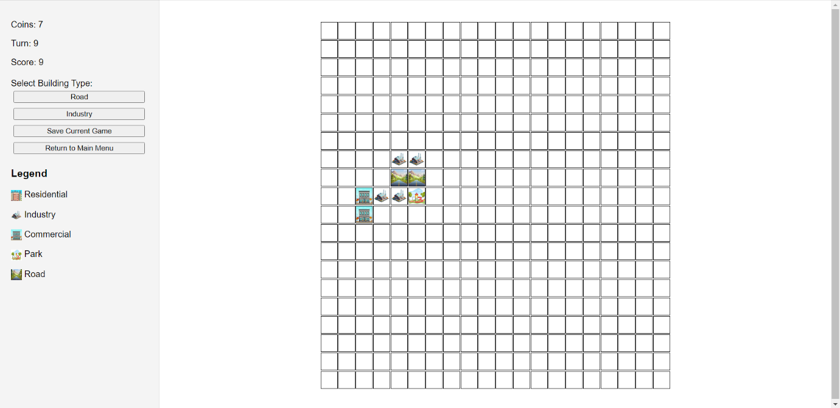
Sprint 2 Arcade Mode with Buildings placed, and adjacent rules applied

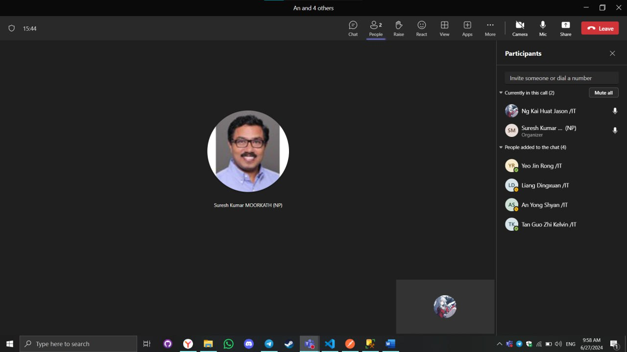
3.2 Sprint Review Discussion

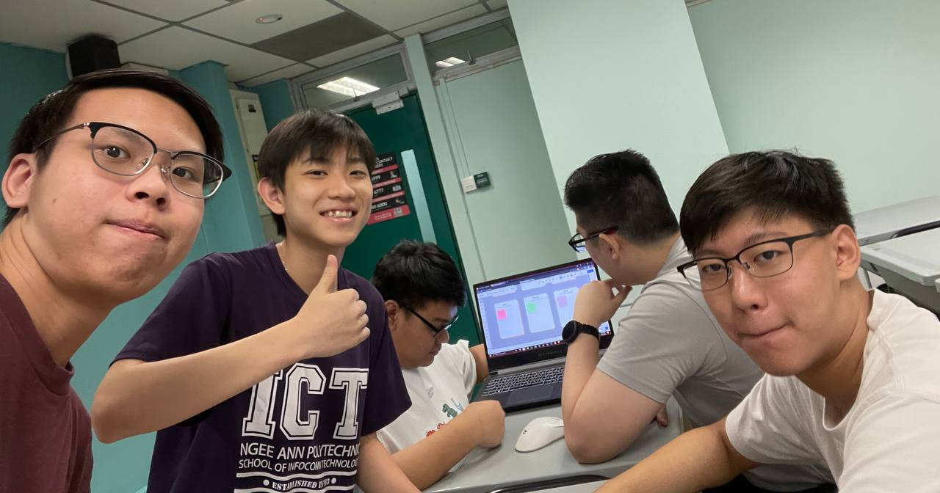

3.2.1 Sprint Review Date
Date: 27th June 2024

3.2.2 Stakeholder Inspection of Outcome of Sprint
During our Sprint Review, our team interacted with our stakeholder as they inspected our next increment produced from the Sprint. We began by demonstrating the functionality of the Main Menu with its UI/UX revamped, as well as the initial game state of the Arcade Game Mode, as well as the functionality to place buildings in the 20x20 Grid

Subsequently, we reassured with the stakeholder on the logic of building placement in Arcade Game Mode, where it is a randomized permutation of 2 buildings from a choice of 5 buildings. Our scrum team also displayed the ability to construct buildings in the arcade game mode.

Stakeholder expressed concern that was alleviated after Scrum Team elaborated on our project plan as our increment planned for Sprint 2 was not fully completed, due to differing time schedules as developers were on holiday. Despite this, we have reassured the stakeholder on expectations to be met, much to the stakeholder’s understanding. Stakeholder has also expressed importance of the major components to game logic must be completed in a timely manner, specifically on building point calculation.

Additionally, we consulted the stakeholder on how we should refocus on the project, by focusing on Arcade Game Mode first, we will be able to familiarise ourselves better with the logic of the game, being able to port over code that can be reutilised in Free Game Mode in the foreseeable future.

3.2.3 Insights
Through the Sprint Review and interaction with stakeholder, we gained valuable insights on how to improve our workflow. We learned the importance of targeted focus on the most challenging aspects as well as not spreading our focus throughout both game modes at the same time.
Additionally, we recognised the importance of team adaptability, especially external factors such as team members rendered unavailable, which greatly hinders progress. This adaptability will help us meet the changing requirements and stakeholder expectations.

3.2.4 Future Adaptations
In the next sprint, we will focus on constructing the game logic to calculate points in the Arcade Game Mode and start the initial game state on Free Game Mode. This change in development focus is expected to streamline and remove impediments for our scrum team, this allows us to collaborate and complete the given task on completing the Arcade Game Mode more smoothly.

3.3 Sprint Retrospective

3.3.1 Highlights of our Scrum Team
- Our scrum team was comparatively more productive than the past sprint, in terms of work done.
- More initiative was undertaken by developers to develop a clearer understanding of the overall project vision, goal and feature(s) required.

3.3.2 Impediments to our Scrum Team
- Due to holidays, our scrum team struggled to schedule scrum events in a timely manner, namely daily scrum as some team members due to circumstances such as no internet connection or health issues were unable to attend daily scrum.

3.3.3 Opportunities for our Scrum Team
- Our scrum team can implement better project management workflows admist assignments that are increasing in workload. This is to circumvent issues with time management in the future.

3.3.4 Negative Practices of our Scrum Team
- Scrum team has time mis-management issues due to holiday period, which snowballs into procrastination.
- Scrum team still has lingering confusion on what work is expected to be completed by the Sprint’s Conclusion, this can be attributed to the scattered focus on both game modes instead of a singular game mode.

3.3.5 Positive Practices to implement for our Scrum Team
- Scrum team can focus on one aspect of the game (Arcade Game) first and foremost, to have a concrete understanding of how to implement a game mode fully, being able to use the lessons learnt and familiarity acquired with the game logic to expedite the process in creating the second game mode (Free Game Mode)

3.3.6 Practices to continue for our Scrum Team
- The team should continue to prioritize maintaining daily scrum meetings and upholding scrum values throughout the team. This practice ensures that all members are aligned, and that the workflow remains transparent and efficient. Additionally, it's important to keep refining and scrutinizing the remaining product backlog items to ensure they are well-defined and actionable. Clear documentation of work is crucial for accountability and transparency, helping everyone stay informed about the project's progress and responsibilities.

- Furthermore, the team should make sure that all developers have a clear understanding of the product backlog, ensuring consistent output that meets the definition of done. This involves regular clarification sessions and rigorous adherence to the definition of done as the product evolves. Continuous cross-feedback and evaluation of each other’s work, along with maintaining open communication among developers, are essential practices to foster collaboration and high-quality output.

3.3.7 Miro Discussion Board
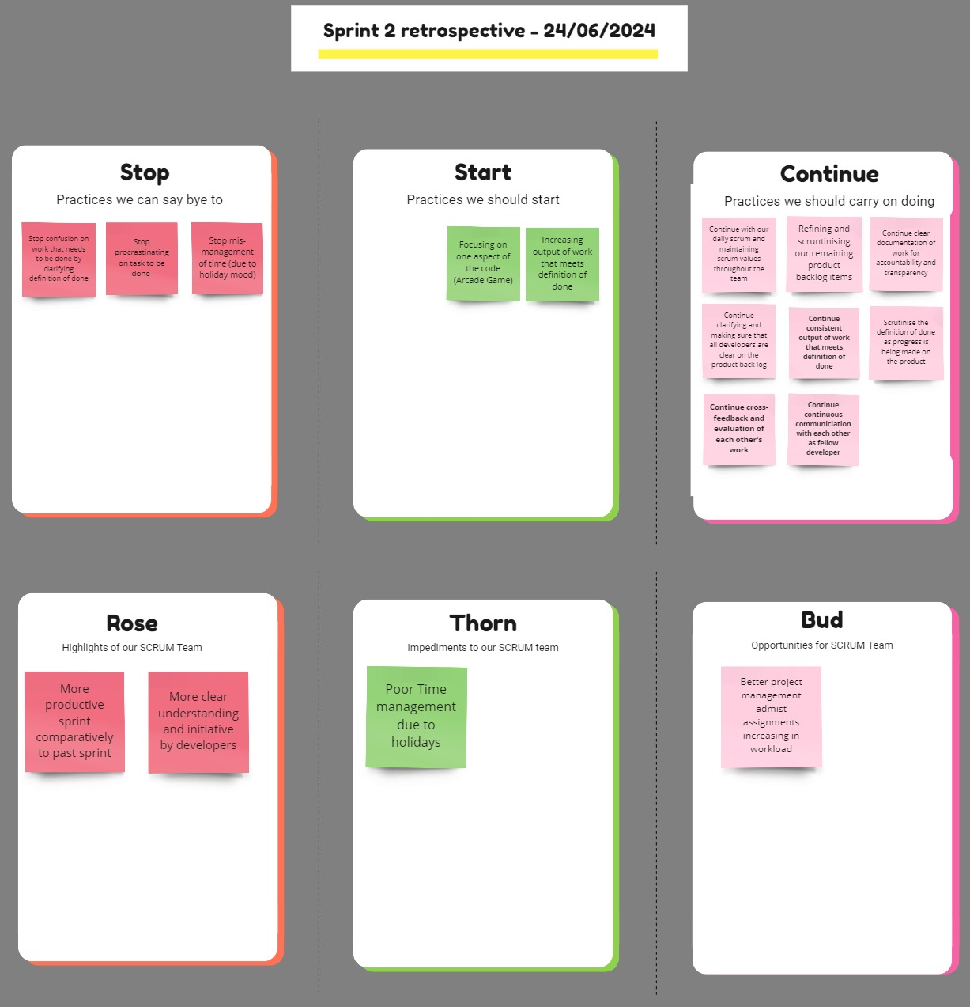

Link to SPM Sprint 2 Miro Retrospective Board:
https://miro.com/app/board/uXjVK9wpDsU=/?share_link_id=468173674750

4. Sprint 3

4.1 Sprint burndown chart report

4.1.1 Sprint Dates
June 25th, 2024 - July 9th, 2024

4.1.2 Sprint Goal
Complete and implement functional arcade game mode such that scrum team can proceed with porting over similar game logic to free game mode

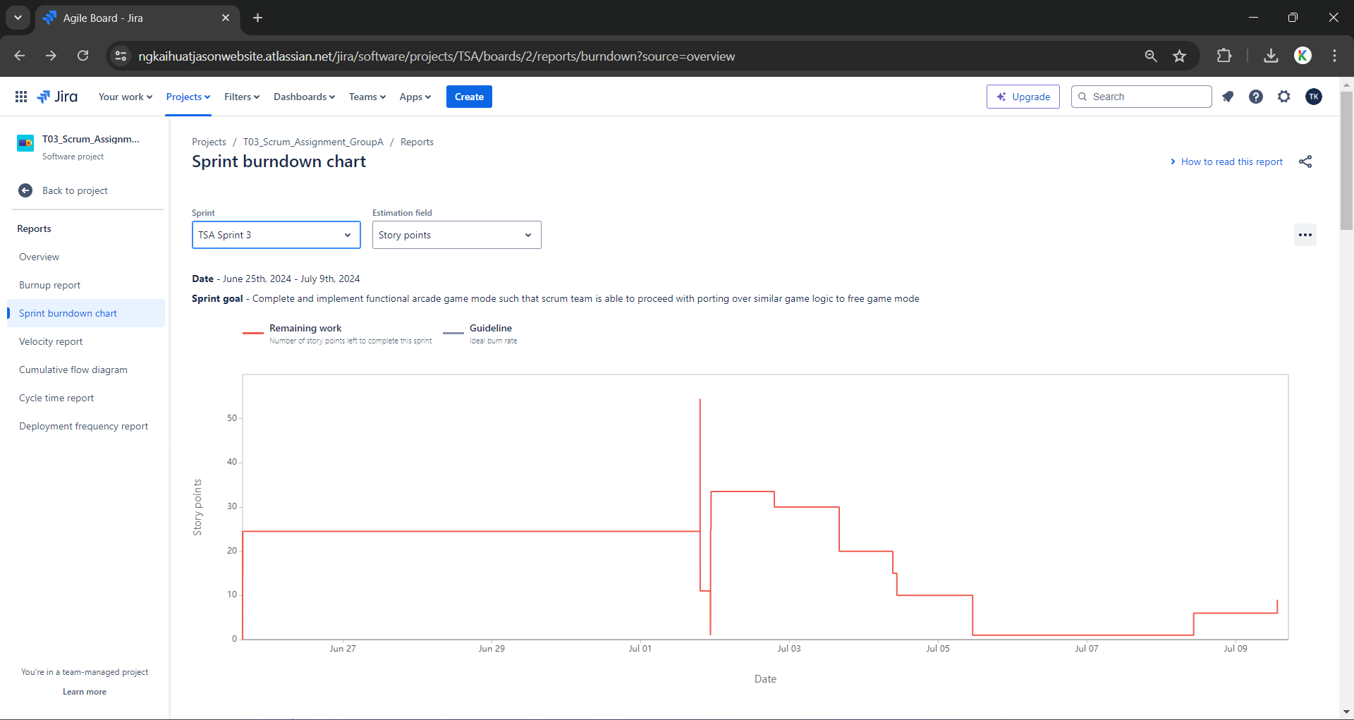
4.1.3 Sprint Burndown Chart

4.1.4 Scope Changes Log
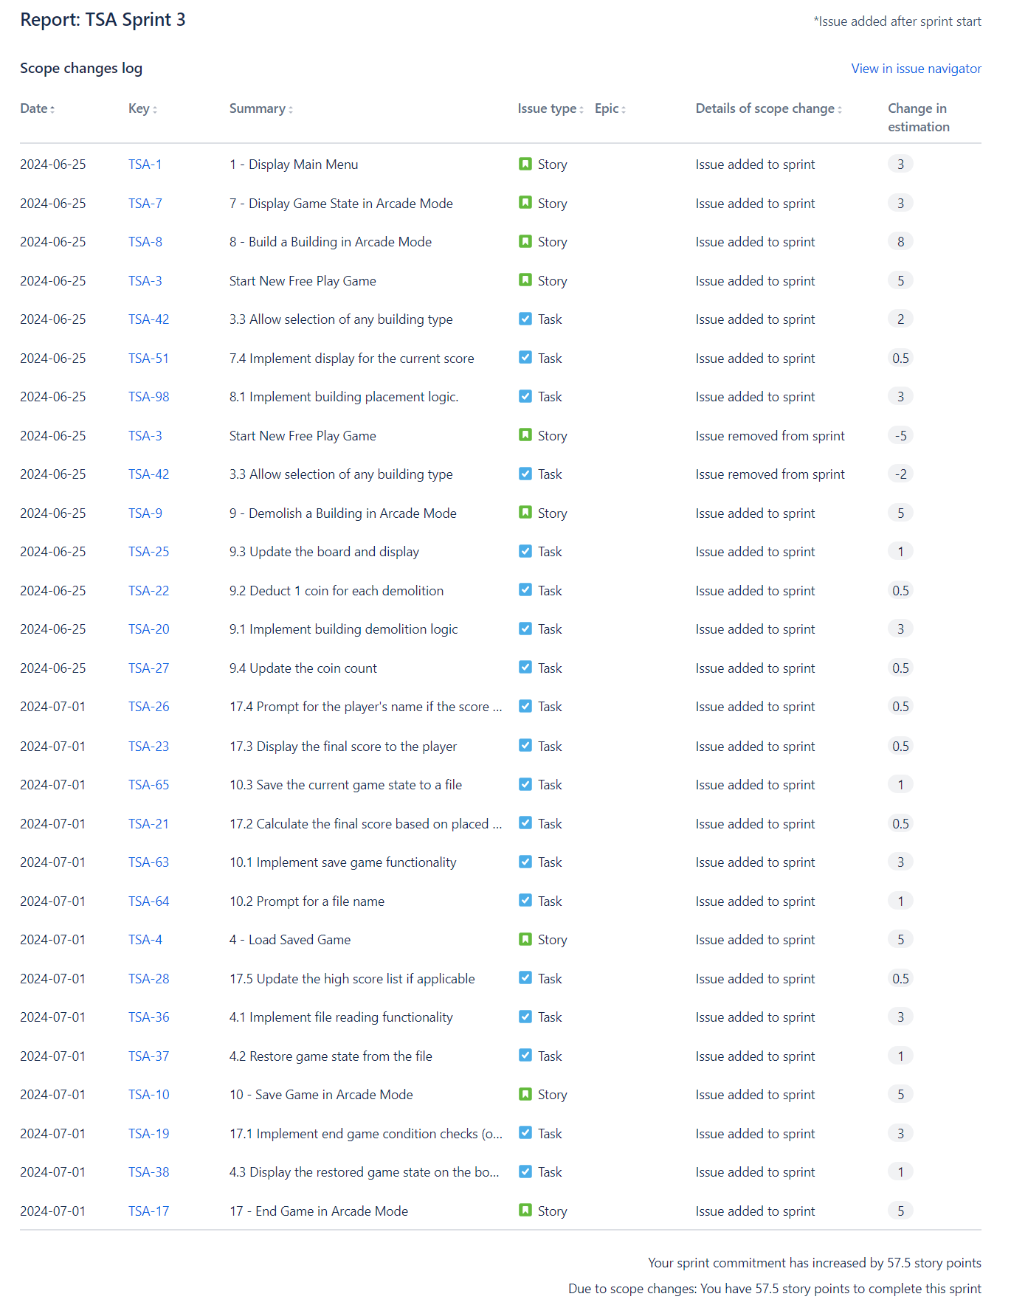

4.1.5 Incomplete Issues
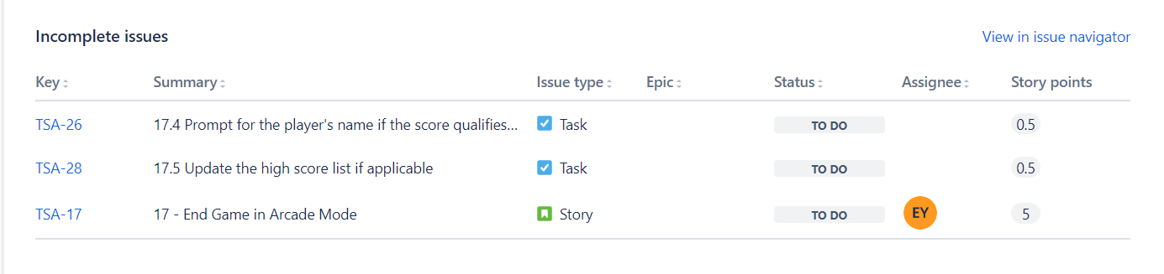

4.1.6 Completed Issues
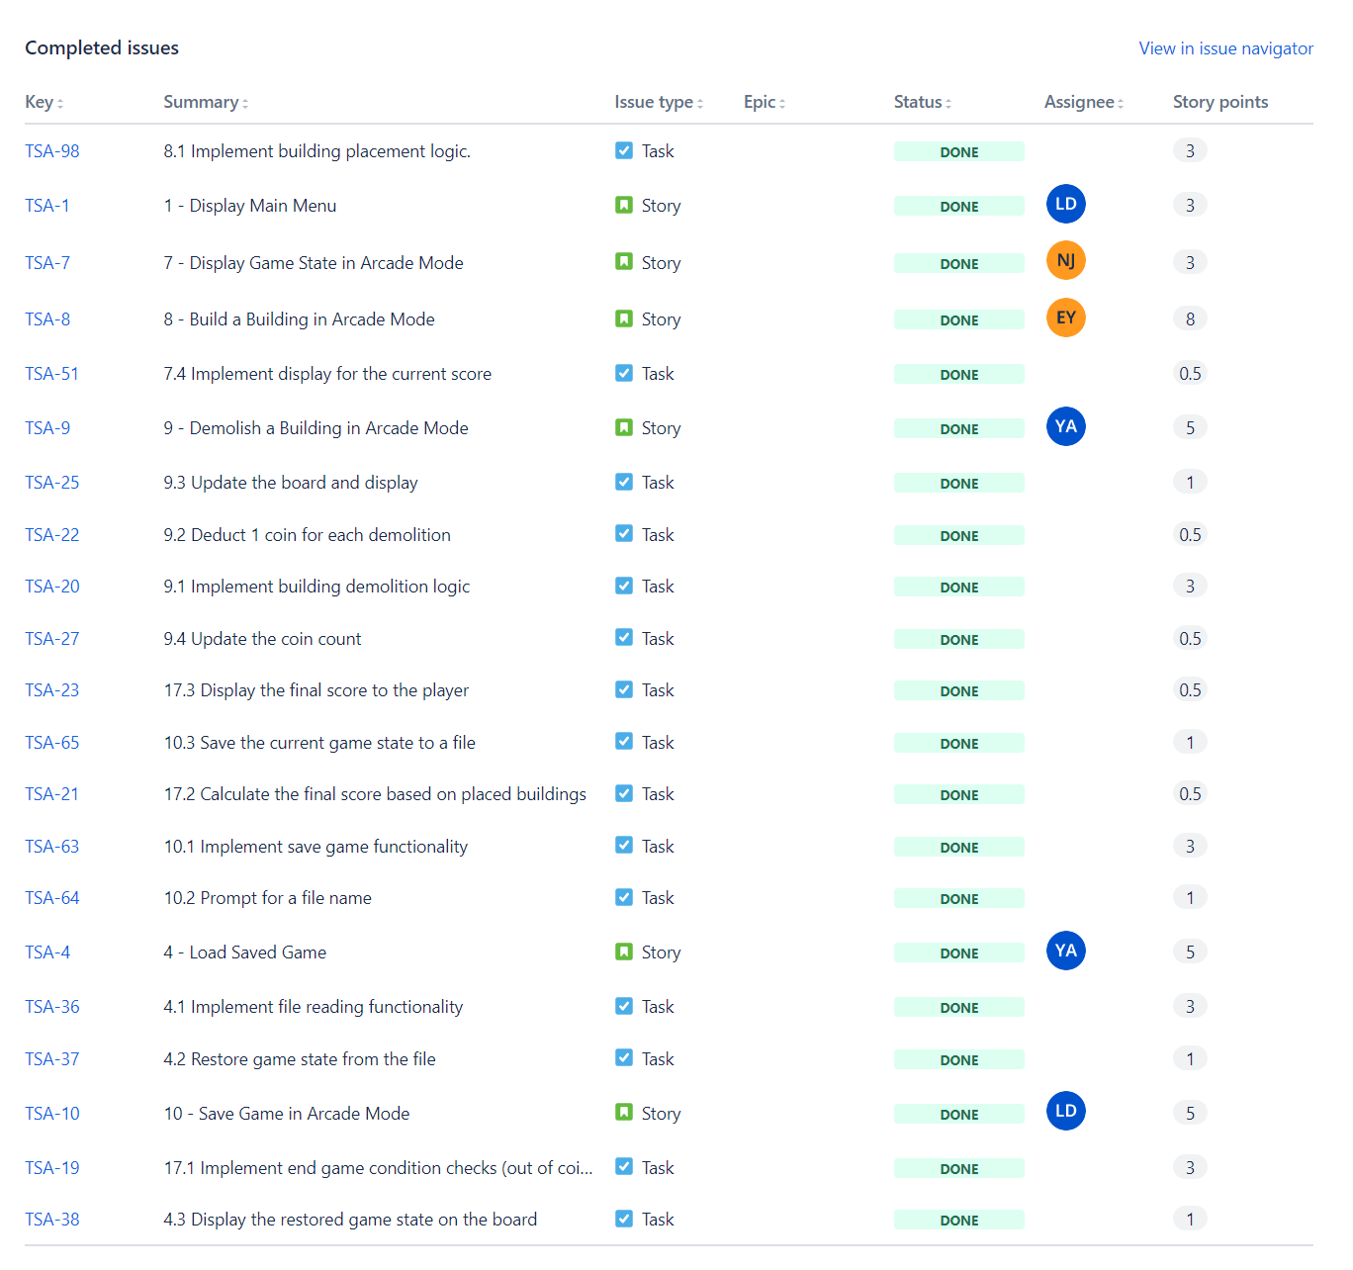

4.1.7 Issues complete outside of Sprint
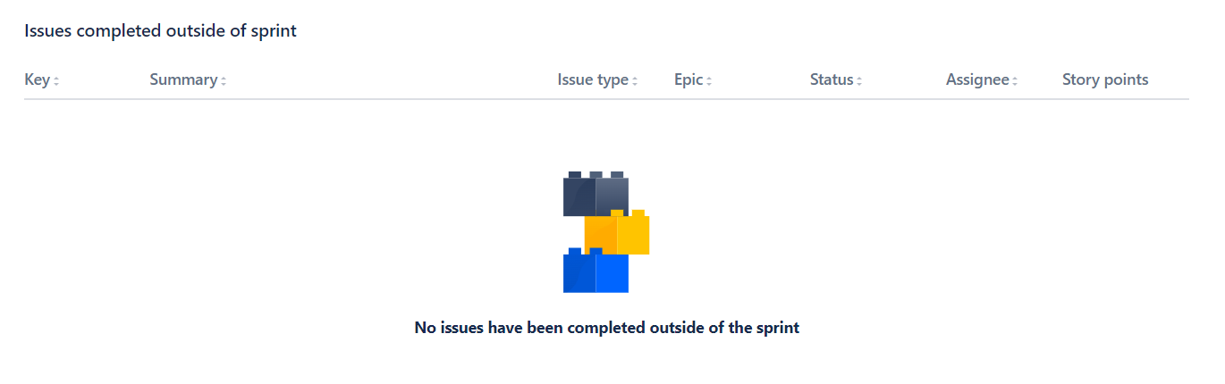

4.1.8 Increment
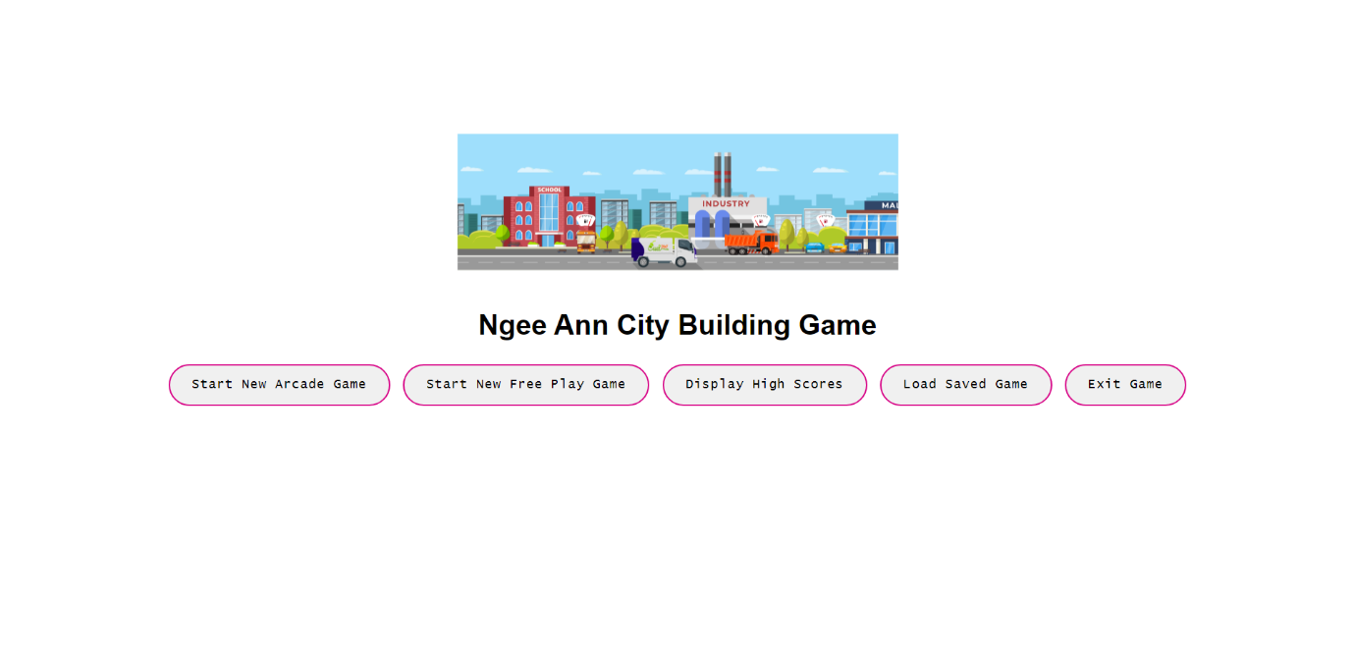
Main Menu + Lottie animation

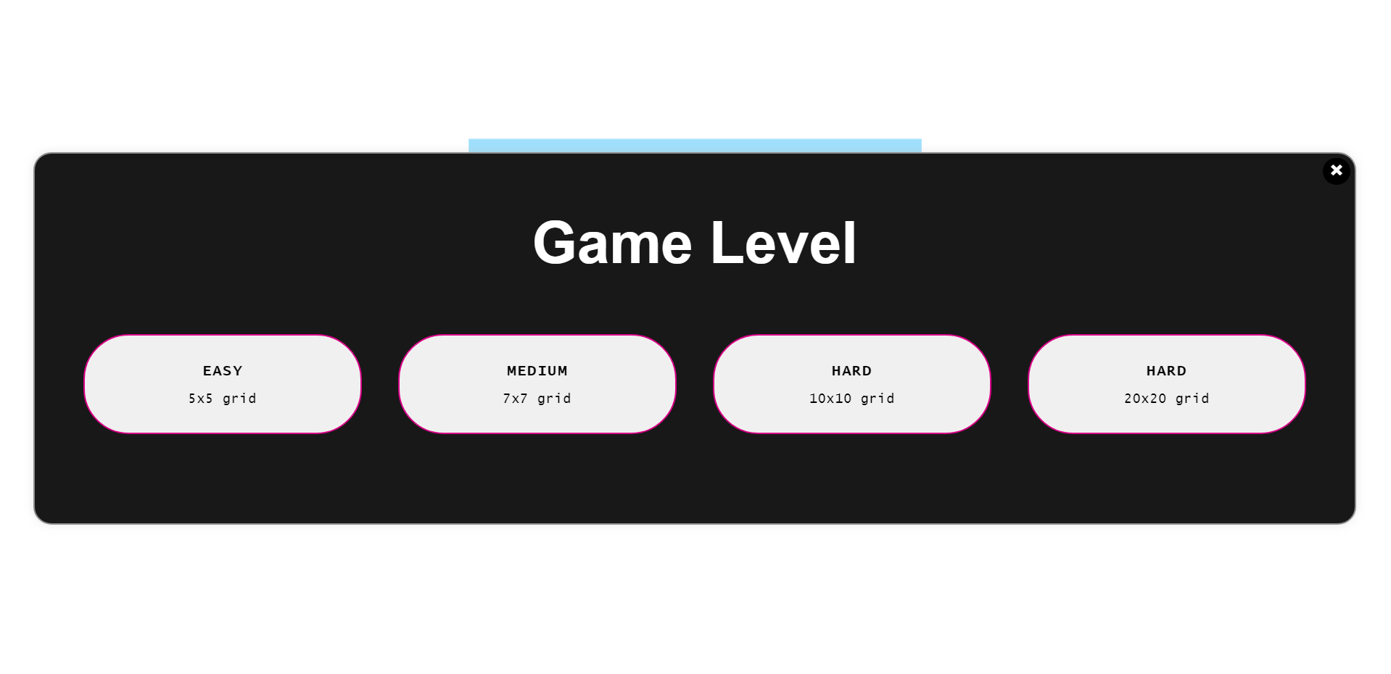
Game Difficulty Selector

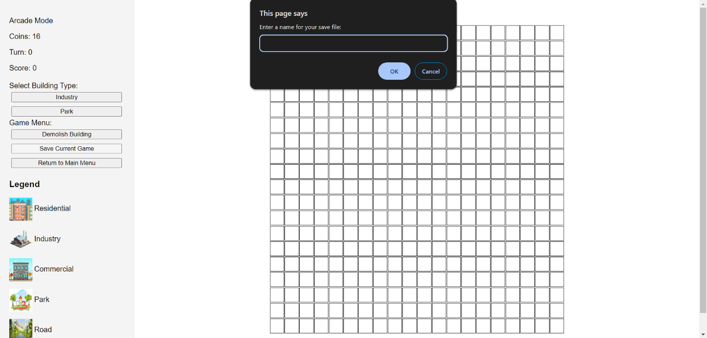
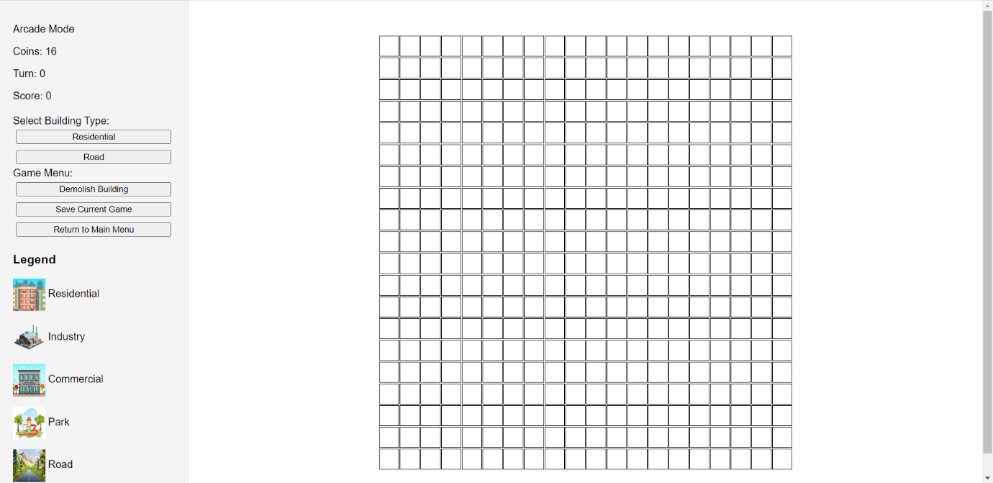
Arcade Mode with Demolish
Arcade Mode prompting save file name (prompt design varies between browsers)

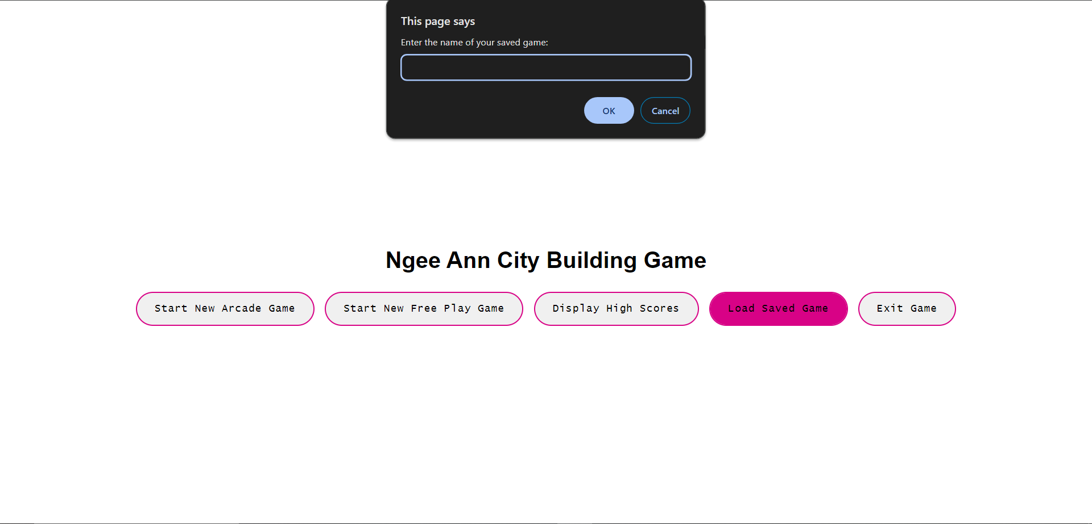
Prompting user for save game file to load

4.2 Sprint Review Discussion
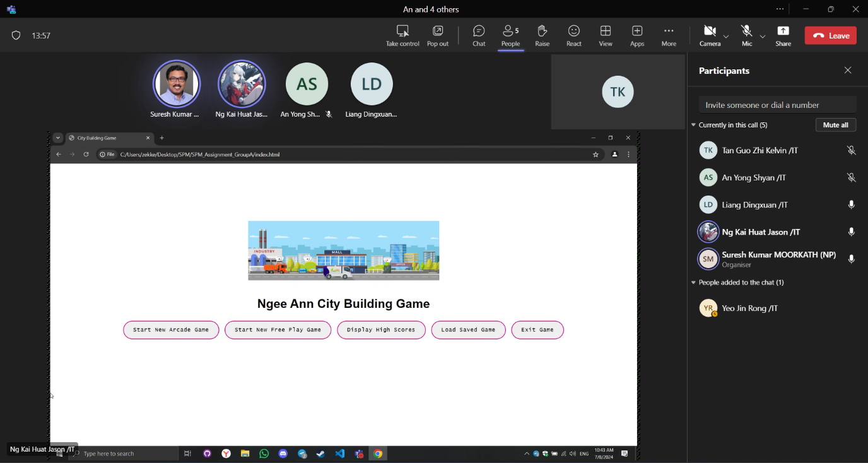

4.2.1 Sprint Review Date
Date: 8th July 2024

4.2.2 Stakeholder Inspection of Outcome of Sprint

During our Sprint Review, our team interacted with our stakeholder as they inspected our increment produced from the sprint. We began by demonstrating demolishing building capabilities, scoring logic for Arcade Game as well as the ability.

Our team clarified on some aspects of the application, such as high scoring and the storage of data pertaining to the leaderboard(s) for high score.

Firstly, our team discussed with the stakeholder for potential solutions regarding cloud database storage. We proposed two solutions, MongoDB and RestDB, highlighting the flaws of both technologies. MongoDB requires time for our team to adjust and adopt the new technology while RestDB has limitations to its restful API, notably that it automatically locks out after hitting a certain limit of API calls.

Secondly, our team clarified on how high score is tabulated and stored. High score(s) for both game modes are kept on separate tables and not consolidated to one leaderboard.

Our stakeholder also specified to be showcased new changes from our previous increment, which was done so accordingly. Stakeholder has also provided feedback on good UI/UX as well as clear and elaborate explanations of improvements. After some discussion with the stakeholder, scrum team has decided to implement a feature of difficulty selection for Arcade Game, to properly reflect the example game of “Ngee Ann City” on the Google Play Store. Stakeholder has expressed concern on burn down chart, however we have reassured him and elaborated on reasons for periods with no work done.
Overall, stakeholder has expressed satisfaction over produced increment, with concerns on delivery of Free Game mode alleviated.

4.2.3 Insights
Through the Sprint Review and interaction with the stakeholder, we gained valuable insights on how our previous decisions and goals have a cascading effect on how our project is shaped throughout the sprints. We learned the importance of keeping to a Sprint Goal and not deviating too much to not jeopardize the sprint goal, as well as having a meaningful and reasonably achievable Sprint Goal. Our Scrum team striving towards completing the Arcade Game mode solely was successful, producing an increment with the largest jump in quality and work that meets definition of done. Having a clear sprint goal and focused target allowed our Scrum team to increase productivity and efficiency.

Our Scrum team’s efforts to continuously clarify and ensure all developers are aware of the project requirements and definition of done has been effective. Confusion on requirements is near non-existent, leading to significantly less impediments and obstructions to our scrum team.

However, our scrum team upon inspection of burn down chart, recognises that there are still areas of improvement to enhance our team’s efficiency and productivity.

4.2.4 Future Adaptations
In the subsequent sprint, our Scrum team will now begin constructing the Free Play Game Mode, as well as high score implementation. Our scrum team will maintain the efficiency and productivity, aiming to have a viable product by the end of Sprint 4. Our team will further improve our coding practices and version control to reduce impediments, allowing us to expedite our workflows.

4.3 Sprint Retrospective

4.3.1 Highlights of our Scrum Team
- Members of the scrum team have managed to complete all tasks in the Sprint in a timely manner
- Members are responsive and contactable to each other, responding promptly to enquiries, not hesitating to clarify doubts through in-depth explanation.
- Members have displayed a stronger sense of responsibility and accountability for their work, taking initiative to complete assigned task(s).
- Members have no impediments or obstacles preventing open honest discussion on issues pertaining to the logic of the game or nuances such as score calculation

4.3.2 Impediments to our Scrum Team

- Poor time management still persists due to other assignment due dates looming
- Logic errors in scoring due to insufficient understanding or lingering misconceptions of acceptance criteria and definition of done has resulted in impediments that deduct valuable time to account for debugging
- Finding time to have a coordinated call for collaboration proves difficult due to difference in schedules as well as medical issues.

4.3.3 Opportunities for our Scrum Team

- Improved time management to offset impediments that could arise from other assignment having schedule conflicts
- Internalise the assignment brief before proceeding onto implementation for Free Play Game Mode
- Have group-level code reviews to ensure all developers are aware of the overall logic and flow of the application

4.3.4 Negative Practices of our Scrum Team

- Team needs to prevent confusion on what work needs to be accomplished by clarifying and understanding acceptance criteria as well as definition of done
- Halt and re-analyse goals and targets set for sprint, being aware to not be over ambitious and unrealistic with workload.
- Team needs to be conscious of proper Github workflows such as committing to branch and pulling into main, to avoid repeated merge conflicts as well as sub-optimal usage of Git
- Unfocused on a singular task, getting side tracked.

4.3.5 Positive Practices to implement for our Scrum Team
- Focus on porting over Arcade mode logic to Free Play mode logic
- Aspire to commit work daily when appropriate
- Having more fluid and transparent communication within the team to allow all developers to be aware of who is accountable for what work
- Sharing work being done either through assigning on Jira or through communication channels like Telegram or MS Teams, to maintain accountability.
- Increased organisation of sprint backlog items to properly reflect priority and which task demands our attention urgently.
- Increase efficient usage of Git to prevent merge conflicts or overriding previous commits by not exercising proper workflow.

4.3.6 Practices to continue for our Scrum Team

- Continue making progress incrementally daily if possible.
- Continue consistent daily scrum with productive outcomes and insights.
- Being able to provide criticism while maintaining a professional environment with an attitude orientated to improvement.
- Effective communication and collaboration between team members with an effort to reduce impediments.
- Effective and efficient code that works smoothly due to refactoring.

4.3.7 Miro Discussion Board
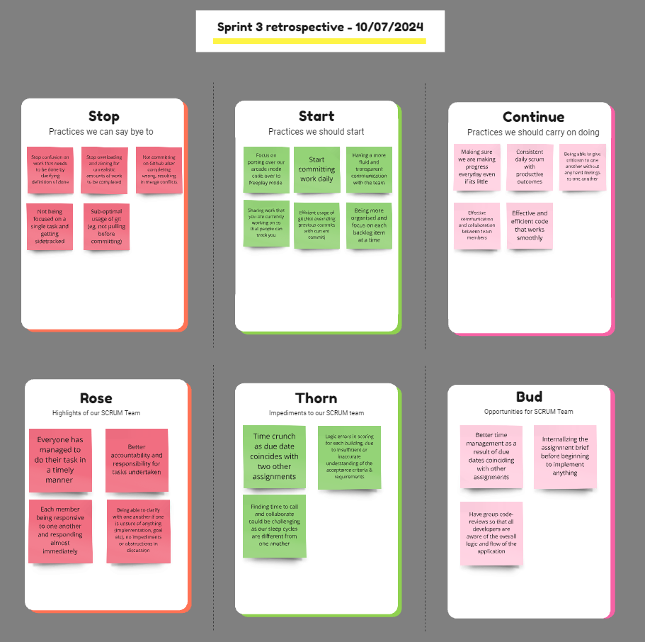

Link to SPM Sprint 3 Miro Retrospective Board:
https://miro.com/app/board/uXjVK9wpDsU=/?share_link_id=468173674750

5. Sprint 4

5.1 Sprint burndown chart report

5.1.1 Sprint Dates
July 9th, 2024 - July 23rd, 2024

5.1.2 Sprint Goal
Construct a functional Free Play Game Mode, porting over the logic and code completed for Arcade Game Mode Consolidate and ensure that product has an increment that meets definition of done, fulfilling all requirements outlined by Product Owner

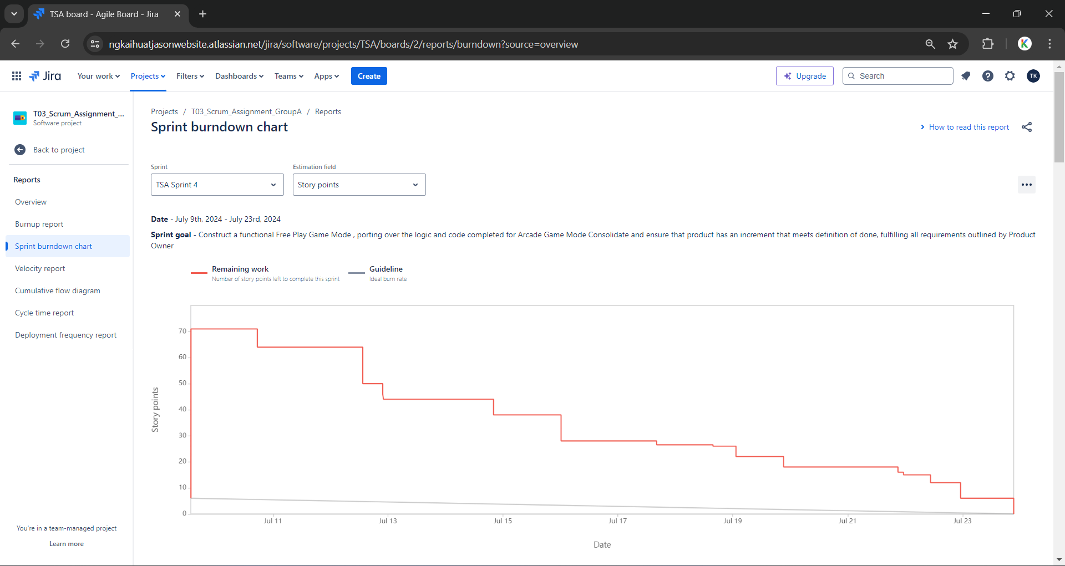
5.1.3 Sprint Burndown Chart

5.1.4 Scope Changes Log
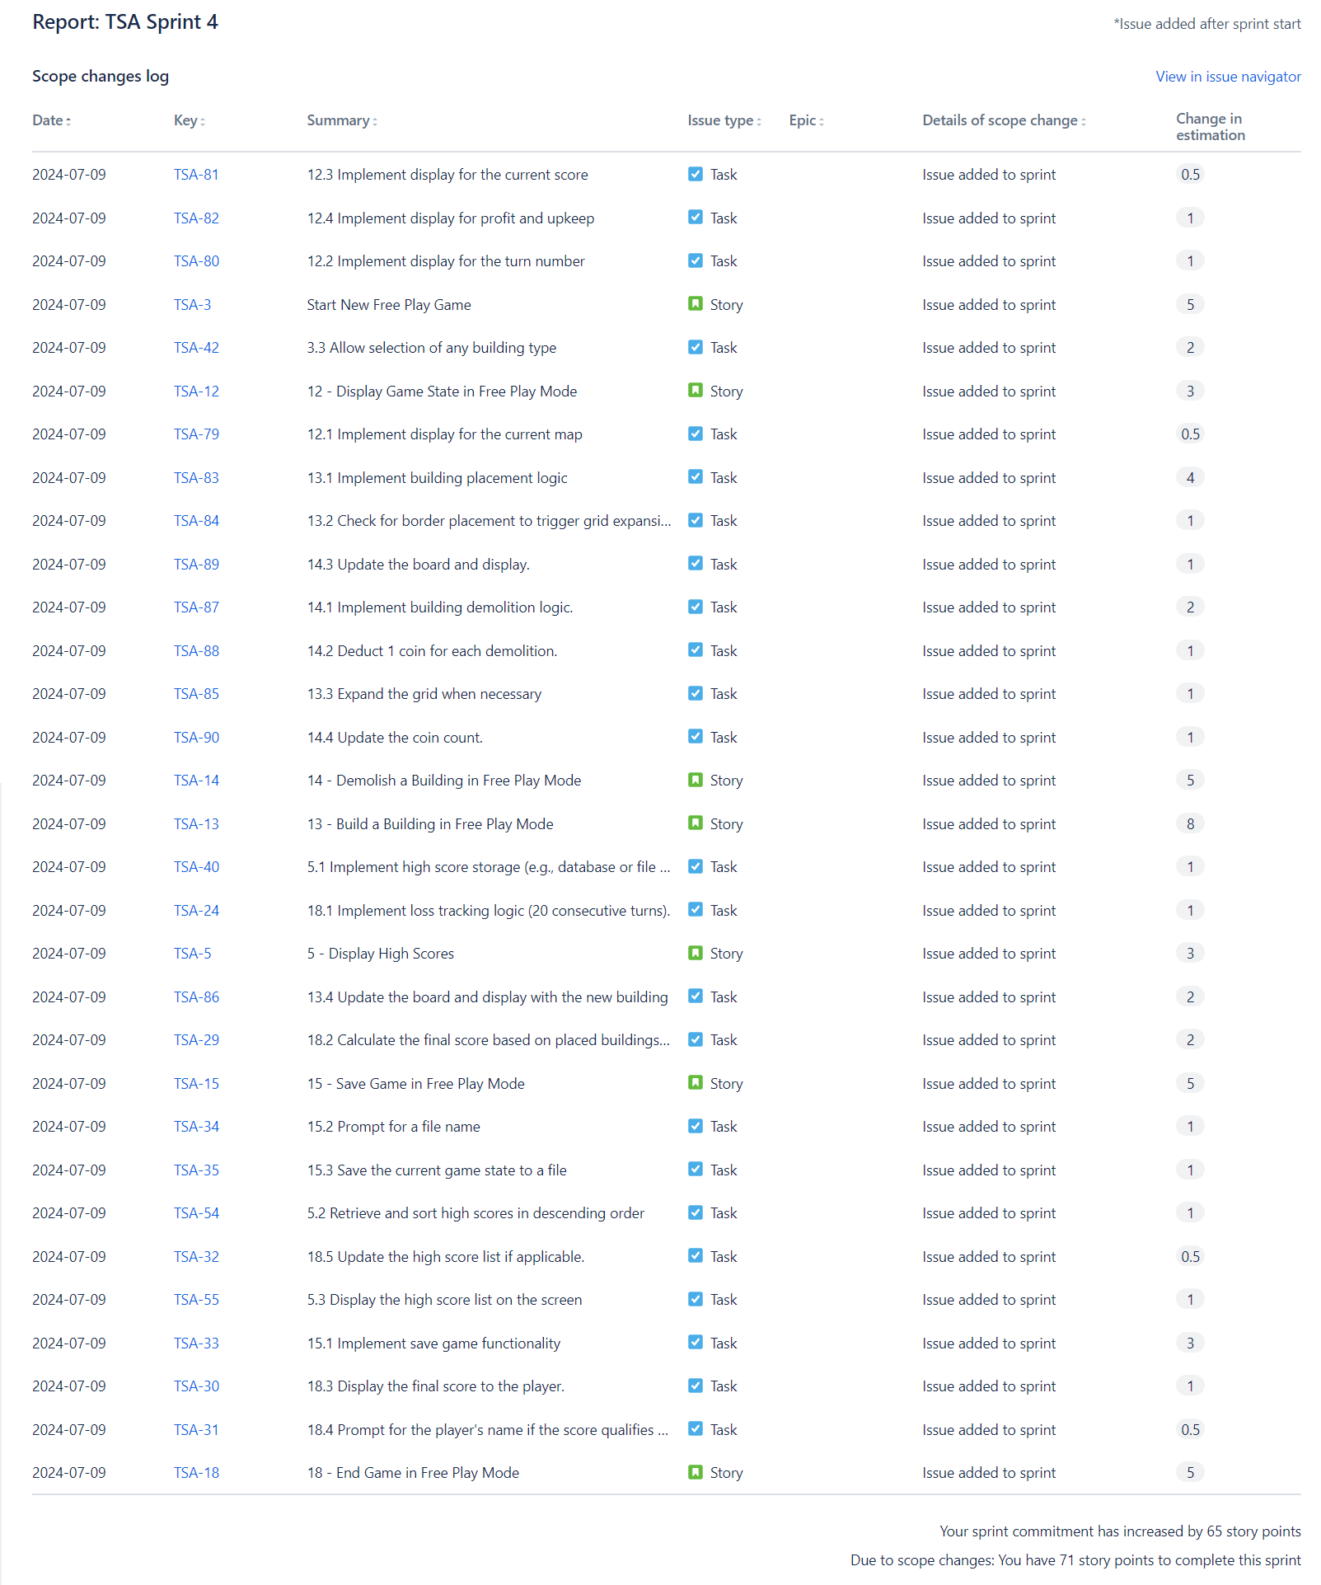

5.1.5 Incomplete Issues
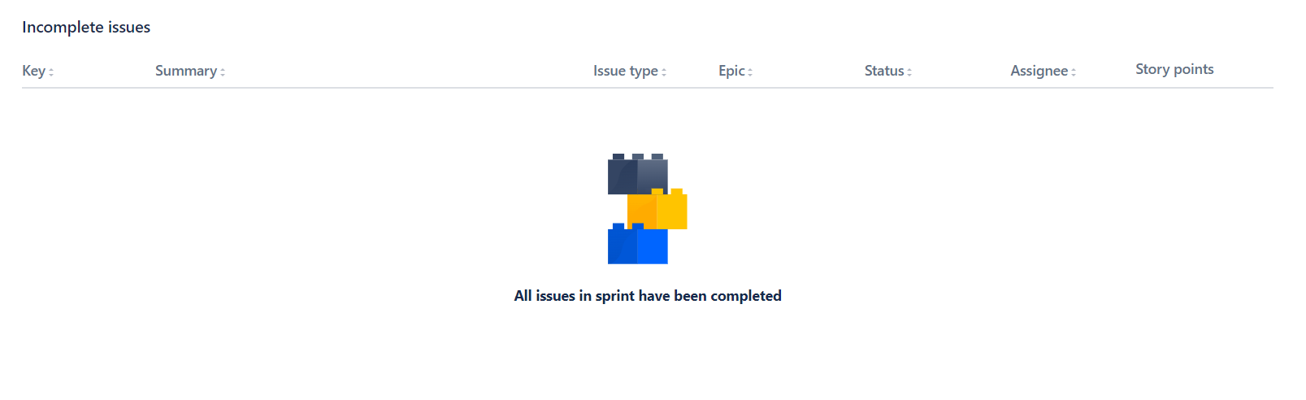

5.1.6 Completed Issues
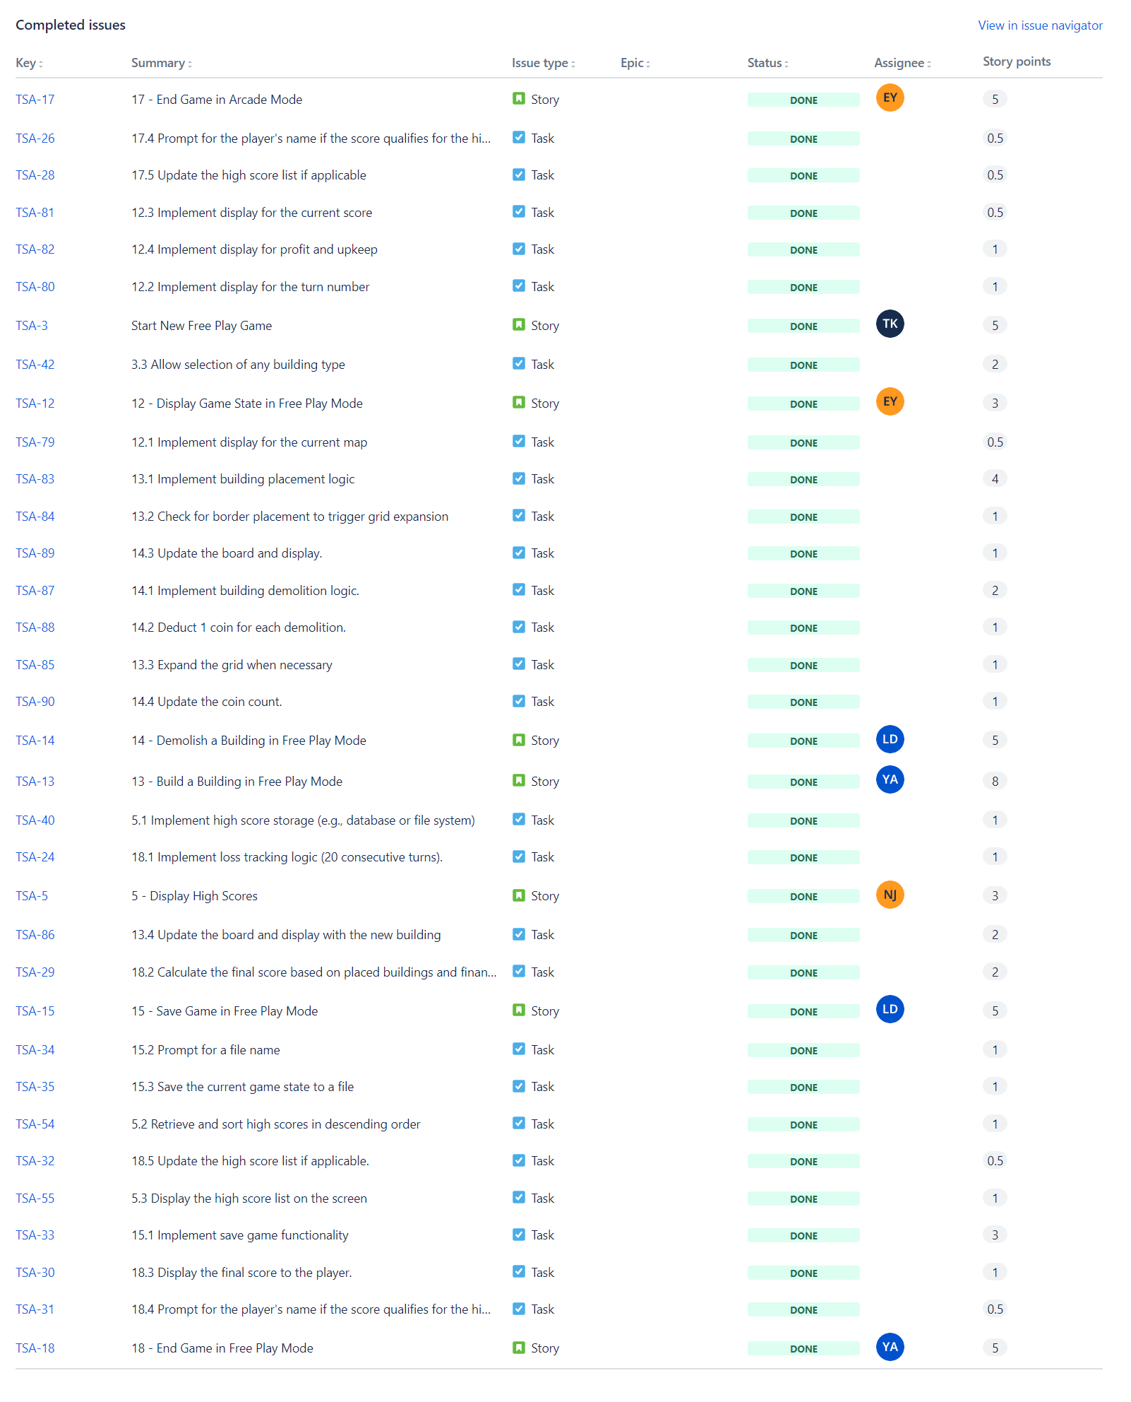

5.1.7 Issues complete outside of Sprint
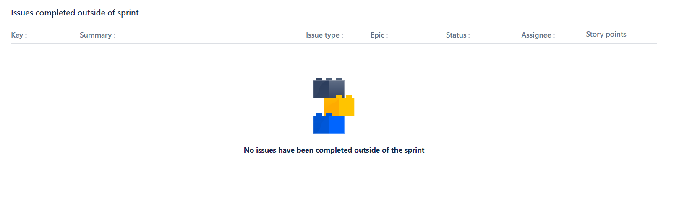

5.1.8 Increment
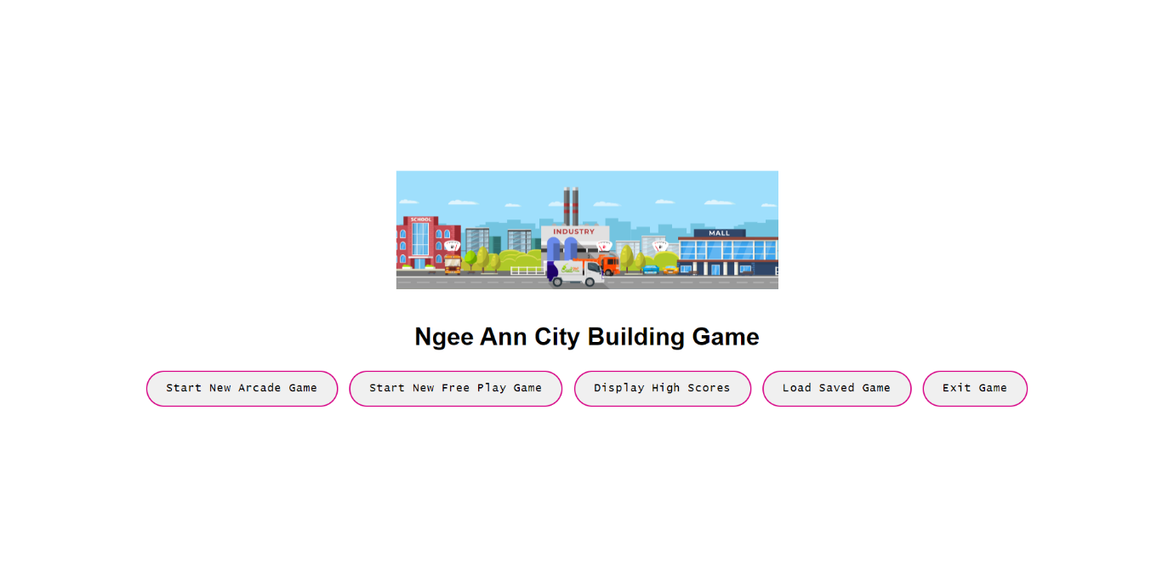
Main menu page

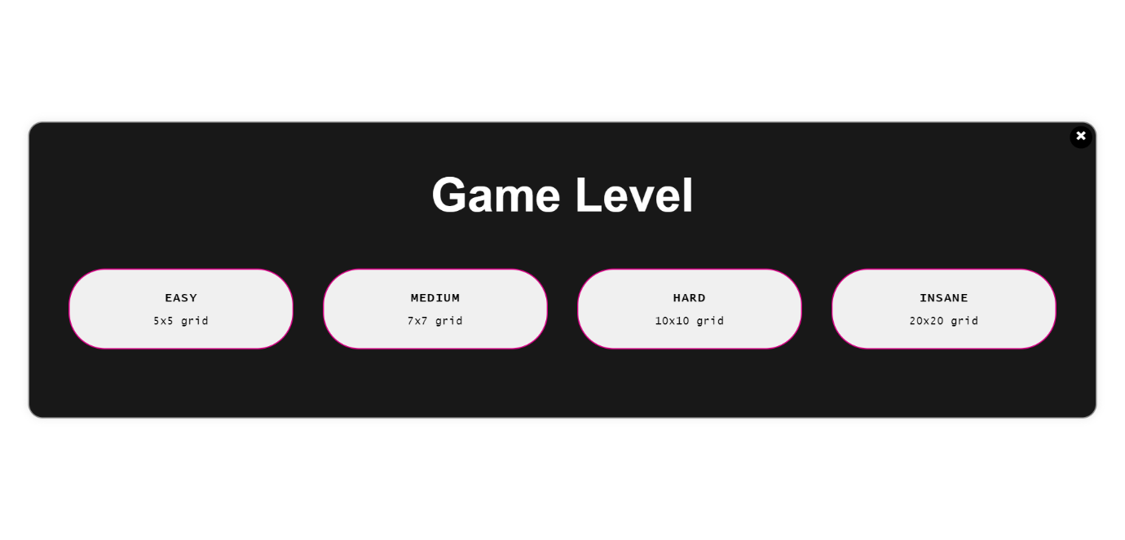
Main menu difficulty selection

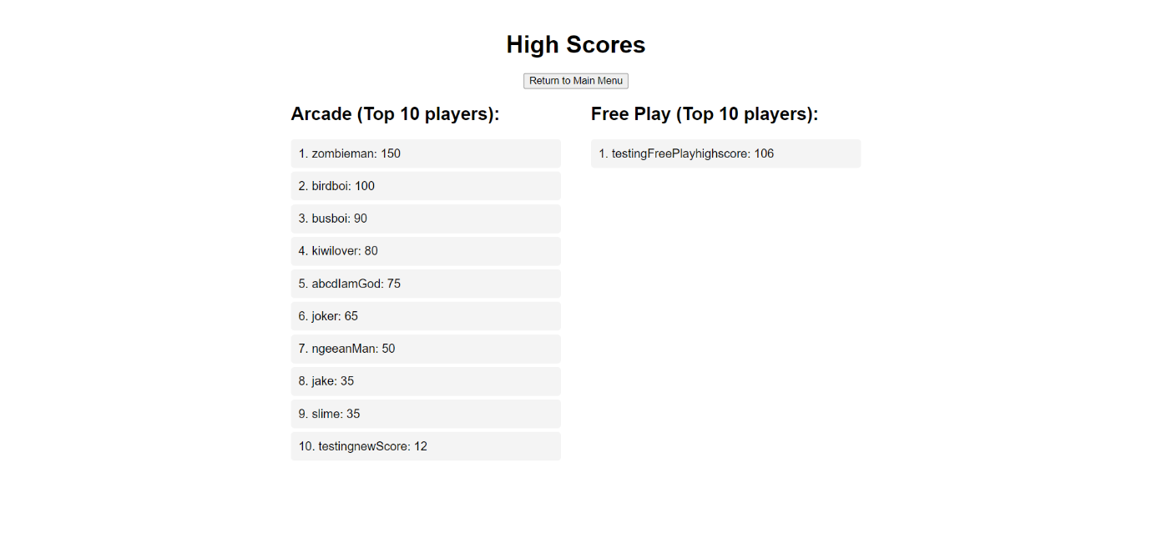
High Scores Page

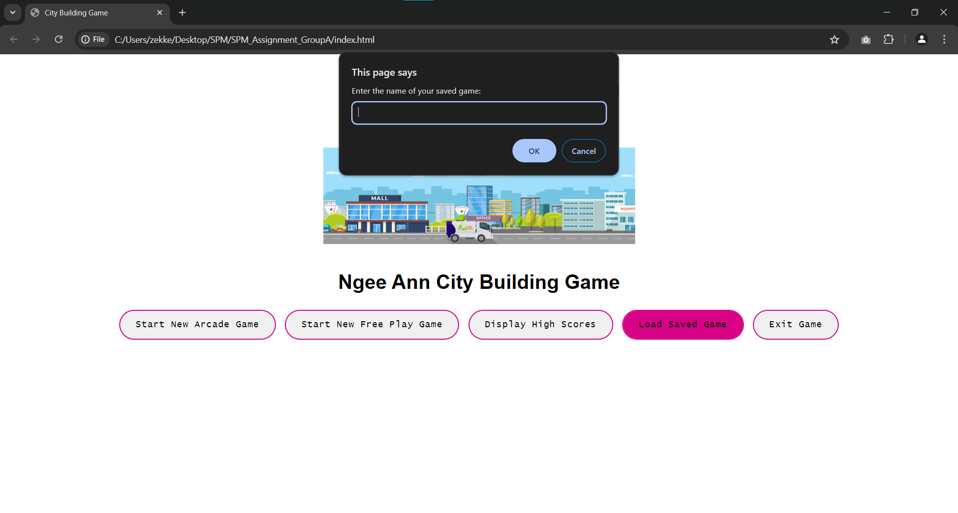
Load Game Prompt
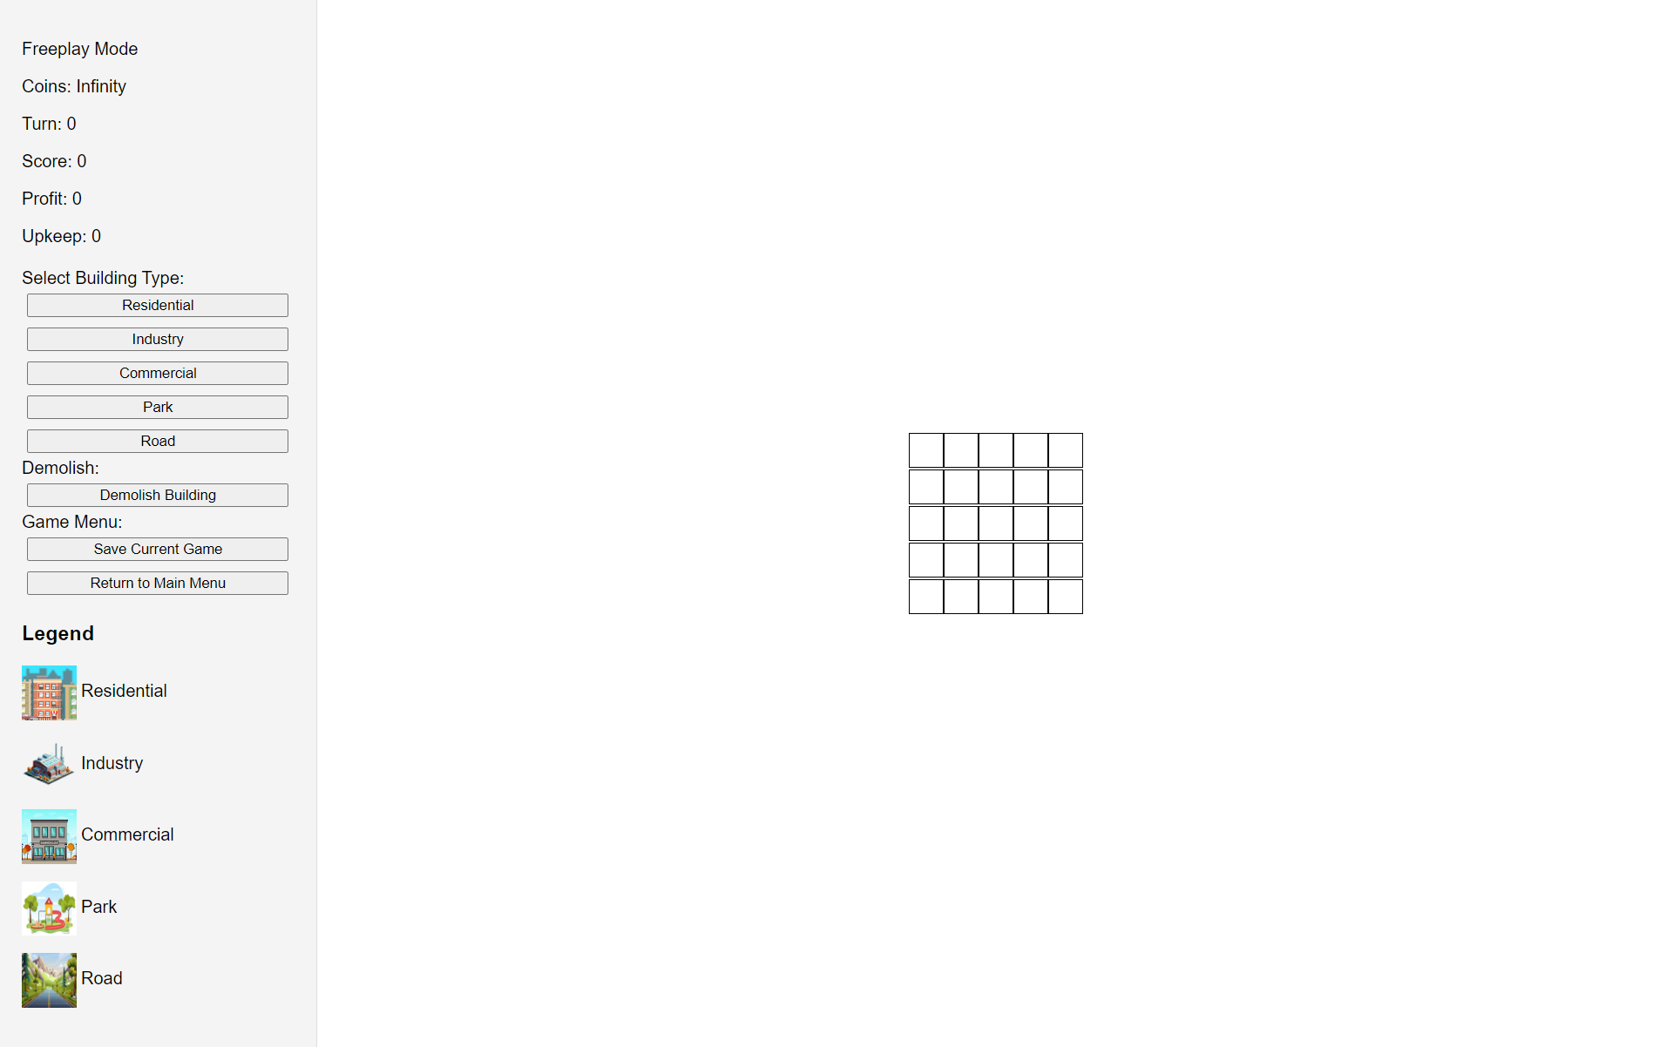
Freeplay Game page

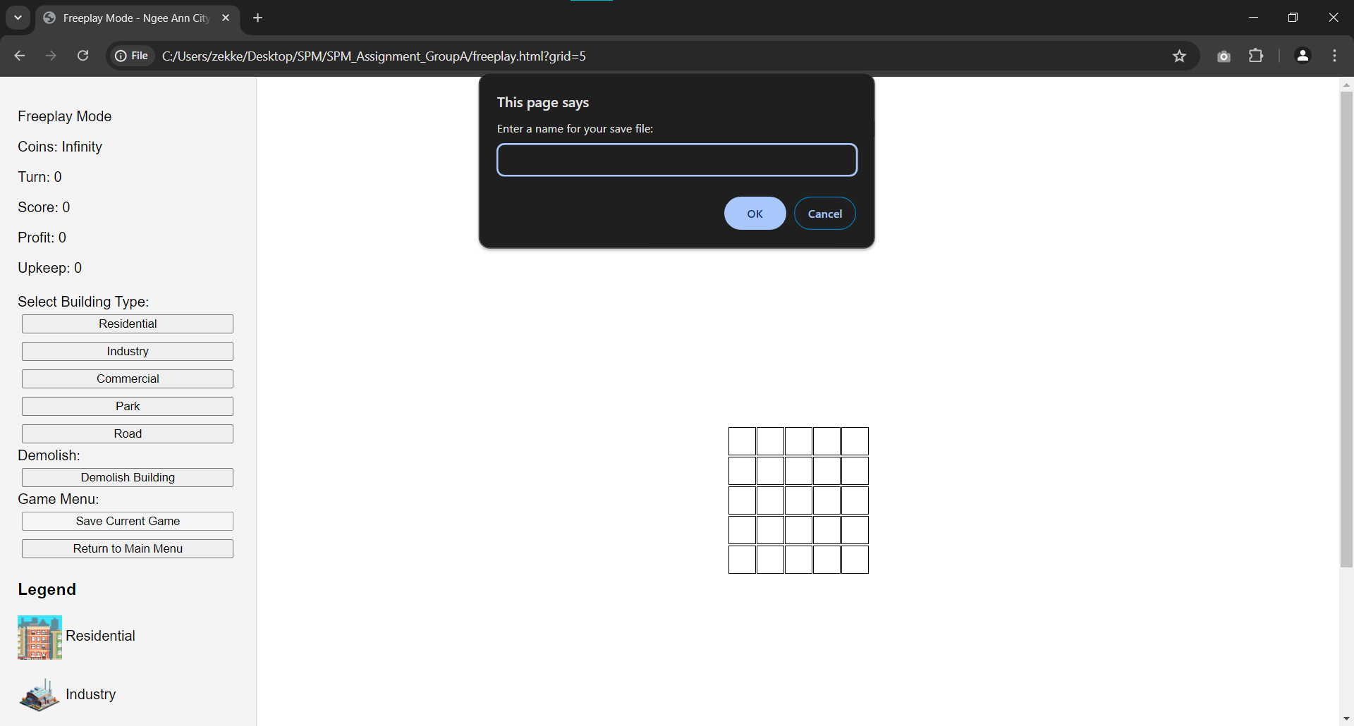
Saving Freeplay Prompt

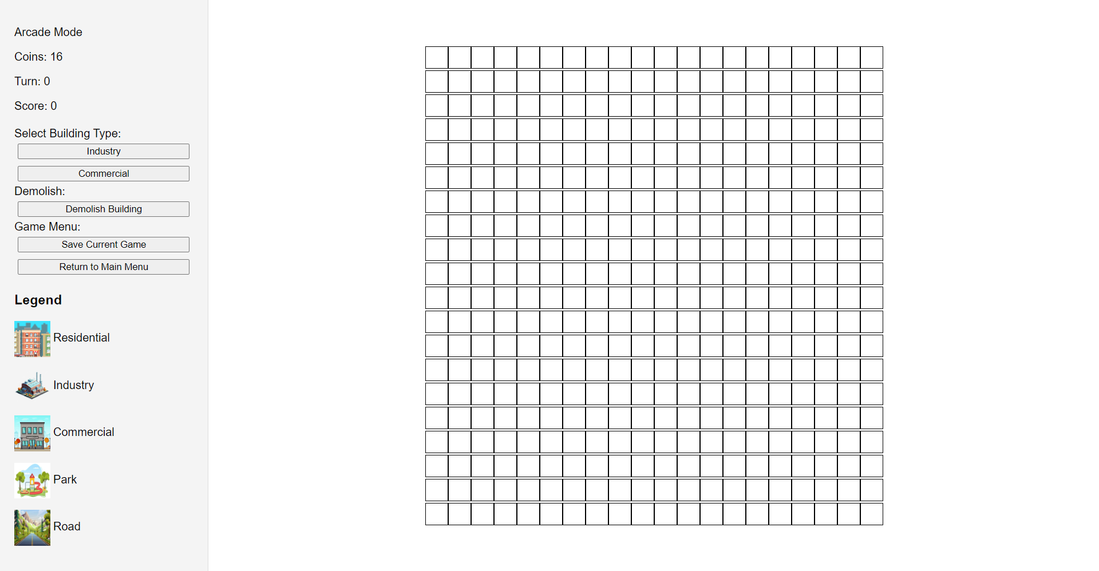
Arcade Game page

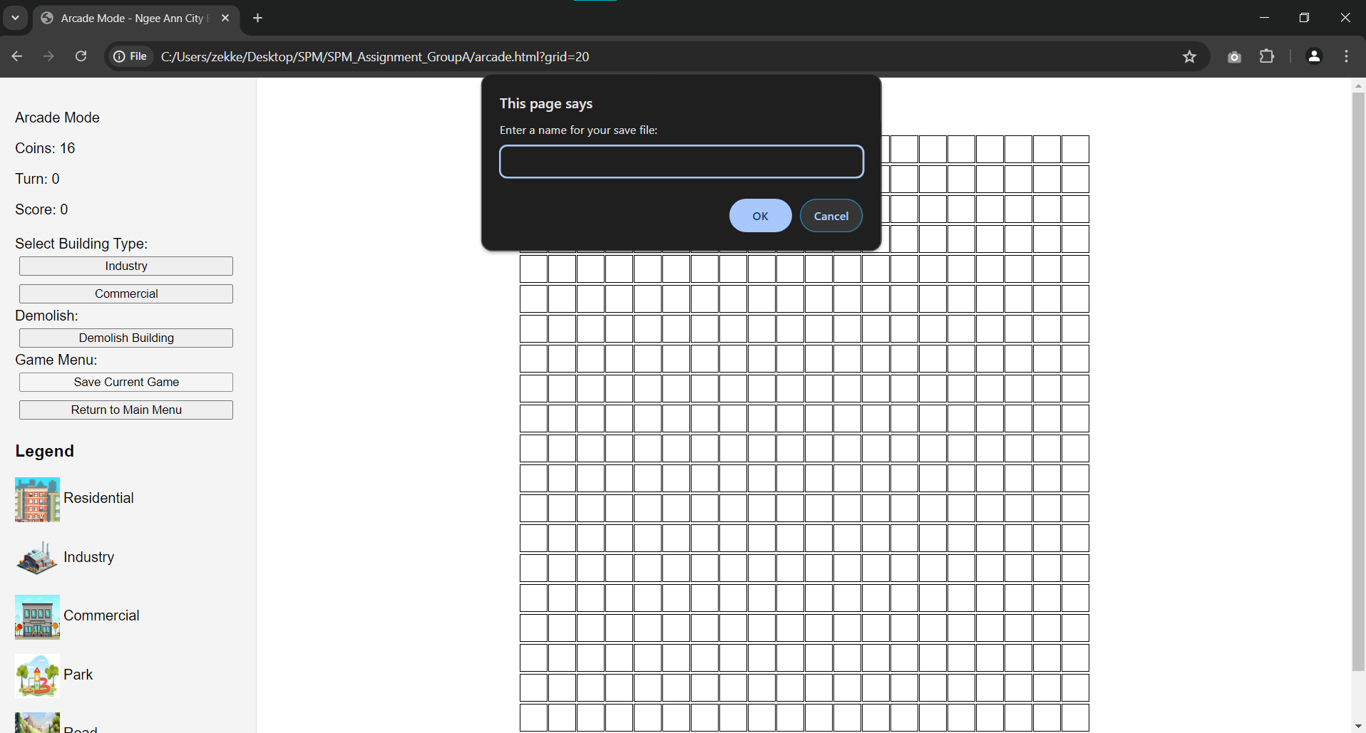
Arcade Save game prompt

5.2 Sprint Review Discussion
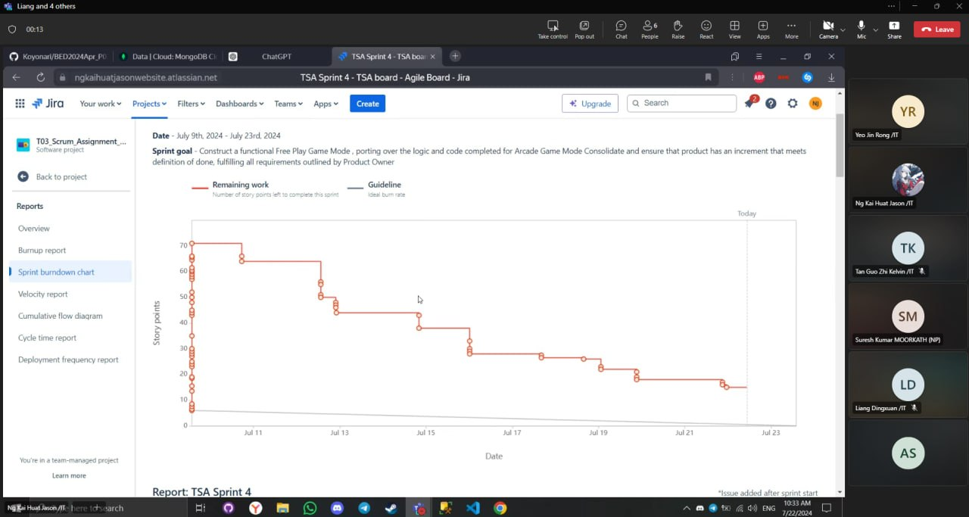

5.2.1 Sprint Review Date
Date: 22nd July 2024

5.2.2 Stakeholder Inspection of Outcome of Sprint
During our sprint review, our team interacted with our stakeholder as they inspected our increment produced from the Sprint. We began by demonstrating the gameplay logic of Free Play, as well as the high score feature available for both the Arcade and Free Play mode

Our team showcased the Free Play game mode functionality to the stakeholder.
Firstly, we demonstrated how the Free Play game mode building placement functionality has been successfully ported over from the Arcade Game Mode

Secondly, we displayed the ability to place buildings anywhere on the provided grid, unique to Free Play game mode only, no longer restricted by adjacency.

Thirdly, we show cased the profit and upkeep functionality, where each building type has its own respective value for profit generation and upkeep cost per turn, as per specifications provided in assignment brief

Finally, we presented how the playable grid expands gradually when a building is placed at the edges of the grid. For example, a 5x5 grid will expand into a 15x15 grid then subsequently 25x25 grid

Our stakeholder expressed overall satisfaction with the increment provided, exuberant that all required features

5.2.3 Insights
Through the Sprint Review and interaction with the stakeholder, we gained valuable insights and reaffirmation on how our implementation of SCRUM and utilisation of JIRA has greatly improved. We learnt how being focused on task, maintaining continuous and clear communication channels and collaboration was paramount to achieving our desired productivity levels.

Subsequently, we acknowledge the importance of transparency and accountability through the SCRUM team members, being responsible for each task assigned and having the initiative to seek help from developers for clarification or assistance is a cornerstone in a successful sprint.

5.2.4 Future Adaptations
In subsequent projects utilising JIRA and/or the SCRUM framework, our team has some key takeaways. Firstly, transparency amongst developers is important, to maintain not only clear communication but also eliminate hesitation to take responsibility and maintain accountability. Secondly, teamwork is critical to a SCRUM team’s success, as SCRUM team is self-managing, ironing out any conflicts during storming must happen to ensure an amicable environment for developers. Finally, consistency is the backbone of SCRUM teams, being able to maintain a steady output of work done across Sprints is important so that feedback is obtained during Sprint Review and Sprint Retrospective, allowing the developers to incorporate feedback and iterate on the product while being aligned with the overall Product goal and vision.

5.3 Sprint Retrospective

5.3.1 Highlights of our Scrum Team
- Proper version control on Github, developers follow version control strictly and pull before pushing their branch. Developers also have proper usage of branches, preventing merge conflicts or unintentional override of code
- Consistent work output is achieved during this Sprint, reflected with a good sprint burndown chart trend
- Efficient workflow resulting in higher productivity across SCRUM team
- Better time management and enhanced focus on work requirements

5.3.2 Impediments to our Scrum Team
- Time crunch due to looming deadline for majority of assignment
- Lack of initiative for final user story (high score), due to other assignments
- Lack of required skill set such as familiarity with cloud databases, which impeded our application design and implementation of highscore function

5.3.3 Opportunities for our Scrum Team
- Account for subsequent sprints when conducting Sprint Planning, preventing backloaded Sprints and ensuring equal consistent workload for each Sprint
- Assign tasks most suitable to developers with matching skill sets to handle Sprint Backlog items more efficiently
- Organise pair programming or skills haring sessions to allow for transference of skill sets within SCRUM team, to allow not only technical skill of overall SCRUM team to increase, but also serving as a safety net to double check all code meets the definition of done

5.3.4 Negative Practices of our Scrum Team
- Developers forget to push to main branch, leading to miscommunication on work done
- Poor Sprint planning resulting in rushed and stressful Sprint, due to overestimation of productivity, capability and realistic time available for SCRUM team
- Heavy workload for current sprint due to entire “Free Play” game mode being implemented

5.3.5 Positive Practices to implement for our Scrum Team
- Test code thoroughly, ensuring code meets Definition of Done before pushing to main branch
- Ensure that Sprint Planning coincides with the workload SCRUM team is capable of handling, not over exceeding capacity
- Be more proactive and prevent friction from arising due to awaiting instructions from more experienced developers within the SCRUM team

5.3.6 Practices to continue for our Scrum Team
- Continue effort in maintaining clarity of product backlog for all developers
- Continue consistent output of work that meets definition of done
- Maintain clear, concise and continuous communication & collaboration amongst developers
- Continue cross-feedback and evaluation of each other’s work
- Continue utilising the SCRUM framework and JIRA software for subsequent projects, to increase transparency and efficiency
- Maintain open-mindedness to criticism and feedback to prevent obstructions to improvement

5.3.7 Miro Discussion Board
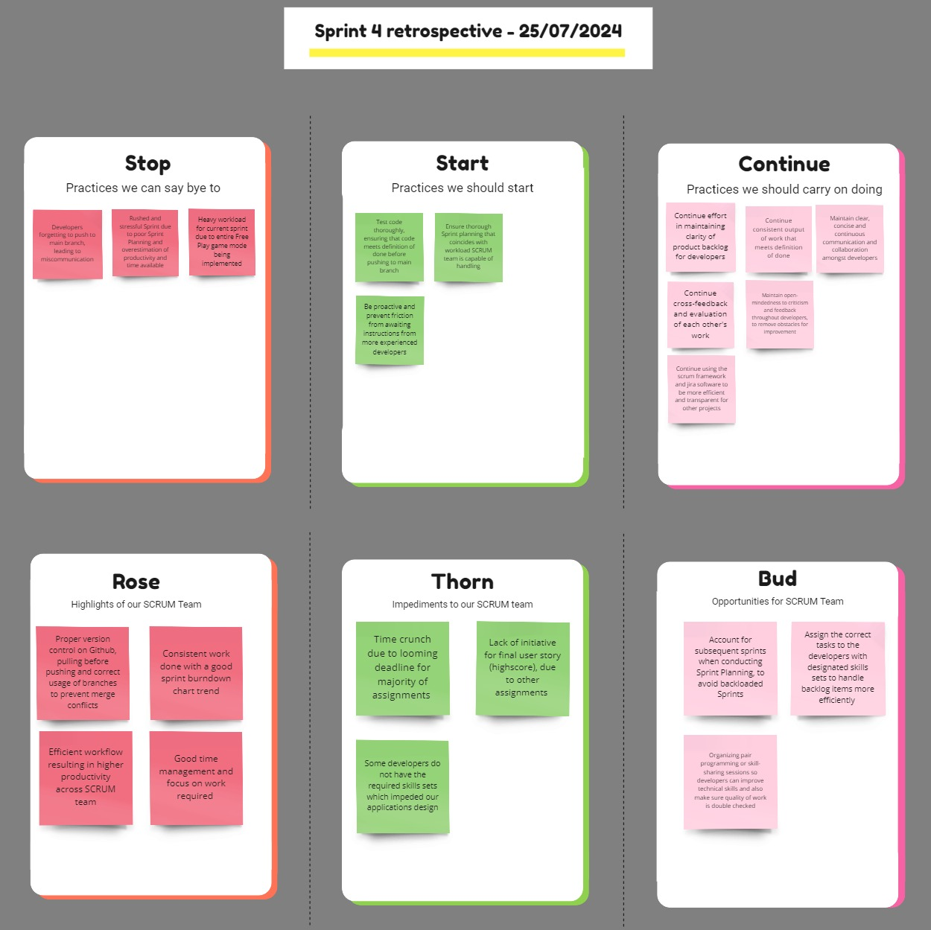

Link to SPM Sprint 4 Miro Retrospective Board:
https://miro.com/app/board/uXjVK9wpDsU=/?share_link_id=468173674750

Appendix A

[TSA-102] 8.5 Update the coin count. Created: 28/May/24 Updated: 16/Jun/24 Resolved: 16/Jun/24
Status: | Done
Project: | T03_Scrum_Assignment_GroupA
Components: | None
Affects versions: | None
Fix versions: | None

Type: | Task | Priority: | Medium
Reporter: | Ng Kai Huat Jason | Assignee: | Unassigned
Resolution: | Done | Votes: | 0
Labels: | None
Remaining Estimate: | Not Specified
Time Spent: | Not Specified
Original estimate: | Not Specified

Rank: | 0|i0000z:wi
Sprint: | TSA Sprint 2
Story point estimate: | 1

[TSA-101] 8.4 Update the board and display with the new building. Created: 28/May/24 Updated: 16/Jun/24 Resolved: 16/Jun/24
Status: | Done
Project: | T03_Scrum_Assignment_GroupA
Components: | None
Affects versions: | None
Fix versions: | None

Type: | Task | Priority: | Medium
Reporter: | Ng Kai Huat Jason | Assignee: | Unassigned
Resolution: | Done | Votes: | 0
Labels: | None
Remaining Estimate: | Not Specified
Time Spent: | Not Specified
Original estimate: | Not Specified

Rank: | 0|i0000z:x
Sprint: | TSA Sprint 2
Story point estimate: | 1

[TSA-100] 8.3 Deduct 1 coin for each building placed. Created: 28/May/24 Updated: 16/Jun/24 Resolved: 16/Jun/24
Status: | Done
Project: | T03_Scrum_Assignment_GroupA
Components: | None
Affects versions: | None
Fix versions: | None

Type: | Task | Priority: | Medium
Reporter: | Ng Kai Huat Jason | Assignee: | Unassigned
Resolution: | Done | Votes: | 0
Labels: | None
Remaining Estimate: | Not Specified
Time Spent: | Not Specified
Original estimate: | Not Specified

Rank: | 0|i0000z:w
Sprint: | TSA Sprint 2
Story point estimate: | 1

[TSA-99] 8.2 Validate adjacency rules for placement. Created: 28/May/24 Updated: 16/Jun/24 Resolved: 16/Jun/24
Status: | Done
Project: | T03_Scrum_Assignment_GroupA
Components: | None
Affects versions: | None
Fix versions: | None

Type: | Task | Priority: | Medium
Reporter: | Ng Kai Huat Jason | Assignee: | Unassigned
Resolution: | Done | Votes: | 0
Labels: | None
Remaining Estimate: | Not Specified
Time Spent: | Not Specified
Original estimate: | Not Specified

Rank: | 0|i0000z:v
Sprint: | TSA Sprint 2
Story point estimate: | 2

[TSA-98] 8.1 Implement building placement logic. Created: 28/May/24 Updated: 01/Jul/24 Resolved: 01/Jul/24
Status: | Done
Project: | T03_Scrum_Assignment_GroupA
Components: | None
Affects versions: | None
Fix versions: | None

Type: | Task | Priority: | Medium
Reporter: | Ng Kai Huat Jason | Assignee: | Unassigned
Resolution: | Done | Votes: | 0
Labels: | None
Remaining Estimate: | Not Specified
Time Spent: | Not Specified
Original estimate: | Not Specified

Rank: | 0|i0000y:zz
Sprint: | TSA Sprint 2, TSA Sprint 3
Story point estimate: | 3

[TSA-92] 1.1 Design the main menu interface. Created: 28/May/24 Updated: 02/Jun/24 Resolved: 02/Jun/24
Status: | Done
Project: | T03_Scrum_Assignment_GroupA
Components: | None
Affects versions: | None
Fix versions: | None

Type: | Task | Priority: | Medium
Reporter: | Liang Dingxuan | Assignee: | Unassigned
Resolution: | Done | Votes: | 0
Labels: | None
Remaining Estimate: | Not Specified
Time Spent: | Not Specified
Original estimate: | Not Specified

Rank: | 0|i00010:
Sprint: | TSA Sprint 1
Story point estimate: | 1

1 - Display Main Menu (TSA-1)

[TSA-91] Design main menu interface Created: 28/May/24 Updated: 09/Jul/24 Resolved: 09/Jul/24
Status: | Done
Project: | T03_Scrum_Assignment_GroupA
Components: | None
Affects versions: | None
Fix versions: | None
Parent: | 1 - Display Main Menu

Type: | Subtask | Priority: | Medium
Reporter: | Liang Dingxuan | Assignee: | Unassigned
Resolution: | Done | Votes: | 0
Labels: | None
Remaining Estimate: | Not Specified
Time Spent: | Not Specified
Original estimate: | Not Specified

Rank: | 0|i000c7:
Sprint: | TSA Sprint 1, TSA Sprint 2, TSA Sprint 3

[TSA-90] 14.4 Update the coin count. Created: 27/May/24 Updated: 12/Jul/24 Resolved: 12/Jul/24
Status: | Done
Project: | T03_Scrum_Assignment_GroupA
Components: | None
Affects versions: | None
Fix versions: | None

Type: | Task | Priority: | Medium
Reporter: | Ng Kai Huat Jason | Assignee: | Unassigned
Resolution: | Done | Votes: | 0
Labels: | None
Remaining Estimate: | Not Specified
Time Spent: | Not Specified
Original estimate: | Not Specified

Rank: | 0|i0000t:3
Sprint: | TSA Sprint 4
Story point estimate: | 1

[TSA-89] 14.3 Update the board and display. Created: 27/May/24 Updated: 15/Jul/24 Resolved: 14/Jul/24
Status: | Done
Project: | T03_Scrum_Assignment_GroupA
Components: | None
Affects versions: | None
Fix versions: | None

Type: | Task | Priority: | Medium
Reporter: | Ng Kai Huat Jason | Assignee: | Unassigned
Resolution: | Done | Votes: | 0
Labels: | None
Remaining Estimate: | Not Specified
Time Spent: | Not Specified
Original estimate: | Not Specified

Rank: | 0|i0000t:2i
Sprint: | TSA Sprint 4
Story point estimate: | 1

[TSA-88] 14.2 Deduct 1 coin for each demolition. Created: 27/May/24 Updated: 12/Jul/24 Resolved: 12/Jul/24
Status: | Done
Project: | T03_Scrum_Assignment_GroupA
Components: | None
Affects versions: | None
Fix versions: | None

Type: | Task | Priority: | Medium
Reporter: | Ng Kai Huat Jason | Assignee: | Unassigned
Resolution: | Done | Votes: | 0
Labels: | None
Remaining Estimate: | Not Specified
Time Spent: | Not Specified
Original estimate: | Not Specified

Rank: | 0|i0000t:2
Sprint: | TSA Sprint 4
Story point estimate: | 1

[TSA-87] 14.1 Implement building demolition logic. Created: 27/May/24 Updated: 12/Jul/24 Resolved: 12/Jul/24
Status: | Done
Project: | T03_Scrum_Assignment_GroupA
Components: | None
Affects versions: | None
Fix versions: | None

Type: | Task | Priority: | Medium
Reporter: | Ng Kai Huat Jason | Assignee: | Unassigned
Resolution: | Done | Votes: | 0
Labels: | None
Remaining Estimate: | Not Specified
Time Spent: | Not Specified
Original estimate: | Not Specified

Rank: | 0|i0000t:
Sprint: | TSA Sprint 4
Story point estimate: | 2

[TSA-86] 13.4 Update the board and display with the new building Created: 27/May/24 Updated: 12/Jul/24 Resolved: 12/Jul/24
Status: | Done
Project: | T03_Scrum_Assignment_GroupA
Components: | None
Affects versions: | None
Fix versions: | None

Type: | Task | Priority: | Medium
Reporter: | Ng Kai Huat Jason | Assignee: | Unassigned
Resolution: | Done | Votes: | 0
Labels: | None
Remaining Estimate: | Not Specified
Time Spent: | Not Specified
Original estimate: | Not Specified

Rank: | 0|i0000s:m
Sprint: | TSA Sprint 4
Story point estimate: | 2

[TSA-85] 13.3 Expand the grid when necessary Created: 27/May/24 Updated: 12/Jul/24 Resolved: 12/Jul/24
Status: | Done
Project: | T03_Scrum_Assignment_GroupA
Components: | None
Affects versions: | None
Fix versions: | None

Type: | Task | Priority: | Medium
Reporter: | Ng Kai Huat Jason | Assignee: | Unassigned
Resolution: | Done | Votes: | 0
Labels: | None
Remaining Estimate: | Not Specified
Time Spent: | Not Specified
Original estimate: | Not Specified

Rank: | 0|i0000s:9
Sprint: | TSA Sprint 4
Story point estimate: | 1

[TSA-84] 13.2 Check for border placement to trigger grid expansion Created: 27/May/24 Updated: 12/Jul/24 Resolved: 12/Jul/24
Status: | Done
Project: | T03_Scrum_Assignment_GroupA
Components: | None
Affects versions: | None
Fix versions: | None

Type: | Task | Priority: | Medium
Reporter: | Ng Kai Huat Jason | Assignee: | Unassigned
Resolution: | Done | Votes: | 0
Labels: | None
Remaining Estimate: | Not Specified
Time Spent: | Not Specified
Original estimate: | Not Specified

Rank: | 0|i0000s:8
Sprint: | TSA Sprint 4
Story point estimate: | 1

[TSA-83] 13.1 Implement building placement logic Created: 27/May/24 Updated: 12/Jul/24 Resolved: 12/Jul/24
Status: | Done
Project: | T03_Scrum_Assignment_GroupA
Components: | None
Affects versions: | None
Fix versions: | None

Type: | Task | Priority: | Medium
Reporter: | Ng Kai Huat Jason | Assignee: | Unassigned
Resolution: | Done | Votes: | 0
Labels: | None
Remaining Estimate: | Not Specified
Time Spent: | Not Specified
Original estimate: | Not Specified

Rank: | 0|i0000s:7
Sprint: | TSA Sprint 4
Story point estimate: | 4

[TSA-82] 12.4 Implement display for profit and upkeep Created: 27/May/24 Updated: 18/Jul/24 Resolved: 18/Jul/24
Status: | Done
Project: | T03_Scrum_Assignment_GroupA
Components: | None
Affects versions: | None
Fix versions: | None

Type: | Task | Priority: | Medium
Reporter: | Ng Kai Huat Jason | Assignee: | Unassigned
Resolution: | Done | Votes: | 0
Labels: | None
Remaining Estimate: | Not Specified
Time Spent: | Not Specified
Original estimate: | Not Specified

Rank: | 0|i0000r:zzzze
Sprint: | TSA Sprint 4
Story point estimate: | 1

[TSA-81] 12.3 Implement display for the current score Created: 27/May/24 Updated: 18/Jul/24 Resolved: 18/Jul/24
Status: | Done
Project: | T03_Scrum_Assignment_GroupA
Components: | None
Affects versions: | None
Fix versions: | None

Type: | Task | Priority: | Medium
Reporter: | Ng Kai Huat Jason | Assignee: | Unassigned
Resolution: | Done | Votes: | 0
Labels: | None
Remaining Estimate: | Not Specified
Time Spent: | Not Specified
Original estimate: | Not Specified

Rank: | 0|i0000r:zzzzb
Sprint: | TSA Sprint 4
Story point estimate: | 0.5

[TSA-80] 12.2 Implement display for the turn number Created: 27/May/24 Updated: 17/Jul/24 Resolved: 17/Jul/24
Status: | Done
Project: | T03_Scrum_Assignment_GroupA
Components: | None
Affects versions: | None
Fix versions: | None

Type: | Task | Priority: | Medium
Reporter: | Ng Kai Huat Jason | Assignee: | Unassigned
Resolution: | Done | Votes: | 0
Labels: | None
Remaining Estimate: | Not Specified
Time Spent: | Not Specified
Original estimate: | Not Specified

Rank: | 0|i0000r:zzzz4
Sprint: | TSA Sprint 4
Story point estimate: | 1

[TSA-79] 12.1 Implement display for the current map Created: 27/May/24 Updated: 18/Jul/24 Resolved: 17/Jul/24
Status: | Done
Project: | T03_Scrum_Assignment_GroupA
Components: | None
Affects versions: | None
Fix versions: | None

Type: | Task | Priority: | Medium
Reporter: | Ng Kai Huat Jason | Assignee: | Unassigned
Resolution: | Done | Votes: | 0
Labels: | None
Remaining Estimate: | Not Specified
Time Spent: | Not Specified
Original estimate: | Not Specified

Rank: | 0|i0000r:zzzz2
Sprint: | TSA Sprint 4
Story point estimate: | 0.5

[TSA-74] 16.2 return to main menu Created: 27/May/24 Updated: 10/Jun/24 Resolved: 02/Jun/24
Status: | Done
Project: | T03_Scrum_Assignment_GroupA
Components: | None
Affects versions: | None
Fix versions: | None

Type: | Task | Priority: | Medium
Reporter: | Ng Kai Huat Jason | Assignee: | Unassigned
Resolution: | Done | Votes: | 0
Labels: | None
Remaining Estimate: | Not Specified
Time Spent: | Not Specified
Original estimate: | Not Specified

Rank: | 0|i00016:nr
Sprint: | TSA Sprint 1
Story point estimate: | 0.5

[TSA-73] 16.1 implement exit functionality Created: 27/May/24 Updated: 10/Jun/24 Resolved: 10/Jun/24
Status: | Done
Project: | T03_Scrum_Assignment_GroupA
Components: | None
Affects versions: | None
Fix versions: | None

Type: | Task | Priority: | Medium
Reporter: | Ng Kai Huat Jason | Assignee: | Unassigned
Resolution: | Done | Votes: | 0
Labels: | None
Remaining Estimate: | Not Specified
Time Spent: | Not Specified
Original estimate: | Not Specified

Rank: | 0|i00016:ni
Sprint: | TSA Sprint 1
Story point estimate: | 0.5

[TSA-72] 2.3 Display initial coins (16) Created: 27/May/24 Updated: 02/Jun/24 Resolved: 02/Jun/24
Status: | Done
Project: | T03_Scrum_Assignment_GroupA
Components: | None
Affects versions: | None
Fix versions: | None

Type: | Task | Priority: | Medium
Reporter: | Ng Kai Huat Jason | Assignee: | Unassigned
Resolution: | Done | Votes: | 0
Labels: | None
Remaining Estimate: | Not Specified
Time Spent: | Not Specified
Original estimate: | Not Specified

Rank: | 0|i00016:
Sprint: | TSA Sprint 1
Story point estimate: | 1

[TSA-71] 2.2 Randomly select and display two buildings. Created: 27/May/24 Updated: 10/Jun/24 Resolved: 10/Jun/24
Status: | Done
Project: | T03_Scrum_Assignment_GroupA
Components: | None
Affects versions: | None
Fix versions: | None

Type: | Task | Priority: | Medium
Reporter: | Ng Kai Huat Jason | Assignee: | Unassigned
Resolution: | Done | Votes: | 0
Labels: | None
Remaining Estimate: | Not Specified
Time Spent: | Not Specified
Original estimate: | Not Specified

Rank: | 0|i00015:r
Sprint: | TSA Sprint 1
Story point estimate: | 3

[TSA-70] 2.1 Initialize an empty 20x20 board Created: 27/May/24 Updated: 02/Jun/24 Resolved: 02/Jun/24
Status: | Done
Project: | T03_Scrum_Assignment_GroupA
Components: | None
Affects versions: | None
Fix versions: | None

Type: | Task | Priority: | Medium
Reporter: | Ng Kai Huat Jason | Assignee: | Unassigned
Resolution: | Done | Votes: | 0
Labels: | None
Remaining Estimate: | Not Specified
Time Spent: | Not Specified
Original estimate: | Not Specified

Rank: | 0|i00015:i
Sprint: | TSA Sprint 1
Story point estimate: | 1

[TSA-68] 1.3 Ensure the buttons navigate to the correct screens or functions Created: 27/May/24 Updated: 12/Jun/24 Resolved: 12/Jun/24
Status: | Done
Project: | T03_Scrum_Assignment_GroupA
Components: | None
Affects versions: | None
Fix versions: | None

Type: | Task | Priority: | Medium
Reporter: | Ng Kai Huat Jason | Assignee: | Unassigned
Resolution: | Done | Votes: | 0
Labels: | None
Remaining Estimate: | Not Specified
Time Spent: | Not Specified
Original estimate: | Not Specified

Rank: | 0|i0000z:i
Sprint: | TSA Sprint 1, TSA Sprint 2
Story point estimate: | 1

[TSA-67] 1.2 Implement buttons for: "Start New Arcade Game" "Start New Free Play Game" "Load Saved Game" "Display High Scores" "Exit Game" Created: 27/May/24 Updated: 02/Jun/24 Resolved: 02/Jun/24
Status: | Done
Project: | T03_Scrum_Assignment_GroupA
Components: | None
Affects versions: | None
Fix versions: | None

Type: | Task | Priority: | Medium
Reporter: | Ng Kai Huat Jason | Assignee: | Unassigned
Resolution: | Done | Votes: | 0
Labels: | None
Remaining Estimate: | Not Specified
Time Spent: | Not Specified
Original estimate: | Not Specified

Rank: | 0|i00013:
Sprint: | TSA Sprint 1
Story point estimate: | 1

[TSA-65] 10.3 Save the current game state to a file Created: 27/May/24 Updated: 03/Jul/24 Resolved: 03/Jul/24
Status: | Done
Project: | T03_Scrum_Assignment_GroupA
Components: | None
Affects versions: | None
Fix versions: | None

Type: | Task | Priority: | Medium
Reporter: | Yong Shyan An | Assignee: | Unassigned
Resolution: | Done | Votes: | 0
Labels: | None
Remaining Estimate: | Not Specified
Time Spent: | Not Specified
Original estimate: | Not Specified

Rank: | 0|i0000y:zy4
Sprint: | TSA Sprint 3
Story point estimate: | 1

[TSA-64] 10.2 Prompt for a file name Created: 27/May/24 Updated: 03/Jul/24 Resolved: 03/Jul/24
Status: | Done
Project: | T03_Scrum_Assignment_GroupA
Components: | None
Affects versions: | None
Fix versions: | None

Type: | Task | Priority: | Medium
Reporter: | Yong Shyan An | Assignee: | Unassigned
Resolution: | Done | Votes: | 0
Labels: | None
Remaining Estimate: | Not Specified
Time Spent: | Not Specified
Original estimate: | Not Specified

Rank: | 0|i0000y:zy3i
Sprint: | TSA Sprint 3
Story point estimate: | 1

[TSA-63] 10.1 Implement save game functionality Created: 27/May/24 Updated: 03/Jul/24 Resolved: 03/Jul/24
Status: | Done
Project: | T03_Scrum_Assignment_GroupA
Components: | None
Affects versions: | None
Fix versions: | None

Type: | Task | Priority: | Medium
Reporter: | Yong Shyan An | Assignee: | Unassigned
Resolution: | Done | Votes: | 0
Labels: | None
Remaining Estimate: | Not Specified
Time Spent: | Not Specified
Original estimate: | Not Specified

Rank: | 0|i0000y:zy3
Sprint: | TSA Sprint 3
Story point estimate: | 3

[TSA-59] 11.2 Return to the main menu Created: 27/May/24 Updated: 10/Jun/24 Resolved: 02/Jun/24
Status: | Done
Project: | T03_Scrum_Assignment_GroupA
Components: | None
Affects versions: | None
Fix versions: | None

Type: | Task | Priority: | Medium
Reporter: | Tan Guo Zhi Kelvin | Assignee: | Unassigned
Resolution: | Done | Votes: | 0
Labels: | None
Remaining Estimate: | Not Specified
Time Spent: | Not Specified
Original estimate: | Not Specified

Rank: | 0|i00016:q
Sprint: | TSA Sprint 1
Story point estimate: | 0.5

[TSA-57] 11.1 Implement exit functionality Created: 27/May/24 Updated: 10/Jun/24 Resolved: 10/Jun/24
Status: | Done
Project: | T03_Scrum_Assignment_GroupA
Components: | None
Affects versions: | None
Fix versions: | None

Type: | Task | Priority: | Medium
Reporter: | Tan Guo Zhi Kelvin | Assignee: | Unassigned
Resolution: | Done | Votes: | 0
Labels: | None
Remaining Estimate: | Not Specified
Time Spent: | Not Specified
Original estimate: | Not Specified

Rank: | 0|i00016:p
Sprint: | TSA Sprint 1
Story point estimate: | 0.5

[TSA-55] 5.3 Display the high score list on the screen Created: 27/May/24 Updated: 21/Jul/24 Resolved: 21/Jul/24
Status: | Done
Project: | T03_Scrum_Assignment_GroupA
Components: | None
Affects versions: | None
Fix versions: | None

Type: | Task | Priority: | Medium
Reporter: | Ng Kai Huat Jason | Assignee: | Unassigned
Resolution: | Done | Votes: | 0
Labels: | None
Remaining Estimate: | Not Specified
Time Spent: | Not Specified
Original estimate: | Not Specified

Rank: | 0|i0000r:u
Sprint: | TSA Sprint 4
Story point estimate: | 1

[TSA-54] 5.2 Retrieve and sort high scores in descending order Created: 27/May/24 Updated: 21/Jul/24 Resolved: 21/Jul/24
Status: | Done
Project: | T03_Scrum_Assignment_GroupA
Components: | None
Affects versions: | None
Fix versions: | None

Type: | Task | Priority: | Medium
Reporter: | Ng Kai Huat Jason | Assignee: | Unassigned
Resolution: | Done | Votes: | 0
Labels: | None
Remaining Estimate: | Not Specified
Time Spent: | Not Specified
Original estimate: | Not Specified

Rank: | 0|i0000r:q
Sprint: | TSA Sprint 4
Story point estimate: | 1

[TSA-51] 7.4 Implement display for the current score Created: 27/May/24 Updated: 02/Jul/24 Resolved: 02/Jul/24
Status: | Done
Project: | T03_Scrum_Assignment_GroupA
Components: | None
Affects versions: | None
Fix versions: | None

Type: | Task | Priority: | Medium
Reporter: | Yong Shyan An | Assignee: | Unassigned
Resolution: | Done | Votes: | 0
Labels: | None
Remaining Estimate: | Not Specified
Time Spent: | Not Specified
Original estimate: | Not Specified

Rank: | 0|i0000y:zy7
Sprint: | TSA Sprint 2, TSA Sprint 3
Story point estimate: | 0.5

[TSA-49] 7.3 Implement display for coins left Created: 27/May/24 Updated: 16/Jun/24 Resolved: 16/Jun/24
Status: | Done
Project: | T03_Scrum_Assignment_GroupA
Components: | None
Affects versions: | None
Fix versions: | None

Type: | Task | Priority: | Medium
Reporter: | Yong Shyan An | Assignee: | Unassigned
Resolution: | Done | Votes: | 0
Labels: | None
Remaining Estimate: | Not Specified
Time Spent: | Not Specified
Original estimate: | Not Specified

Rank: | 0|i0000z:zi
Sprint: | TSA Sprint 2
Story point estimate: | 0.5

[TSA-46] 7.2 Implement display for the turn number Created: 27/May/24 Updated: 16/Jun/24 Resolved: 16/Jun/24
Status: | Done
Project: | T03_Scrum_Assignment_GroupA
Components: | None
Affects versions: | None
Fix versions: | None

Type: | Task | Priority: | Medium
Reporter: | Yong Shyan An | Assignee: | Unassigned
Resolution: | Done | Votes: | 0
Labels: | None
Remaining Estimate: | Not Specified
Time Spent: | Not Specified
Original estimate: | Not Specified

Rank: | 0|i0000z:z
Sprint: | TSA Sprint 2
Story point estimate: | 1

[TSA-45] 7.1 Implement display for the current map Created: 27/May/24 Updated: 16/Jun/24 Resolved: 16/Jun/24
Status: | Done
Project: | T03_Scrum_Assignment_GroupA
Components: | None
Affects versions: | None
Fix versions: | None

Type: | Task | Priority: | Medium
Reporter: | Yong Shyan An | Assignee: | Unassigned
Resolution: | Done | Votes: | 0
Labels: | None
Remaining Estimate: | Not Specified
Time Spent: | Not Specified
Original estimate: | Not Specified

Rank: | 0|i0000z:y
Sprint: | TSA Sprint 2
Story point estimate: | 1

[TSA-42] 3.3 Allow selection of any building type Created: 27/May/24 Updated: 12/Jul/24 Resolved: 10/Jul/24
Status: | Done
Project: | T03_Scrum_Assignment_GroupA
Components: | None
Affects versions: | None
Fix versions: | None

Type: | Task | Priority: | Medium
Reporter: | Tan Guo Zhi Kelvin | Assignee: | Unassigned
Resolution: | Done | Votes: | 0
Labels: | None
Remaining Estimate: | Not Specified
Time Spent: | Not Specified
Original estimate: | Not Specified

Rank: | 0|i0000s:4
Sprint: | TSA Sprint 1, TSA Sprint 2, TSA Sprint 4
Story point estimate: | 2

[TSA-41] 3.2 Set up logic for unlimited coins Created: 27/May/24 Updated: 02/Jun/24 Resolved: 02/Jun/24
Status: | Done
Project: | T03_Scrum_Assignment_GroupA
Components: | None
Affects versions: | None
Fix versions: | None

Type: | Task | Priority: | Medium
Reporter: | Tan Guo Zhi Kelvin | Assignee: | Unassigned
Resolution: | Done | Votes: | 0
Labels: | None
Remaining Estimate: | Not Specified
Time Spent: | Not Specified
Original estimate: | Not Specified

Rank: | 0|i00015:
Sprint: | TSA Sprint 1
Story point estimate: | 1

[TSA-40] 5.1 Implement high score storage (e.g., database or file system) Created: 27/May/24 Updated: 21/Jul/24 Resolved: 21/Jul/24
Status: | Done
Project: | T03_Scrum_Assignment_GroupA
Components: | None
Affects versions: | None
Fix versions: | None

Type: | Task | Priority: | Medium
Reporter: | Yong Shyan An | Assignee: | Unassigned
Resolution: | Done | Votes: | 0
Labels: | None
Remaining Estimate: | Not Specified
Time Spent: | Not Specified
Original estimate: | Not Specified

Rank: | 0|i0000r:hzzzi
Sprint: | TSA Sprint 4
Story point estimate: | 1

[TSA-39] 3.1 Initialize an empty 5x5 board Created: 27/May/24 Updated: 02/Jun/24 Resolved: 02/Jun/24
Status: | Done
Project: | T03_Scrum_Assignment_GroupA
Components: | None
Affects versions: | None
Fix versions: | None

Type: | Task | Priority: | Medium
Reporter: | Tan Guo Zhi Kelvin | Assignee: | Unassigned
Resolution: | Done | Votes: | 0
Labels: | None
Remaining Estimate: | Not Specified
Time Spent: | Not Specified
Original estimate: | Not Specified

Rank: | 0|i00014:
Sprint: | TSA Sprint 1
Story point estimate: | 2

[TSA-38] 4.3 Display the restored game state on the board Created: 27/May/24 Updated: 04/Jul/24 Resolved: 04/Jul/24
Status: | Done
Project: | T03_Scrum_Assignment_GroupA
Components: | None
Affects versions: | None
Fix versions: | None

Type: | Task | Priority: | Medium
Reporter: | Yong Shyan An | Assignee: | Unassigned
Resolution: | Done | Votes: | 0
Labels: | None
Remaining Estimate: | Not Specified
Time Spent: | Not Specified
Original estimate: | Not Specified

Rank: | 0|i0000y:zy22
Sprint: | TSA Sprint 3
Story point estimate: | 1

[TSA-37] 4.2 Restore game state from the file Created: 27/May/24 Updated: 04/Jul/24 Resolved: 04/Jul/24
Status: | Done
Project: | T03_Scrum_Assignment_GroupA
Components: | None
Affects versions: | None
Fix versions: | None

Type: | Task | Priority: | Medium
Reporter: | Yong Shyan An | Assignee: | Unassigned
Resolution: | Done | Votes: | 0
Labels: | None
Remaining Estimate: | Not Specified
Time Spent: | Not Specified
Original estimate: | Not Specified

Rank: | 0|i0000y:zy25
Sprint: | TSA Sprint 3
Story point estimate: | 1

[TSA-36] 4.1 Implement file reading functionality Created: 27/May/24 Updated: 04/Jul/24 Resolved: 04/Jul/24
Status: | Done
Project: | T03_Scrum_Assignment_GroupA
Components: | None
Affects versions: | None
Fix versions: | None

Type: | Task | Priority: | Medium
Reporter: | Yong Shyan An | Assignee: | Unassigned
Resolution: | Done | Votes: | 0
Labels: | None
Remaining Estimate: | Not Specified
Time Spent: | Not Specified
Original estimate: | Not Specified

Rank: | 0|i0000y:zy2
Sprint: | TSA Sprint 3
Story point estimate: | 3

[TSA-35] 15.3 Save the current game state to a file Created: 27/May/24 Updated: 15/Jul/24 Resolved: 15/Jul/24
Status: | Done
Project: | T03_Scrum_Assignment_GroupA
Components: | None
Affects versions: | None
Fix versions: | None

Type: | Task | Priority: | Medium
Reporter: | Yong Shyan An | Assignee: | Unassigned
Resolution: | Done | Votes: | 0
Labels: | None
Remaining Estimate: | Not Specified
Time Spent: | Not Specified
Original estimate: | Not Specified

Rank: | 0|i0000r:zzzzx
Sprint: | TSA Sprint 4
Story point estimate: | 1

[TSA-34] 15.2 Prompt for a file name Created: 27/May/24 Updated: 15/Jul/24 Resolved: 15/Jul/24
Status: | Done
Project: | T03_Scrum_Assignment_GroupA
Components: | None
Affects versions: | None
Fix versions: | None

Type: | Task | Priority: | Medium
Reporter: | Yong Shyan An | Assignee: | Unassigned
Resolution: | Done | Votes: | 0
Labels: | None
Remaining Estimate: | Not Specified
Time Spent: | Not Specified
Original estimate: | Not Specified

Rank: | 0|i0000r:zzzzv
Sprint: | TSA Sprint 4
Story point estimate: | 1

[TSA-33] 15.1 Implement save game functionality Created: 27/May/24 Updated: 15/Jul/24 Resolved: 15/Jul/24
Status: | Done
Project: | T03_Scrum_Assignment_GroupA
Components: | None
Affects versions: | None
Fix versions: | None

Type: | Task | Priority: | Medium
Reporter: | Yong Shyan An | Assignee: | Unassigned
Resolution: | Done | Votes: | 0
Labels: | None
Remaining Estimate: | Not Specified
Time Spent: | Not Specified
Original estimate: | Not Specified

Rank: | 0|i0000r:zzzzr
Sprint: | TSA Sprint 4
Story point estimate: | 3

[TSA-32] 18.5 Update the high score list if applicable. Created: 27/May/24 Updated: 22/Jul/24 Resolved: 22/Jul/24
Status: | Done
Project: | T03_Scrum_Assignment_GroupA
Components: | None
Affects versions: | None
Fix versions: | None

Type: | Task | Priority: | Medium
Reporter: | Liang Dingxuan | Assignee: | Unassigned
Resolution: | Done | Votes: | 0
Labels: | None
Remaining Estimate: | Not Specified
Time Spent: | Not Specified
Original estimate: | Not Specified

Rank: | 0|i0000r:zzzz1s
Sprint: | TSA Sprint 4
Story point estimate: | 0.5

[TSA-31] 18.4 Prompt for the player's name if the score qualifies for the high score list Created: 27/May/24 Updated: 22/Jul/24 Resolved: 22/Jul/24
Status: | Done
Project: | T03_Scrum_Assignment_GroupA
Components: | None
Affects versions: | None
Fix versions: | None

Type: | Task | Priority: | Medium
Reporter: | Liang Dingxuan | Assignee: | Unassigned
Resolution: | Done | Votes: | 0
Labels: | None
Remaining Estimate: | Not Specified
Time Spent: | Not Specified
Original estimate: | Not Specified

Rank: | 0|i0000r:zzzz1k
Sprint: | TSA Sprint 4
Story point estimate: | 0.5

[TSA-30] 18.3 Display the final score to the player. Created: 27/May/24 Updated: 19/Jul/24 Resolved: 19/Jul/24
Status: | Done
Project: | T03_Scrum_Assignment_GroupA
Components: | None
Affects versions: | None
Fix versions: | None

Type: | Task | Priority: | Medium
Reporter: | Liang Dingxuan | Assignee: | Unassigned
Resolution: | Done | Votes: | 0
Labels: | None
Remaining Estimate: | Not Specified
Time Spent: | Not Specified
Original estimate: | Not Specified

Rank: | 0|i0000r:zzzz14
Sprint: | TSA Sprint 4
Story point estimate: | 1

[TSA-29] 18.2 Calculate the final score based on placed buildings and financial performance. Created: 27/May/24 Updated: 22/Jul/24 Resolved: 19/Jul/24
Status: | Done
Project: | T03_Scrum_Assignment_GroupA
Components: | None
Affects versions: | None
Fix versions: | None

Type: | Task | Priority: | Medium
Reporter: | Liang Dingxuan | Assignee: | Unassigned
Resolution: | Done | Votes: | 0
Labels: | None
Remaining Estimate: | Not Specified
Time Spent: | Not Specified
Original estimate: | Not Specified

Rank: | 0|i0000r:zzzz13i
Sprint: | TSA Sprint 4
Story point estimate: | 2

[TSA-28] 17.5 Update the high score list if applicable Created: 27/May/24 Updated: 23/Jul/24 Resolved: 23/Jul/24
Status: | Done
Project: | T03_Scrum_Assignment_GroupA
Components: | None
Affects versions: | None
Fix versions: | None

Type: | Task | Priority: | Medium
Reporter: | Yong Shyan An | Assignee: | Unassigned
Resolution: | Done | Votes: | 0
Labels: | None
Remaining Estimate: | Not Specified
Time Spent: | Not Specified
Original estimate: | Not Specified

Rank: | 0|i0000r:6
Sprint: | TSA Sprint 3, TSA Sprint 4
Story point estimate: | 0.5

[TSA-27] 9.4 Update the coin count Created: 27/May/24 Updated: 01/Jul/24 Resolved: 01/Jul/24
Status: | Done
Project: | T03_Scrum_Assignment_GroupA
Components: | None
Affects versions: | None
Fix versions: | None

Type: | Task | Priority: | Medium
Reporter: | Ng Kai Huat Jason | Assignee: | Unassigned
Resolution: | Done | Votes: | 0
Labels: | None
Remaining Estimate: | Not Specified
Time Spent: | Not Specified
Original estimate: | Not Specified

Rank: | 0|i0000y:zy94
Sprint: | TSA Sprint 3
Story point estimate: | 0.5

[TSA-26] 17.4 Prompt for the player's name if the score qualifies for the high score list Created: 27/May/24 Updated: 23/Jul/24 Resolved: 23/Jul/24
Status: | Done
Project: | T03_Scrum_Assignment_GroupA
Components: | None
Affects versions: | None
Fix versions: | None

Type: | Task | Priority: | Medium
Reporter: | Yong Shyan An | Assignee: | Unassigned
Resolution: | Done | Votes: | 0
Labels: | None
Remaining Estimate: | Not Specified
Time Spent: | Not Specified
Original estimate: | Not Specified

Rank: | 0|i0000r:5
Sprint: | TSA Sprint 3, TSA Sprint 4
Story point estimate: | 0.5

[TSA-25] 9.3 Update the board and display Created: 27/May/24 Updated: 01/Jul/24 Resolved: 01/Jul/24
Status: | Done
Project: | T03_Scrum_Assignment_GroupA
Components: | None
Affects versions: | None
Fix versions: | None

Type: | Task | Priority: | Medium
Reporter: | Ng Kai Huat Jason | Assignee: | Unassigned
Resolution: | Done | Votes: | 0
Labels: | None
Remaining Estimate: | Not Specified
Time Spent: | Not Specified
Original estimate: | Not Specified

Rank: | 0|i0000y:zy99
Sprint: | TSA Sprint 3
Story point estimate: | 1

[TSA-24] 18.1 Implement loss tracking logic (20 consecutive turns). Created: 27/May/24 Updated: 22/Jul/24 Resolved: 19/Jul/24
Status: | Done
Project: | T03_Scrum_Assignment_GroupA
Components: | None
Affects versions: | None
Fix versions: | None

Type: | Task | Priority: | Medium
Reporter: | Liang Dingxuan | Assignee: | Unassigned
Resolution: | Done | Votes: | 0
Labels: | None
Remaining Estimate: | Not Specified
Time Spent: | Not Specified
Original estimate: | Not Specified

Rank: | 0|i0000r:zzzz13
Sprint: | TSA Sprint 4
Story point estimate: | 1

[TSA-23] 17.3 Display the final score to the player Created: 27/May/24 Updated: 05/Jul/24 Resolved: 05/Jul/24
Status: | Done
Project: | T03_Scrum_Assignment_GroupA
Components: | None
Affects versions: | None
Fix versions: | None

Type: | Task | Priority: | Medium
Reporter: | Yong Shyan An | Assignee: | Unassigned
Resolution: | Done | Votes: | 0
Labels: | None
Remaining Estimate: | Not Specified
Time Spent: | Not Specified
Original estimate: | Not Specified

Rank: | 0|i0000y:zy02
Sprint: | TSA Sprint 3
Story point estimate: | 0.5

[TSA-22] 9.2 Deduct 1 coin for each demolition Created: 27/May/24 Updated: 01/Jul/24 Resolved: 01/Jul/24
Status: | Done
Project: | T03_Scrum_Assignment_GroupA
Components: | None
Affects versions: | None
Fix versions: | None

Type: | Task | Priority: | Medium
Reporter: | Ng Kai Huat Jason | Assignee: | Unassigned
Resolution: | Done | Votes: | 0
Labels: | None
Remaining Estimate: | Not Specified
Time Spent: | Not Specified
Original estimate: | Not Specified

Rank: | 0|i0000y:zya
Sprint: | TSA Sprint 3
Story point estimate: | 0.5

[TSA-21] 17.2 Calculate the final score based on placed buildings Created: 27/May/24 Updated: 05/Jul/24 Resolved: 05/Jul/24
Status: | Done
Project: | T03_Scrum_Assignment_GroupA
Components: | None
Affects versions: | None
Fix versions: | None

Type: | Task | Priority: | Medium
Reporter: | Yong Shyan An | Assignee: | Unassigned
Resolution: | Done | Votes: | 0
Labels: | None
Remaining Estimate: | Not Specified
Time Spent: | Not Specified
Original estimate: | Not Specified

Rank: | 0|i0000y:zy05
Sprint: | TSA Sprint 3
Story point estimate: | 0.5

[TSA-20] 9.1 Implement building demolition logic Created: 27/May/24 Updated: 01/Jul/24 Resolved: 01/Jul/24
Status: | Done
Project: | T03_Scrum_Assignment_GroupA
Components: | None
Affects versions: | None
Fix versions: | None

Type: | Task | Priority: | Medium
Reporter: | Ng Kai Huat Jason | Assignee: | Unassigned
Resolution: | Done | Votes: | 0
Labels: | None
Remaining Estimate: | Not Specified
Time Spent: | Not Specified
Original estimate: | Not Specified

Rank: | 0|i0000y:zyb
Sprint: | TSA Sprint 3
Story point estimate: | 3

[TSA-19] 17.1 Implement end game condition checks (out of coins or full board) Created: 27/May/24 Updated: 05/Jul/24 Resolved: 05/Jul/24
Status: | Done
Project: | T03_Scrum_Assignment_GroupA
Components: | None
Affects versions: | None
Fix versions: | None

Type: | Task | Priority: | Medium
Reporter: | Yong Shyan An | Assignee: | Unassigned
Resolution: | Done | Votes: | 0
Labels: | None
Remaining Estimate: | Not Specified
Time Spent: | Not Specified
Original estimate: | Not Specified

Rank: | 0|i0000y:zy0a
Sprint: | TSA Sprint 3
Story point estimate: | 3

[TSA-18] 18 - End Game in Free Play Mode Created: 26/May/24 Updated: 22/Jul/24 Resolved: 22/Jul/24
Status: | Done
Project: | T03_Scrum_Assignment_GroupA
Components: | None
Affects versions: | None
Fix versions: | None

Type: | Story | Priority: | Medium
Reporter: | Ng Kai Huat Jason | Assignee: | Yong Shyan An
Resolution: | Done | Votes: | 0
Labels: | None
Remaining Estimate: | Not Specified
Time Spent: | Not Specified
Original estimate: | Not Specified

Rank: | 0|i0000r:zzzz12
Sprint: | TSA Sprint 4
Story point estimate: | 5

Description

User Story: End Game in Free Play Mode

User Story
- As a player,
- I would like to see my final score when my city makes a loss for 20 turns
- So that I could understand my performance and try to improve in future games.

Details
- Story Points: 5
- Owner: [Yong Shyan]
- Context: When the player's city makes a loss for 20 consecutive turns, the game should end and display the final score.
- Assumption: The city has been making a loss for 20 turns.
- Dependencies: Build a Building in Free Play Mode

Technical Tasks
- Implement loss tracking logic (20 consecutive turns).
- Calculate the final score based on placed buildings and financial performance.
- Display the final score to the player.
- Prompt for the player's name if the score qualifies for the high score list.
- Update the high score list if applicable.

Definition of Done
- Loss tracking logic correctly counts 20 consecutive turns.
- Final score is calculated and displayed accurately.
- Player can enter their name if the score qualifies for the high score list.
- High score list updates correctly if applicable.
- End game functionality is tested and confirmed to work correctly.

[TSA-17] 17 - End Game in Arcade Mode Created: 26/May/24 Updated: 23/Jul/24 Resolved: 23/Jul/24
Status: | Done
Project: | T03_Scrum_Assignment_GroupA
Components: | None
Affects versions: | None
Fix versions: | None

Type: | Story | Priority: | Medium
Reporter: | Ng Kai Huat Jason | Assignee: | Edric Yeo
Resolution: | Done | Votes: | 0
Labels: | None
Remaining Estimate: | Not Specified
Time Spent: | Not Specified
Original estimate: | Not Specified

Rank: | 0|i0000r:4hzzv
Sprint: | TSA Sprint 3, TSA Sprint 4
Story point estimate: | 5

Description

User Story: End Game in Arcade Mode

User Story
- As a player,
- I would like to see my final score when I run out of coins or fill the board
- So that I could understand my performance and try to improve in future games.

Details
- Story Points: 5
- Owner: [Edric]
- Context: When the player can no longer place buildings due to running out of coins or filling the grid, the game should end and display the final score.
- Assumption: The player has run out of coins or the grid is full.
- Dependencies: Build a Building in Arcade Mode

Technical Tasks
- Implement end game condition checks (out of coins or full board).
- Calculate the final score based on placed buildings.
- Display the final score to the player.
- Prompt for the player's name if the score qualifies for the high score list.
- Update the high score list if applicable.

Definition of Done
- End game conditions (out of coins or full board) are checked correctly.
- Final score is calculated and displayed accurately.
- Player can enter their name if the score qualifies for the high score list.
- High score list updates correctly if applicable.
- End game functionality is tested and confirmed to work correctly.

[TSA-16] Exit to Main Menu from Free Play Mode Created: 26/May/24 Updated: 10/Jun/24 Resolved: 10/Jun/24
Status: | Done
Project: | T03_Scrum_Assignment_GroupA
Components: | None
Affects versions: | None
Fix versions: | None

Type: | Story | Priority: | Medium
Reporter: | Ng Kai Huat Jason | Assignee: | Ng Kai Huat Jason
Resolution: | Done | Votes: | 0
Labels: | None
Remaining Estimate: | Not Specified
Time Spent: | Not Specified
Original estimate: | Not Specified

Rank: | 0|i00016:n
Sprint: | TSA Sprint 1
Story point estimate: | 1

Description

User Story: Exit to Main Menu from Free Play Mode

User Story
- As a player,
- I would like to exit to the main menu without saving
- So that I could end my current game session.

Details
- Story Points: 1
- Owner: [Kelvin]
- Context: The player exits the current game and returns to the main menu.
- Assumption: The player wants to stop the current game session.
- Dependencies: Start New Free Play Game

Technical Tasks
- Implement exit functionality.
- Return to the main menu.

Definition of Done
- The game exits to the main menu without saving.
- No errors or crashes occur upon exiting.
- Exit functionality is tested and confirmed to work correctly.

[TSA-15] 15 - Save Game in Free Play Mode Created: 26/May/24 Updated: 15/Jul/24 Resolved: 15/Jul/24
Status: | Done
Project: | T03_Scrum_Assignment_GroupA
Components: | None
Affects versions: | None
Fix versions: | None

Type: | Story | Priority: | Medium
Reporter: | Ng Kai Huat Jason | Assignee: | Liang Dingxuan
Resolution: | Done | Votes: | 0
Labels: | None
Remaining Estimate: | Not Specified
Time Spent: | Not Specified
Original estimate: | Not Specified

Rank: | 0|i0000r:zzzzi
Sprint: | TSA Sprint 4
Story point estimate: | 5

Description

User Story: Save Game in Free Play Mode

User Story
- As a player,
- I would like to save my game state
- So that I could return to it later.

Details
- Story Points: 5
- Owner: [Ding Xuan]
- Context: The player can save the current state of the game to a file.
- Assumption: The player wants to save progress.
- Dependencies: Start New Free Play Game

Technical Tasks
- Implement save game functionality.
- Prompt for a file name.
- Save the current game state to a file.

Definition of Done
- The game state can be saved to a file.
- The player is prompted for a file name.
- The game state is saved accurately and can be loaded later.
- Save functionality is tested and confirmed to work correctly.

[TSA-14] 14 - Demolish a Building in Free Play Mode Created: 26/May/24 Updated: 15/Jul/24 Resolved: 14/Jul/24
Status: | Done
Project: | T03_Scrum_Assignment_GroupA
Components: | None
Affects versions: | None
Fix versions: | None

Type: | Story | Priority: | Medium
Reporter: | Ng Kai Huat Jason | Assignee: | Liang Dingxuan
Resolution: | Done | Votes: | 0
Labels: | None
Remaining Estimate: | Not Specified
Time Spent: | Not Specified
Original estimate: | Not Specified

Rank: | 0|i0000s:t
Sprint: | TSA Sprint 4
Story point estimate: | 5

Description

User Story: Demolish a Building in Free Play Mode

User Story
- As a player,
- I would like to demolish a building for 1 coin
- So that I could rearrange my city layout.

Details
- Story Points: 5
- Owner: [Yong Shyan]
- Context: The player should be able to select and remove a building from the grid, with a coin deducted for the action.
- Assumption: The player has at least 1 coin.
- Dependencies: Start New Free Play Game

Technical Tasks
- Implement building demolition logic.
- Deduct 1 coin for each demolition.
- Update the board and display.
- Update the coin count.

Definition of Done
- Buildings can be demolished for 1 coin each.
- Coins are deducted correctly for each demolition.
- The board updates visually to reflect the demolition.
- Demolition logic is tested and confirmed to work correctly.

[TSA-13] 13 - Build a Building in Free Play Mode Created: 26/May/24 Updated: 12/Jul/24 Resolved: 12/Jul/24
Status: | Done
Project: | T03_Scrum_Assignment_GroupA
Components: | None
Affects versions: | None
Fix versions: | None

Type: | Story | Priority: | Medium
Reporter: | Ng Kai Huat Jason | Assignee: | Yong Shyan An
Resolution: | Done | Votes: | 0
Labels: | None
Remaining Estimate: | Not Specified
Time Spent: | Not Specified
Original estimate: | Not Specified

Rank: | 0|i0000s:6
Sprint: | TSA Sprint 4
Story point estimate: | 8

Description

User Story: Build a Building in Free Play Mode

User Story
- As a player,
- I would like to construct any building on the board and expand the city when necessary
- So that I could grow my city without constraints.

Details
- Story Points: 8
- Owner: [Edric]
- Context: The player should be able to place any building on the grid, and the grid should expand when a building is placed on the border.
- Assumption: The player has selected a building and placed it on the border to trigger expansion.
- Dependencies: Start New Free Play Game

Technical Tasks
- Implement building placement logic.
- Check for border placement to trigger grid expansion.
- Expand the grid when necessary.
- Update the board and display with the new building.

Definition of Done
- Buildings can be placed on the board with unlimited coins.
- Grid expands correctly when a building is placed on the border.
- The board updates visually to reflect the new building and grid expansion.
- Placement and expansion logic are tested and confirmed to work correctly.

[TSA-12] 12 - Display Game State in Free Play Mode Created: 26/May/24 Updated: 18/Jul/24 Resolved: 18/Jul/24
Status: | Done
Project: | T03_Scrum_Assignment_GroupA
Components: | None
Affects versions: | None
Fix versions: | None

Type: | Story | Priority: | Medium
Reporter: | Ng Kai Huat Jason | Assignee: | Edric Yeo
Resolution: | Done | Votes: | 0
Labels: | None
Remaining Estimate: | Not Specified
Time Spent: | Not Specified
Original estimate: | Not Specified

Rank: | 0|i0000r:zzzz1
Sprint: | TSA Sprint 4
Story point estimate: | 3

Description

User Story: Display Game State in Free Play Mode

User Story
- As a player,
- I would like to see the current map, turn number, current score, profit, and upkeep
- So that I could manage my city effectively.

Details
- Story Points: 3
- Owner: [Jason]
- Context: While playing in Free Play mode, the player needs to see their current status including the map, turn number, score, profit, and upkeep.
- Assumption: The player is in Free Play mode.
- Dependencies: Start New Free Play Game

Technical Tasks
- Implement display for the current map.
- Implement display for the turn number.
- Implement display for the current score.
- Implement display for profit and upkeep.

Definition of Done
- The current map, turn number, score, profit, and upkeep are displayed on the screen.
- Information updates correctly after each turn.
- The display is clear and readable.
- The game state display is tested and confirmed to be accurate.

[TSA-11] Exit to Main Menu from Arcade Mode Created: 26/May/24 Updated: 10/Jun/24 Resolved: 10/Jun/24
Status: | Done
Project: | T03_Scrum_Assignment_GroupA
Components: | None
Affects versions: | None
Fix versions: | None

Type: | Story | Priority: | Medium
Reporter: | Ng Kai Huat Jason | Assignee: | Tan Guo Zhi Kelvin
Resolution: | Done | Votes: | 0
Labels: | None
Remaining Estimate: | Not Specified
Time Spent: | Not Specified
Original estimate: | Not Specified

Rank: | 0|i00016:o
Sprint: | TSA Sprint 1
Story point estimate: | 1

Description

User Story: Exit to Main Menu from Arcade Mode

User Story
- As a player,
- I would like to exit to the main menu without saving
- So that I could end my current game session.

Details
- Story Points: 1
- Owner: [Kelvin]
- Context: The player exits the current game and returns to the main menu.
- Assumption: The player wants to stop the current game session.
- Dependencies: Start New Arcade Game

Technical Tasks
- Implement exit functionality.
- Return to the main menu.

Definition of Done
- The game exits to the main menu without saving.
- No errors or crashes occur upon exiting.
- Exit functionality is tested and confirmed to work correctly.

[TSA-10] 10 - Save Game in Arcade Mode Created: 26/May/24 Updated: 03/Jul/24 Resolved: 03/Jul/24
Status: | Done
Project: | T03_Scrum_Assignment_GroupA
Components: | None
Affects versions: | None
Fix versions: | None

Type: | Story | Priority: | Medium
Reporter: | Ng Kai Huat Jason | Assignee: | Liang Dingxuan
Resolution: | Done | Votes: | 0
Labels: | None
Remaining Estimate: | Not Specified
Time Spent: | Not Specified
Original estimate: | Not Specified

Rank: | 0|i0000y:zy2a
Sprint: | TSA Sprint 3
Story point estimate: | 5

Description

User Story
- As a player,
- I would like to save my game state
- So that I could return to it later.

Details
- Story Points: 5
- Owner: [Ding Xuan]
- Context: The player can save the current state of the game to a file.
- Assumption: The player wants to save progress.
- Dependencies: Start New Arcade Game

Technical Tasks
- Implement save game functionality.
- Prompt for a file name.
- Save the current game state to a file.

Definition of Done
- The game state can be saved to a file.
- The player is prompted for a file name.
- The game state is saved accurately and can be loaded later.
- Save functionality is tested and confirmed to work correctly.

[TSA-9] 9 - Demolish a Building in Arcade Mode Created: 26/May/24 Updated: 01/Jul/24 Resolved: 01/Jul/24
Status: | Done
Project: | T03_Scrum_Assignment_GroupA
Components: | None
Affects versions: | None
Fix versions: | None

Type: | Story | Priority: | Medium
Reporter: | Ng Kai Huat Jason | Assignee: | Yong Shyan An
Resolution: | Done | Votes: | 0
Labels: | None
Remaining Estimate: | Not Specified
Time Spent: | Not Specified
Original estimate: | Not Specified

Rank: | 0|i0000y:zy9i
Sprint: | TSA Sprint 3
Story point estimate: | 5

Description

User Story
- As a player,
- I would like to demolish a building for 1 coin
- So that I could rearrange my city layout.

Details
- Story Points: 5
- Owner: [Yong Shyan]
- Context: The player should be able to select and remove a building from the grid, with a coin deducted for the action.
- Assumption: The player has at least 1 coin.
- Dependencies: Start New Arcade Game

Technical Tasks
- Implement building demolition logic.
- Deduct 1 coin for each demolition.
- Update the board and display.
- Update the coin count.

Definition of Done
- Buildings can be demolished for 1 coin each.
- Coins are deducted correctly for each demolition.
- The board updates visually to reflect the demolition.
- Demolition logic is tested and confirmed to work correctly.

[TSA-8] 8 - Build a Building in Arcade Mode Created: 26/May/24 Updated: 01/Jul/24 Resolved: 01/Jul/24
Status: | Done
Project: | T03_Scrum_Assignment_GroupA
Components: | None
Affects versions: | None
Fix versions: | None

Type: | Story | Priority: | Medium
Reporter: | Ng Kai Huat Jason | Assignee: | Edric Yeo
Resolution: | Done | Votes: | 0
Labels: | None
Remaining Estimate: | Not Specified
Time Spent: | Not Specified
Original estimate: | Not Specified

Rank: | 0|i0000y:zzi
Sprint: | TSA Sprint 2, TSA Sprint 3
Story point estimate: | 8

Description

User Story
- As a player,
- I would like to construct a building on the board following adjacency and coin cost rules
- So that I could expand my city strategically.

Details
- Story Points: 8
- Owner: [Edric]
- Context: The player should be able to place a building on the grid following specific adjacency rules and have the coin cost deducted from their total.
- Assumption: The player has enough coins and is placing buildings according to adjacency rules.
- Dependencies: Start New Arcade Game

Technical Tasks
- Implement building placement logic.
- Validate adjacency rules for placement.
- Deduct 1 coin for each building placed.
- Update the board and display with the new building.
- Update the coin count.

Definition of Done
- Buildings can be placed on the board according to adjacency rules.
- Coins are deducted correctly for each building placed.
- The board updates visually to reflect the new building.
- Placement logic is tested and confirmed to work correctly.

[TSA-7] 7 - Display Game State in Arcade Mode Created: 26/May/24 Updated: 02/Jul/24 Resolved: 02/Jul/24
Status: | Done
Project: | T03_Scrum_Assignment_GroupA
Components: | None
Affects versions: | None
Fix versions: | None

Type: | Story | Priority: | Medium
Reporter: | Ng Kai Huat Jason | Assignee: | Ng Kai Huat Jason
Resolution: | Done | Votes: | 0
Labels: | None
Remaining Estimate: | Not Specified
Time Spent: | Not Specified
Original estimate: | Not Specified

Rank: | 0|i0000y:zy4k
Sprint: | TSA Sprint 2, TSA Sprint 3
Story point estimate: | 3

Description

User Story
- As a player,
- I would like to see the current map, turn number, coins left, and current score
- So that I could keep track of my progress while playing.

Details
- Story Points: 3
- Owner: [Jason]
- Context: While playing in Arcade mode, the player needs to see their current status including the map, turn number, coins left, and score.
- Assumption: The player is in Arcade mode.
- Dependencies: Start New Arcade Game

Technical Tasks
- Implement display for the current map.
- Implement display for the turn number.
- Implement display for coins left.Implement display for the current score.

Definition of Done
- The current map, turn number, coins left, and score are displayed on the screen.
- Information updates correctly after each turn.
- The display is clear and readable.
- The game state display is tested and confirmed to be accurate.

[TSA-5] 5 - Display High Scores Created: 26/May/24 Updated: 22/Jul/24 Resolved: 22/Jul/24
Status: | Done
Project: | T03_Scrum_Assignment_GroupA
Components: | None
Affects versions: | None
Fix versions: | None

Type: | Story | Priority: | Medium
Reporter: | Ng Kai Huat Jason | Assignee: | Ng Kai Huat Jason
Resolution: | Done | Votes: | 0
Labels: | None
Remaining Estimate: | Not Specified
Time Spent: | Not Specified
Original estimate: | Not Specified

Rank: | 0|i0000r:8zzzr
Sprint: | TSA Sprint 4
Story point estimate: | 3

Description

User Story
- As a player,
- I would like to see a list of the top 10 players in descending order of score
- So that I could compare my performance with other players.

Details
- Story Points: 3
- Owner: [Jason]
- Context: Players should be able to view the top 10 high scores from the main menu.
- Assumption: The high score list is stored and accessible.
- Dependencies: Display Main Menu

Technical Tasks
- Implement high score storage (e.g., database or file system).
- Retrieve and sort high scores in descending order.
- Display the high score list on the screen.

Definition of Done
- High scores are stored and retrievable.
- High scores are displayed in descending order.
- The top 10 high scores are displayed without errors.

[TSA-4] 4 - Load Saved Game Created: 26/May/24 Updated: 04/Jul/24 Resolved: 04/Jul/24
Status: | Done
Project: | T03_Scrum_Assignment_GroupA
Components: | None
Affects versions: | None
Fix versions: | None

Type: | Story | Priority: | Medium
Reporter: | Ng Kai Huat Jason | Assignee: | Yong Shyan An
Resolution: | Done | Votes: | 0
Labels: | None
Remaining Estimate: | Not Specified
Time Spent: | Not Specified
Original estimate: | Not Specified

Rank: | 0|i0000y:zy15
Sprint: | TSA Sprint 3
Story point estimate: | 5

Description

User Story
- As a player,
- I would like to load a saved game
- So that I could continue playing from where I left off.

Details
- Story Points: 5
- Owner: [Yong Shyan]
- Context: The player selects "Load Saved Game" from the main menu, and the game state is restored from a save file.
- Assumption: The player has a saved game file.
- Dependencies: Display Main Menu

Technical Tasks
- Implement file reading functionality.
- Restore game state from the file.
- Display the restored game state on the board.

Definition of Done
- Saved game files can be read and loaded correctly.
- The game state is restored accurately from the save file.
- The restored game state is displayed to the player without errors.
- The player can continue playing from the restored state.

[TSA-3] Start New Free Play Game Created: 26/May/24 Updated: 10/Jul/24 Resolved: 10/Jul/24
Status: | Done
Project: | T03_Scrum_Assignment_GroupA
Components: | None
Affects versions: | None
Fix versions: | None

Type: | Story | Priority: | Medium
Reporter: | Ng Kai Huat Jason | Assignee: | Tan Guo Zhi Kelvin
Resolution: | Done | Votes: | 0
Labels: | None
Remaining Estimate: | Not Specified
Time Spent: | Not Specified
Original estimate: | Not Specified

Rank: | 0|i0000s:
Sprint: | TSA Sprint 1, TSA Sprint 2, TSA Sprint 4
Story point estimate: | 5

Description

User Story
- As a player,
- I would like to start a new Free Play game with an empty 5x5 board
- So that I could build my city with unlimited coins and expand the grid.

Details
- Story Points: 5
- Owner: [Kelvin]
- Context: Upon selecting "Start New Free Play Game" from the main menu, the player should see an empty 5x5 grid with unlimited coins and be able to build any type of building.
- Assumption: The player has selected "Start New Free Play Game" from the main menu.
- Dependencies: Display Main Menu

Technical Tasks
- Initialize an empty 5x5 board.
- Set up logic for unlimited coins.
- Allow selection of any building type.

Definition of Done
- An empty 5x5 board is displayed upon starting a new Free Play game.
- The player has unlimited coins.
- The player can select any type of building.
- The game state is correctly initialized and ready for player interaction.

[TSA-2] Start New Arcade Game Created: 26/May/24 Updated: 10/Jun/24 Resolved: 10/Jun/24
Status: | Done
Project: | T03_Scrum_Assignment_GroupA
Components: | None
Affects versions: | None
Fix versions: | None

Type: | Story | Priority: | Medium
Reporter: | Ng Kai Huat Jason | Assignee: | Liang Dingxuan
Resolution: | Done | Votes: | 0
Labels: | None
Remaining Estimate: | Not Specified
Time Spent: | Not Specified
Original estimate: | Not Specified

Rank: | 0|i00015:9
Sprint: | TSA Sprint 1
Story point estimate: | 5

Description

User Story
- As a player,
- I would like to start a new Arcade game with an empty 20x20 board and 16 coins
- So that I could begin building my city with specific constraints and objectives.

Details
- Story Points: 5
- Owner: [Ding Xuan]
- Context: Upon selecting "Start New Arcade Game" from the main menu, the player should see an empty 20x20 grid with 16 coins and be presented with two randomly selected buildings to choose from.
- Assumption: The player has selected "Start New Arcade Game" from the main menu.
- Dependencies: Display Main Menu

Technical Tasks
- Initialize an empty 20x20 board.
- Randomly select and display two buildings.
- Display initial coins (16).

Definition of Done
- An empty 20x20 board is displayed upon starting a new Arcade game.
- The player starts with 16 coins.
- Two buildings are randomly selected and displayed to the player.
- The game state is correctly initialized and ready for player interaction.

[TSA-1] 1 - Display Main Menu Created: 26/May/24 Updated: 09/Jul/24 Resolved: 09/Jul/24
Status: | Done
Project: | T03_Scrum_Assignment_GroupA
Components: | None
Affects versions: | None
Fix versions: | None

Type: | Story | Priority: | Medium
Reporter: | Ng Kai Huat Jason | Assignee: | Liang Dingxuan
Resolution: | Done | Votes: | 0
Labels: | None
Σ Remaining Estimate: | Not Specified | Remaining Estimate: | Not Specified
Σ Time Spent: | Not Specified | Time Spent: | Not Specified
Σ Original Estimate: | Not Specified | Original estimate: | Not Specified

Sub-tasks:
  Key | Summary | Type | Status | Assignee
  TSA-91 | Design main menu interface | Subtask | Done
Rank: | 0|i0000z:
Sprint: | TSA Sprint 1, TSA Sprint 2, TSA Sprint 3
Story point estimate: | 3

Description

User Story
- As a player,
- I would like to see a main menu when the program is first run
- So that I could navigate to different parts of the game.

Details
- Story Points: 3
- Owner: [Edric]
- Context: Upon launching the game, the player should be able to access the main menu to start a new game, load a saved game, view high scores, or exit.
- Assumption: The player has launched the game.
- Dependencies: None

Technical Tasks
- Design the main menu interface.
- Implement buttons for:
  - "Start New Arcade Game"
  - "Start New Free Play Game"
  - "Load Saved Game"
  - "Display High Scores"
  - "Exit Game"
- Ensure the buttons navigate to the correct screens or functions.

Definition of Done
- Main menu interface is designed and implemented.
- All buttons are functional and navigate to the correct screens or functions.
- No navigation or display bugs are present.
- The main menu is tested and confirmed to work on initial launch.

Generated at Thu Jul 25 06:27:53 UTC 2024 by Tan Guo Zhi Kelvin using Jira 1001.0.0-SNAPSHOT#100259-rev:526ca62d0e2def526173eaa446a363e48cb37b9f.

Appendix B
Link to Excel Sheet:
https://docs.google.com/spreadsheets/d/1L7HRQvy4ODp_DPDnzwWqHgpFFEt5fpHZT_PUaLOeT2Y/edit?pli=1&gid=0#gid=0

Attached below is the excel sheet for our tracking of burn down chart for each individual sprint

Sprint 1
Conducted from 27/05/2024 to 10/06/2024
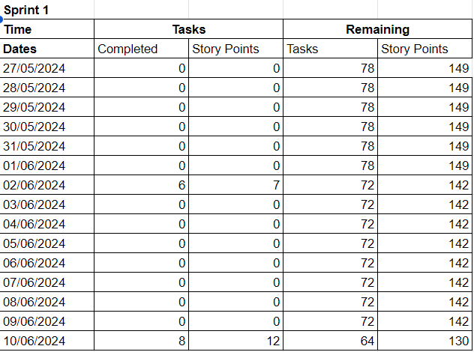

Sprint 2
Conducted from 10/06/2024 to 24/06/2024
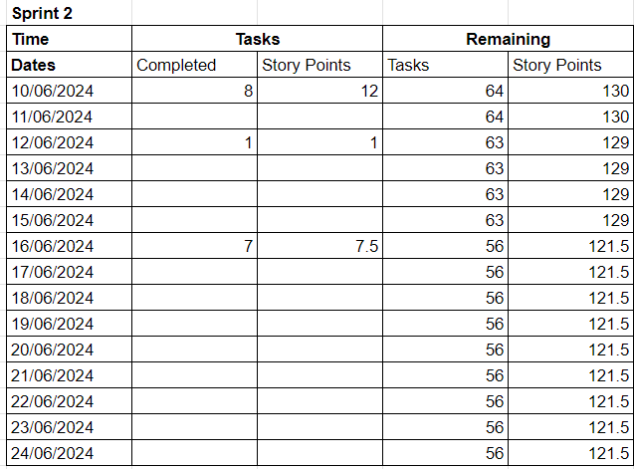

Sprint 3
Conducted from 25/06/2024 to 09/07/2024
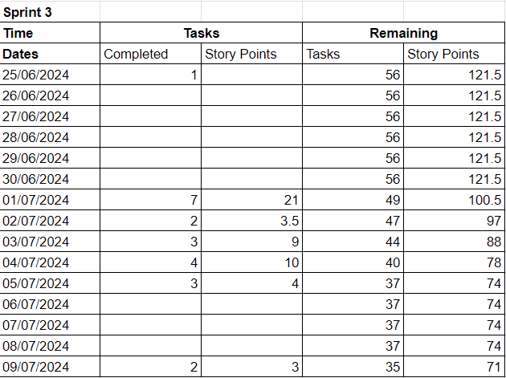

Sprint 4
Conducted from 09/07/2024 to 23/07/2024
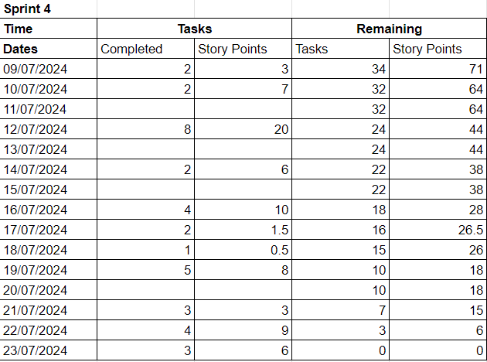

Overall Sprint
Below is the overview of all 4 sprints, as well as a combined burn down chart
